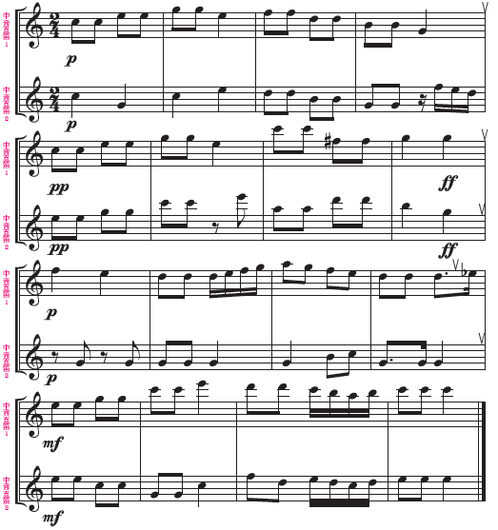







[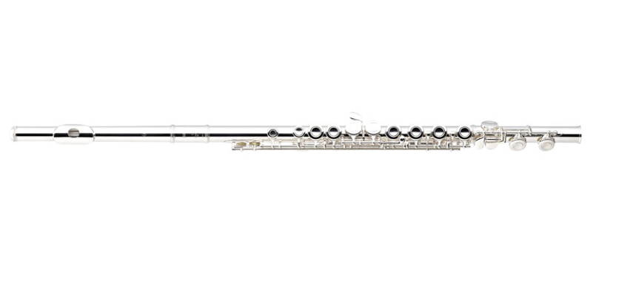](http://www.google.com.tw/url?sa=i&rct=j&q=&esrc=s&source=images&cd=&cad=rja&uact=8&ved=0ahUKEwik05CpgMjOAhWDj5QKHSTSCgIQjRwIBw&url=http%3A%2F%2Fwww.music-classroom.tw%2FClassSubList%2FCT0003&psig=AFQjCNGzo4JYy_DLs1v8YZLCbbM0eMrDqA&ust=1471507914186459)[https://encrypted-tbn1.gstatic.com/images?q=tbn:ANd9GcQ1eXgHYuWzAyyWCCNTbHAGaCqs31j4Z7jbTQ6GI16NR1AgS0MBPw](https://www.google.com.tw/url?sa=i&rct=j&q=&esrc=s&source=images&cd=&cad=rja&uact=8&ved=0ahUKEwin15mz_8fOAhVINpQKHQyRCC0QjRwIBw&url=https%3A%2F%2Fmarket.cloud.edu.tw%2Fcontent%2Fjunior%2Fmusic%2Fks_wg%2Fcontent%2Finstrument%2Foboe.htm&psig=AFQjCNFeFYfsIOAgaNAXNjI6dWn8rXGAOw&ust=1471507663159044)[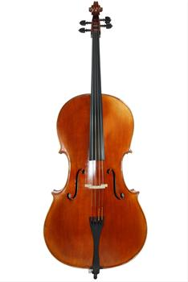](http://www.google.com.tw/url?sa=i&rct=j&q=&esrc=s&source=images&cd=&cad=rja&uact=8&ved=0ahUKEwiB4-mM8cfOAhVGE5QKHSAUAR8QjRwIBw&url=http%3A%2F%2Fwww.hotfrog.com.tw%2F%25E5%2585%25AC%25E5%258F%25B8%2F%25E8%2587%25BA%25E5%258C%2597%25E5%25B8%2582%2F%25E5%25A4%25A7%25E5%25AE%2589%25E5%258D%2580%2F%25E6%2585%2595%25E6%258F%2590%25E5%259C%258B%25E9%259A%259B%25E6%25A8%2582%25E5%2599%25A8&psig=AFQjCNEhmUoG1z1CMnH1jRtHXSbVFJj67A&ust=1471503730452589)

