第壹部分：單選題（占 72 分）
一、詞彙題（占 15 分）
說明︰第 題至第 題，每題有 4 個選項，其中只有一個是正確或最適當的選項，請畫記在答案卡之「選擇題答案區」。各題答對者，得 1 分；答錯、未作答或畫記多於一個選項者，該題以零分計算。
A rise in prices of daily commodities has shocked people nationwide, some of whom do not know how to cope with the sharp increase.
moist dense fake steep
Our English teacher would her teaching methods to suit the needs of both high achievers and slow learners.
publish install adjust expose
In the fierce storm, waves crashed the boats. Two fishermen were unfortunately killed and another three were missing.
trendy gigantic fluent primitive
Since the road ahead is blocked for construction, Tim has no choice but to take a different to downtown.
pace route trial zone
Professor Bell would never the discussion in class to textbook-based questions. Any related topics or social issues are often discussed as well.
confine enclose struggle inspire
Many people show their great for the flood victims by generously donating money and lots of relief supplies.
passion optimism sympathy commitment
The audience in surprise when the magician suddenly made a fire truck disappear into thin air.
drifted gasped carved fumed
Customers love to shop here because they may take as many as they like to the fitting room and try them on.
complaints antiques employees garments
Laura’s son has severe allergies, so she is very careful with his eating and only buys food for food-allergic children.
promptly specifically partially temporarily
Most of the germs and viruses are to the naked eye; you’ll need the help of a microscope to clearly see what they actually look like.
invisible innumerable inevitable intolerable
With her excellent form in this season, the defending champion through the following rounds and lifted up the trophy once again effortlessly.
accessed tumbled breezed enforced
The Apple Daily, one of the most popular newspapers in Taiwan, has a(n) of almost five hundred thousand evey day.
circulation appreciation collection reputation
Even though English is spoken throughout America, there are variations. People from California and Kansas may speak with very different accents.
regional permanent essential consistent
This special activity is for physically-challenged kids. It is hoped that they can have fun and interact with one another as much as other kids.
demanded engaged regulated intended
All the patients’ medical records should be treated in the strictest by doctors, for it is against the law and ethics to reveal someone’s privacy.
efficiency confidence preservation achievement

二、綜合測驗（占 15 分）
說明︰第 題至第 題，每題一個空格，請依文意選出最適當的一個選項，請畫記在答案卡之「選擇題答案區」。各題答對者，得 1 分；答錯、未作答或畫記多於一個選項者，該題以零分計算。

Cockroaches are commonly believed to be the most indestructible species on earth. However, it is not the truth. Based on a few studies, it is tardigrades that are the most species on this planet. Tardigrades are eight-legged micro animals, measuring only 0.02 inches long. They look like chubby piglets in puffy coats. They live in water most of the time. is amazing about them is that they can survive for decades without taking in any food and water. They can even unbelievably endure extreme heat of 150 Celsius degrees or ultimately rigid coldness. , they will be the
last species existing on earth after disasters destroy all the other life forms. As a matter of fact, tardigrades’ of surviving long after mankind becomes extinct suggests that there could
be life on other barren planets in the universe. This is likely to be true because scientific research has proved there are subsurface oceans underneath the ice of Europa and Enceladus, the moons of Mars. Tiny as tardigrades are, the discovery of them has led to profound and significant conclusions.
mortal prosperous resilient aggressive
That Which How What
In other words On the contrary In the meantime For no reason
capability consequence frustration folklore
created held received turned

Most scientists agree that about 65 million years ago, a large asteroid crashed into our planet. This collision is believed to have drastic changes in climate and wiped out dinosaurs. On top of that, it is also thought that the massive impact sent rocks and other debris from Earth into space.
For years, scientists had not been able to accurately estimate the quantities of rocks or the distances they traveled. It is not until recently, however, researchers successfully simulate the results of that collision with the help of computer modeling. These models show thousands of rocks from Earth the planet Mars, with some even landing on the moons of Jupiter.
Some scientists now believe that organisms from Earth to other planets on these
rocks at that time. They point to discoveries of extremophiles — organisms that live in the harshest environments on Earth, such as undersea or volcanoes. Some such microscopic organisms have been shown to survive short journeys into space on the surface of spacecraft. Nevertheless, think that a longer voyage through sub-zero temperatures and high radiation could be deadly. They wonder if such lifeforms could survive in the environments of other planets.
made up come across brought about adapted to
did when as that
being reached to reach reaching by reaching
should travel might have traveled must be traveling can travel
skeptics astrologers advocates delegates

When the rulers of Dubai in the United Arab Emirates set out to make their nation a major tourist attraction, they turned to British architect Tom Wright. They wanted him to create a(n) — a building like the Sydney Opera House or Eiffel Tower — that would bring travelers to this land of only 700,000 people. Wright’s Burj al-Arab Hotel rose to the challenge. on an artificial island, the hotel resembles the shape of the sailing dhows on the sea.
The Burj al-Arab is one of the world’s tallest hotels. Yet, it’s more than height that our attention; the building’s bold engineering and jaw-dropping decorations provide envy-inducing talking points for the world’s wealthiest travelers. Among these notable features, the lily-pad heliport at top connects to a lavish penthouse a restaurant built underwater is accessible only by submarine. Inside the hotel is an atrium that runs the full height of the structure. The beautiful sail provides a screen from the withering sun, heat and light in the interior. At night, the sail provides a backdrop for elaborate light shows — a reminder that Dubai is closer to Las Vegas than you might think. How much does it cost to spend a night here? If you have to ask, you probably won’t be visiting.
elite scale fame icon
Situating Situated To situate Having situated
requires collects appeals commands
with as while once
offering deleting reducing expanding
三、文意選填（占 10 分）
說明︰第 題至第 題，每題一個空格，請依文意在文章後所提供的 到 選項中分別選出最適當者，並將其英文字母代號畫記在答案卡之「選擇題答案區」。各題答對者，得 1 分；答錯、未作答或畫記多於一個選項者，該題以零分計算。

We all have seen a confused and anxious look on the faces of elders, who could be our neighbors or loved ones. They don’t seem to remember the good old days. Some of them have trouble recognizing their family. They are suffering from Alzheimer’s disease. In 2015, around 46 million people were by Alzheimer’s disease. However, the actual should be larger than that because people with poorer health care are usually less aware of the disease.
Although Alzheimer’s is widely known, do we know about its cause. We just know it’s
a disease of the brain slowly losing its function, and affects people who are over 65. In early stages, patients show symptoms like short-term memory loss. They cannot remember names, directions and eventually lose the ability to perform daily tasks, such as making tea or doing the laundry. Gradually, their language ability would also be lost. At its , Alzheimer’s disease patients lose most of the cognitive abilities and become extremely violent and emotionally unstable.
So far, there is no for Alzheimer’s disease. No known medicine or scientific methods can stop the disease from happening, reversing it. Nevertheless, the best way to prevent the disease is to adopt a new lifestyle. As far as treating or preventing Alzheimer’s disease is concerned, mental stimulation is as important as physical exercise. The brain resembles a(n) , which gets stronger when constantly used. Therefore, the vitality of the brain can be by playing cards, reading, learning a musical instrument or picking up a new language, any of which can deter the elders from getting Alzheimer’s disease. The brain can remain active if the elders are doing work
they enjoy. Hence, retired people are encouraged to do voluntary work or just help take care of grandchildren. Eventually, we all get old. Including these activities in our life to keep our mind is indeed necessary. After all, we all want to reduce the risk of having this awful disease.
figure sharp worst enhanced let alone
little cure tortured muscle anything but

四、閱讀測驗（占 32 分）
說明︰第 題至第 題，每題請分別根據各篇文章之文意選出最適當的一個選項，請畫記在答案卡之「選擇題答案區」。各題答對者，得 2 分；答錯、未作答或畫記多於一個選項者，該題以零分計算。

After a front handspring onto the vaulting horse, she twisted and turned in the air. In everyone’s oohs and ahhs, she landed, in a crouch. She was eventually placed seventh in the event of vault but created history. In the 2016 Rio Olympics, Oksana Chusovitina became the first gymnast ever to compete in the Olympics seven times consecutively.
Oksana Chusovitina was born in Uzbekistan in 1975. At the age of 15, she gained world recognition in her first international appearance. Her Olympic debut was in 1992, where she represented the Soviet Union and won the team gold medal. After the fall of the Soviet Union that same year, Chusovitina returned to Uzbekistan, for which she represented the following several years. In 1999, when her son Alisher was born, Chusovitina was considering winding down her career and moving into coaching. Only a cruel twist of fate changed all that. Alisher was diagnosed with leukemia and was dying. Chusovitina knew immediately that Uzbekistan’s patchy medical system would be ill-equipped to help. Luckily, she was introduced to a hospital in Germany, where Alisher could receive the best care, but the huge cost was beyond her capacity. In the end, she solved the problem by doing what she did best. Chusovitina moved to Germany, entered the national team,
and started to compete on behalf of Germany to earn more prize money to cover her son’s medical expenses. She attended the 2008 Beijing Olympics, where her silver medal on vault was the only medal for the German women’s team that year.
After representing Germany at the 2012 Olympics, Chusovitina returned to her homeland and
she has competed for her country ever since. Now, Chusovitina is having far too much fun to stop competing. With five skills named after her in the International Gymnastics Code of Points, this inspiring gymnast continues to shine in Asian Games in 2018, winning the silver on vault and becoming the oldest medalist in Gymnastics in history. Probably we might see her create history again if she represents her country in her eighth Olympics in Tokyo in 2020.
What can be the best title for this passage?
A Living Legend in the World of Gymnastics — Oskana Chusovitina.
Oskana Chusovitina — A Brave Mom Who Survives A Deadly Disease.
The Secret Behind Oskana Chusovitina’s Longevity in the World of Gymnastics.
An Ageless Diva of the Vault — Oskana Chusovitina, Her Successes and Failures.
Which countries did Oskana Chusovitina represent in the Olympics of 1992, 1996, 2008 and 2012?
Uzbekistan, Uzbekistan, Germany, Germany.
Uzbekistan, Uzbekistan, Germany, Uzbekistan.
the Soviet Union, Germany, Germany, Uzbekistan.
the Soviet Union, Uzbekistan, Germany, Germany.
Which one of the following is NOT Oskana Chusovitina’s special achievement?
Being the oldest competitor in Asian Games.
Attending the most Olympics on end in gymnastics.
Having skills in gymnastics named after her.
Winning both personal and team medals in Olympics.
According to the passage, which one of the following statements is true?
Chusovitina has represented four different countries in the Olympics.
Chusovitina’s participation in the Olympics has spanned for 28 years on end.
The reason that drove Chusovitina to leave her homeland was her son’s illness.
Chusovitina will represent Uzbekistan in her eighth Olympics in Tokyo in 2020.

Near Gryfino, a small town lying around western Poland, there is a bizarre forest. The forest is called Krzywy Las, or the crooked forest, which is a patch of woodland with 400 trees. What makes it different from other forests is that the trunks of these trees are bent 90 degrees at the base and then zip back up into the sky, shaping like “Js.” All of the curved trees oddly point toward the north. A lot of tourists visit this dreamlike woodland to see these strangely shaped trees.
Behind the unusually picturesque view of the crooked forest, there has been a feel of mystery about the queer formation of the trees. The trees are believed to have been planted around the 1930s and have suffered from a certain force or damage, which led to the curvature of the trunks. There are several versions of explanations. One is that gravitational forces changed and then a certain force pulled the tree trunks. However, this explanation is abandoned quickly since the force of gravity drags things down rather than sideways. Another theory is that heavy snow might have covered the young trees for a while. This one sounds more plausible, but is still unlikely because the curved trees are surrounded by normal straight trees. It’s hard to explain why a severe snowstorm should have affected certain woodland only without touching the neighboring trees.
Instead of the natural force, some people believe the crooked forest was caused by humans.
One prevailing theory is that farmers back in the 1930s deliberately bent the tree trunks for
the purpose of building ships. One document regarding vessel construction can support this hypothesis — “... timbers curving naturally are most suitable to strengthen the structure internally.” Therefore, the particularly-arranged bent trees pointing to the same direction were probably for ship construction. Due to the interruption of World War II, the trees were left there, leaving this incredible forest scenery we see nowadays. However, none of the explanations has been scientifically proved. Still, it doesn’t bother those who walk into this enchanting forest and get immersed in the mystery.
What is the passage mainly about?
The theory of building ships. The contribution of Krzywy Las.
The values of the crooked forest. The origin of a special woodland.
Which of the following pictures best describes the crooked forest?
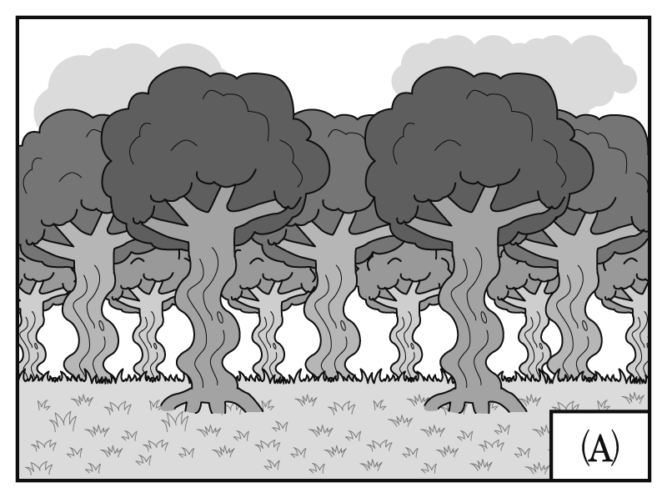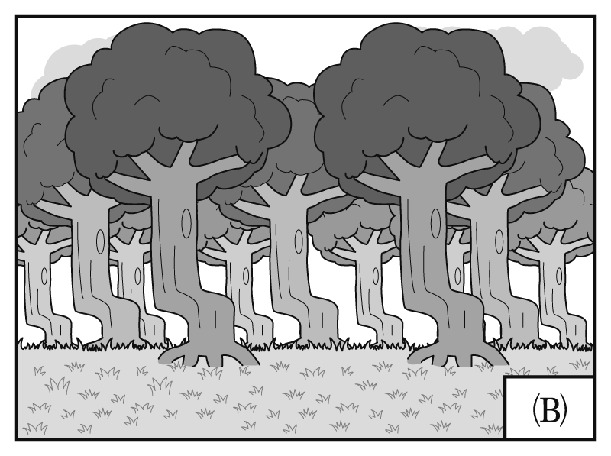
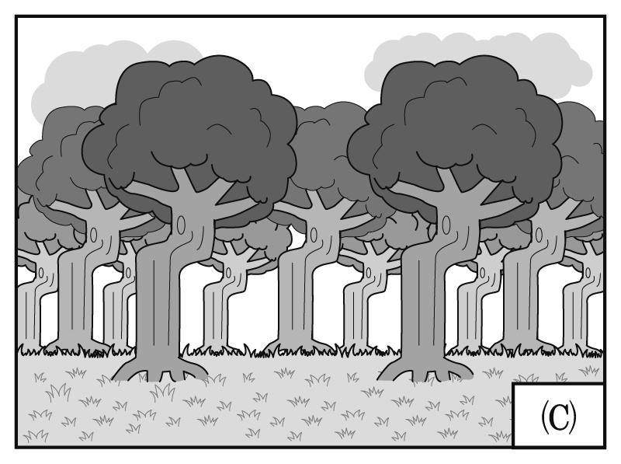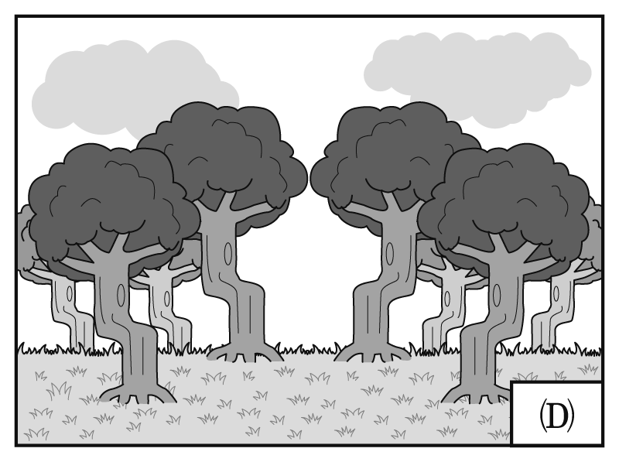
What does the author think is most likely to be responsible for the crooked forest?
Gravity. Wars. Humans. Heavy snow.
According to the passage, which of the following is true?
The wildlife in Krzywy Las attracts numbers of tourists every year.
The naturally grown trees in Krzywy Las were perfect for building ships.
Soldiers were ordered to destroy all the woodlands in Fryfino except for Krzywy Las.
There is no solid scientific evidence to prove how the crooked forest was formed.

In Twende, Tanzania, a group of young builders are discussing how they can fix a problem while making their own products. It’s a school as well as a workshop. These young people believe they have the ability to create something.
Twende was founded and is now directed by Bernard Kiwia, who is hailed as “the father of rural invention in Tanzania.” Innovation has been in Bernard’s DNA since his parents, a mechanic and a tailor, had been building and making new things out of old and unwanted stuff in his childhood.
He became a bicycle repairman and electrician when he grew up. He was known for inventing a bicycle-powered phone charger. Then one trip to the U.S. for an innovation conference motivated him to start an innovation center in Tanzania.
Bernard and his team in the school believe Tanzanians, if given opportunities, can be bright
and daring and become innovators. They don’t have any restrictions for people to join the school. They welcome innovators of all ages and genders as long as they are open-minded and passionate.
A lot of successful innovations have been devised. Most of them made use of old parts from daily commodities. One is the Fert-Cart, which is a wheelbarrow that helps reduce the time farmers spend in spreading fertilizers and animal waste by hand. The inventor can rent the Fert-Cart to other farmers and make money from it. The avocado oil press is another example of invention. Some farmers cannot get a nice price for avocados at the market and just let them rot after they fall from trees.
The oil press can help the farmers process avocados and extract oil for sale.
The Twende school changes Tanzanians’ life. Quirky and simple as they seem, inventions like the Fert-Cart and the avocado oil press not only fix inventors’ problems but also bring them profits so that they can pay children’s tuition fees. The Twende school has been striving to offer resources to innovators and will continue to do so in the future.
Which of the following titles best describes the main idea of this passage?
Africans Rising Above Poverty Africa’s School for Inventors
Best Inventions in Africa Throughout History Life-changing Experiences in Tanzania
What is the basic requirement for people who go to the Twende school?
They must be young and bright.
They must come from an agricultural background.
They must be enthusiastic about creating things.
They must have an experience of inventing something from bicycle parts.

Which of the following is NOT one of the advantages of attending the Twende school?
Helping rescue unwanted fruits.
Making farmers work more efficiently.
Making more money to support the family.
Helping farmers selling produce at a higher price.
Which of the following can be inferred from the passage?
The Twende school is a success with positive impacts.
Most Tanzanians cannot accept the strange-looking inventions.
All Twende members used to be bicycle repairmen or electricians.
Bernard Kiwia has won an award in the U.S. with his bicycle-powered phone charger.

During the late 1930s and early 1940s, a fashion trend in the United States caused such controversy that it led to violence and rioting. The zoot suit, an oversized and colorful suit
initially worn by young African-Americans, was subsequently adopted by second-generation Mexican-Americans known as “pachucos.” The pachucos wore the zoot suit out of a desire to distance themselves from mainstream America, which they felt had rejected them. Instead of trying
to fit in as their parents had, the pachucos sought to stand out, both in their choice of clothing and the way they behaved. As the pachucos’ opposition to authority sometimes crossed the line into minor crimes and drug use, the zoot suit began to be associated with criminal behavior.
During World War II, the US experienced a fabric shortage. The government thus introduced tailoring restrictions, which outlawed the manufacture of zoot suits. Demand remained strong, however, and underground tailors continued production. In the eyes of the public, zoot suit wearers were deemed unpatriotic, as wearing them represented a dismissive attitude toward the warfare.
In 1943, tensions between uniformed military servicemen and gangs of zoot-suit-wearing pachucos exploded into violence in Los Angeles. During weeks of rioting, zoot suit wearers were routinely hunted down, attacked and stripped off their offending suits by servicemen. The pachucos, unsurprisingly, fought back. However, the press only emphasized the pachucos’ part of violence
and embellished the soldiers’ acts as “fair punishment.” Reporters also largely ignored the number
of women and white men among those wearing zoot suits, implying zoot suits wearers were either Mexican-American or African-American males trying to avoid military service.
Though little attempt was made to look into the circumstances behind the riots then, people nowadays can fully understand the social, economic, and racial factors contributing to the riots.
There is no denying that the zoot suit riots had strong influence on the entire generation of socially disadvantaged youths. The political awareness and discontent caused by the conflict helped make possible the activism of minorities in the civic rights movement of the 1960s, which eventually led to greater equality and opportunity for all.
What is the passage mainly about?
Zoot suit and its manufacturing purpose.
Zoot suit and the political instability it caused.
Zoot suit and its social and cultural significance.
Zoot suit and its historical relation with Mexican-Americans.
Why did the pachucos adopt the zoot suit?
It showed that they were unwilling to comply with conventional standards of American culture.
It proved that pachucos were able to create outstanding fashion trends within American society.
It allowed pachucos to declare independence from their parents and reject their original culture.
It helped the general public to accept pachucos despite their reputation for committing illegal acts.
What might “unpatriotic” people most likely do?
They would pursue their own benefits at the cost of other people’s welfare.
They might turn a blind eye toward their country’s domestic and international affairs.
They might be violent enough to cause riots and turbulences among their community.
They would deliberately violate laws that are supposed to help maintain social orders.
According to the passage, which one of the following statements is NOT true?
The zoot suit riots open up a gate for future equality movements in America.
When the riots exploded, the press sided with and spoke in favor of the military servicemen.
Zoot suits are a widely embraced fashion statement among different ethnic groups in America.
At times of riots, most people failed to link the riots to the minority youths’ unequaled social status.

第貳部分：非選擇題（占 28 分）
說明：本部分共有二題，請依各題指示作答，答案必須寫在「答案卷」上，並標明大題號（一、二）。作答務必使用筆尖較粗之黑色墨水的筆書寫，且不得使用鉛筆。
一、中譯英（占 8 分）
說明：請將以下中文句子譯成正確、通順、達意的英文，並將答案寫在「答案卷」上。
請依序作答，並標明子題號。每題 4 分，共 8 分。
智慧型手機已成為生活中不可或缺的一部分，協助我們解決問題並使生活更便利。
現在我們能透過智慧型手機支付費用、管理個人財務，更可以和人工智慧互動。

二、英文作文（占 20 分）
說明：依提示在「答案卷」上寫一篇英文作文。
文長至少 120 個單詞（words）。
提示︰隨著網路的盛行與發達，有愈來愈多人在網路上發表個人意見、分享心得、針砭時事，因此逐漸開始出現所謂的「youtuber」或「網紅」（Internet Celebrity）現象。許多年輕人更利用這樣的網路平臺模式進行商業化的經營或與其他網友互動及交流。請以此種「網紅現象」為題，寫一篇英文作文。第一段，以個人經驗或報導所聞為例，試描述這種情形，並分析網紅之所以會盛行的原因。第二段，說明自己對此現象的心得、看法或感想。

