第壹部分：單選題（占 72 分）
一、詞彙題（占 15 分）
說明︰第 題至第 題，每題有 4 個選項，其中只有一個是正確或最適當的選項，請畫記在答案卡之「選擇題答案區」。各題答對者，得 1 分；答錯、未作答或畫記多於一個選項者，該題以零分計算。
A rise in prices of daily commodities has shocked people nationwide, some of whom do not know how to cope with the sharp increase.
moist dense fake steep
答案：
解析： 考形容詞。日用品價格 幅度已震驚全國人民，其中有些人不知如何因應此急遽漲幅。
溼潤的 密集的 假的 過高的；陡峭的
Our English teacher would her teaching methods to suit the needs of both high achievers and slow learners.
publish install adjust expose
答案：
解析：考動詞。我們英文老師會 她的教學方法，以符合高成就學生以及學習緩慢者的需求。
出版 安裝 調整 暴露
In the fierce storm, waves crashed the boats. Two fishermen were unfortunately killed and another three were missing.
trendy gigantic fluent primitive
答案：
解析：考形容詞。強烈暴風雨中， 浪擊垮了船隻，很不幸地兩名漁夫喪生，另外三名失蹤。
時髦的 巨大的 流利的 原始的
Since the road ahead is blocked for construction, Tim has no choice but to take a different to downtown.
pace route trial zone
答案：
解析： 考名詞。前方的路因施工而被封住，Tim 只得走另一條 進市區。
步調 路徑 試煉 區域
Professor Bell would never the discussion in class to textbook-based questions. Any related topics or social issues are often discussed as well.
confine enclose struggle inspire
答案：
解析： 考動詞。Bell 教授從不會將課堂討論 於以教科書為本的問題。任何相關的主題或社會議題也經常被討論。
侷限 隨信附上；圍住 掙扎 啟發

Many people show their great for the flood victims by generously donating money and lots of relief supplies.
passion optimism sympathy commitment
答案：
解析： 考名詞。許多人藉由慷慨捐款以及紓困物資來表達他們對水災受害者們的 。
熱情 樂觀 同情心 承諾
The audience in surprise when the magician suddenly made a fire truck disappear into thin air.
drifted gasped carved fumed
答案：
解析： 考動詞。當魔術師突然使一輛消防車憑空消失時，觀眾們驚訝的 。
漂浮 倒抽一口氣 雕刻 生怒氣
Customers love to shop here because they may take as many as they like to the fitting room and try them on.
complaints antiques employees garments
答案：
解析： 考名詞。顧客喜歡在這裡購物，因為他們可以愛拿幾件就拿幾件 到試衣間試穿。
抱怨 骨董 員工 衣物
Laura’s son has severe allergies, so she is very careful with his eating and only buys food for food-allergic children.
promptly specifically partially temporarily
答案：
解析： 考副詞。Laura 的兒子嚴重過敏，因此對於其飲食小心翼翼，她只買 給食物過敏孩童吃的食品。
迅速；立即地 專門地 部分地 暫時地
Most of the germs and viruses are to the naked eye; you’ll need the help of a microscope to clearly see what they actually look like.
invisible innumerable inevitable intolerable
答案：
解析： 考形容詞。大部分的細菌和病毒都是肉眼 ；你需要顯微鏡的幫助來看清它們的樣貌。
看不見的 數不盡的 無可避免的 不可容忍的
With her excellent form in this season, the defending champion through the following rounds and lifted up the trophy once again effortlessly.
accessed tumbled breezed enforced
答案：
解析： 考動詞。憑藉著這一季絕佳的狀態，衛冕冠軍 通過她接下來幾輪的賽事，並輕而易舉地再次捧起獎盃。
取得…的使用權 踉蹌 輕鬆地（做…） 強制執行

The Apple Daily, one of the most popular newspapers in Taiwan, has a(n) of almost five hundred thousand evey day.
circulation appreciation collection reputation
答案：
解析： 考名詞。《蘋果日報》是臺灣最受歡迎的報紙，它每天的 有將近五十萬份。
發行量 欣賞 收集品；一系列作品 名聲
Even though English is spoken throughout America, there are variations. People from California and Kansas may speak with very different accents.
regional permanent essential consistent
答案：
解析： 考形容詞。即使美國到處都說英語，但還是有 的差異。來自加州和堪薩斯州的人們可能就有著不同的口音。
區域上的 永恆的 必要的 一貫的
This special activity is for physically-challenged kids. It is hoped that they can have fun and interact with one another as much as other kids.
demanded engaged regulated intended
答案：
解析： 考動詞。這個特別的活動是 殘疾孩童參加的，以期望他們可以如其他孩童一樣盡情享樂彼此互動。
要求 從事；訂婚 規範 打算；預定
All the patients’ medical records should be treated in the strictest by doctors, for it is against the law and ethics to reveal someone’s privacy.
efficiency confidence preservation achievement
答案：
解析： 考名詞。所有病人的醫療紀錄都須被醫生們嚴格 ，因為洩漏他人隱私不但違法還很缺德。
效率 機密 保育；保護 成就

二、綜合測驗（占 15 分）
說明︰第 題至第 題，每題一個空格，請依文意選出最適當的一個選項，請畫記在答案卡之「選擇題答案區」。各題答對者，得 1 分；答錯、未作答或畫記多於一個選項者，該題以零分計算。

Cockroaches are commonly believed to be the most indestructible species on earth. However, it is not the truth. Based on a few studies, it is tardigrades that are the most species on this planet. Tardigrades are eight-legged micro animals, measuring only 0.02 inches long. They look like chubby piglets in puffy coats. They live in water most of the time. is amazing about them is that they can survive for decades without taking in any food and water. They can even unbelievably endure extreme heat of 150 Celsius degrees or ultimately rigid coldness. , they will be the
last species existing on earth after disasters destroy all the other life forms. As a matter of fact, tardigrades’ of surviving long after mankind becomes extinct suggests that there could
be life on other barren planets in the universe. This is likely to be true because scientific research has proved there are subsurface oceans underneath the ice of Europa and Enceladus, the moons of Mars. Tiny as tardigrades are, the discovery of them has led to profound and significant conclusions.
mortal prosperous resilient aggressive
That Which How What
In other words On the contrary In the meantime For no reason
capability consequence frustration folklore
created held received turned
答案： ； ； ； ；
解析：
一般人相信蟑螂是地球上最強韌的物種。然而，事實並非如此。根據一些研究，水熊蟲才是這個星球上最強韌的物種。水熊蟲是八隻腳的微生動物，身長只有 0.02 英吋，看起來像是穿著蓬鬆外套圓滾滾的小豬，牠們大部分的時間住在水裡。牠們令人驚奇之處是能夠不攝取任何食物與水而存活數十年，甚至很不可思議地能夠忍受攝氏 150 度的高溫或是極嚴峻的寒冷；換句話說，在災難將所有其他生物滅絕之後，牠們將會是存活在地球上的最後一種物種。事實上，水熊蟲能在人類滅絕很久以後還活著，這件事暗示著宇宙中其他貧瘠的星球可能有生命存在。這很可能是真的，因為科學研究已證明火星的衛星歐羅巴以及恩賽勒達斯的冰層之下有海洋。雖然水熊蟲很小，但是牠們的發現已有深度且有意義的結論。
會死的 繁榮興盛的 有韌性的 好鬥的；有野心的
以前文關鍵字 the most indestructible，選 有韌性的。
本題考複合關係詞 what (＝the thing that ... )，what 引導一名詞子句當 is that ... 的主詞，故選 。
換言之 相反地 同時 沒有理由地
本題考轉折語副詞。前文提到 tardigrades 可以耐熱耐寒，這種特性所代表的意思是當地球變得太冷或太熱而讓不耐熱或冷的生物全滅絕時，牠們會是唯一可存活下來的，故選 。
能力 結果 挫折 民間故事
本題考名詞。依前文文意：tardigrades 超耐寒及熱，故有浩劫後仍可存活的「能力」，故選 。
創造 認為 接受 轉向；變成
本題考動詞。S＋be held true 被視為是真的，依文意選 。
重要字、詞與片語
indestructible adj. 不可摧毀的 tardigrade n. 水熊蟲 chubby adj. 圓胖的 piglet n. 小豬
puffy adj. 蓬鬆的 rigid adj. 嚴峻的 barren adj. 貧瘠的

Most scientists agree that about 65 million years ago, a large asteroid crashed into our planet. This collision is believed to have drastic changes in climate and wiped out dinosaurs. On top of that, it is also thought that the massive impact sent rocks and other debris from Earth into space.

For years, scientists had not been able to accurately estimate the quantities of rocks or the distances they traveled. It is not until recently, however, researchers successfully simulate the results of that collision with the help of computer modeling. These models show thousands of rocks from Earth the planet Mars, with some even landing on the moons of Jupiter.
Some scientists now believe that organisms from Earth to other planets on these
rocks at that time. They point to discoveries of extremophiles — organisms that live in the harshest environments on Earth, such as undersea or volcanoes. Some such microscopic organisms have been shown to survive short journeys into space on the surface of spacecraft. Nevertheless, think that a longer voyage through sub-zero temperatures and high radiation could be deadly. They wonder if such lifeforms could survive in the environments of other planets.
made up come across brought about adapted to
did when as that
being reached to reach reaching by reaching
should travel might have traveled must be traveling can travel
skeptics astrologers advocates delegates
答案： ； ； ； ；
解析：
大部分的科學家都認同 6,500 萬年前曾有一個巨大的隕石撞擊地球。這起撞擊據信造成了氣候急遽的變化，並且澈底使恐龍滅絕。除此之外，大家還認為這起巨大的撞擊將許多地球上的殘骸和石塊送上了太空。
一直以來，科學家無法精確地估量這些石塊的數量以及它們在太空中移動了多長距離。然而直到最近，藉由電腦模擬，科學家成功地模擬出撞擊造成的結果。這些模擬顯示了成千個來自地球的碎石到達了火星，有些甚至還落在木星的衛星群上。
部分科學家現在相信有些來自地球上的微生物可能當時伴隨著這些碎石塊一起到了其他星球。它們將證據指向了「嗜極生物」，一種住在地球極端氣候環境下的有機體，例如海底或是火山中。有些這樣的微生物被證實可以附著於太空梭的表層上，並於太空梭進入太空的短暫旅程中存活。然而，有些懷疑論者認為長時間在零度以下的溫度以及高輻射中的航程是致命的。他們懷疑這樣的生命體是否真的能存活於其他星球的環境中。
捏造 偶遇 導致 適應
本題考片語搭配。根據上下文文意，正確選項為 。
本題考句型概念：It is not until ... that，「直到…才…」。
本題考句構概念。本句主詞為 These models、動詞是 show，而後面 thousands of rocks from Erath the planet Mars 為受詞，因此空格處需選動名詞 reaching。 是被動語態，不合文意， 不定詞表示目的， by reaching 表達手段、方式，皆不合語意。
本題考文法概念。might have＋pp. 表示對過去事情做出的推測。科學家認為當時隕石撞地球時，許多微生物伴隨著石礫一起進了太空，表示對當時發生事情做的推斷，因此 為正解。
懷疑論者 占星學家 提倡者 代表
本題考單字運用。從上下文可得知，「懷疑論者」對許多科學家提出的論點持懷疑的態度，並從最後一句 They wonder 可推知本題最佳選項為 。

重要字、詞與片語
asteroid n. 隕石 collision n. 撞擊 drastic adj. 劇烈的 debris n. 殘骸；礫石 simulate v. 模擬
Mars n. 火星 Jupiter n. 木星 extremophile n. 嗜極生物 organism n. 有機體 radiation n. 輻射

When the rulers of Dubai in the United Arab Emirates set out to make their nation a major tourist attraction, they turned to British architect Tom Wright. They wanted him to create a(n) — a building like the Sydney Opera House or Eiffel Tower — that would bring travelers to this land of only 700,000 people. Wright’s Burj al-Arab Hotel rose to the challenge. on an artificial island, the hotel resembles the shape of the sailing dhows on the sea.
The Burj al-Arab is one of the world’s tallest hotels. Yet, it’s more than height that our attention; the building’s bold engineering and jaw-dropping decorations provide envy-inducing talking points for the world’s wealthiest travelers. Among these notable features, the lily-pad heliport at top connects to a lavish penthouse a restaurant built underwater is accessible only by submarine. Inside the hotel is an atrium that runs the full height of the structure. The beautiful sail provides a screen from the withering sun, heat and light in the interior. At night, the sail provides a backdrop for elaborate light shows — a reminder that Dubai is closer to Las Vegas than you might think. How much does it cost to spend a night here? If you have to ask, you probably won’t be visiting.
elite scale fame icon
Situating Situated To situate Having situated
requires collects appeals commands
with as while once
offering deleting reducing expanding
答案： ； ； ； ；
解析：
當杜拜的統治者打算將他們的城市變成一個主要的觀光景點時，他們向英國的建築師 Tom Wright 尋求協助。他們要他創造出一棟具代表性的建築物，像雪梨歌劇院或是艾菲爾鐵塔那般，可以將觀光客們引來這塊僅有七十萬居民的土地上。Wright 創造出來的帆船飯店達成了這項挑戰。座落於一座人工島嶼上，這棟飯店看起來就像一艘航行在海上的帆船。
帆船飯店是全世界最高的飯店之一。然而吸引我們目光焦點的不僅僅只是它的高度；這棟建築物大膽的工程以及令人嘖嘖稱奇的裝飾都成為了全世界最富有的旅者們口中引人稱羨的話題焦點。在這些令人注目的建築特色中，飯店頂端的荷葉形直升機停機坪可以直通高樓層奢華的獨立別墅套房，而一間建築在水底下的餐廳則僅能藉由搭乘潛水艇連通。飯店內是一座中庭，撐起整個建築物的高度。而美麗的風帆則提供屏蔽阻擋烈日，減少室內的熱度及光線。夜晚時，風帆則成為精緻燈光秀的背景布幕—令你感受拉斯維加斯和杜拜比想像中更為相似。在這裡住一晚要多少錢呢？如果你會問這個問題的話，你恐怕就不會想來了。
菁英 規模 名聲 具代表性的（形象、建築等）
本題考單字運用。從上下文（雪梨歌劇院及艾菲爾鐵塔）可推知，本格答案為 。

考主被動及單字概念。原句應為：(As the hotel is) situated on an artificial island, the hotel .... 分詞構句概念，將連接詞 As，相同主詞 the hotel 一併省略，is 變成 being，在句首亦可省略，因此為 Situated 開頭。另外，若以 situate 表示座落於…的語意，則使用被動。
要求 收集 吸引 博得；引得
本題考搭配字詞（單字）。command one’s attention：吸引某人目光。
選項 需改成 appeal to＋N 才能表示吸引。
本題考轉承連接概念。此處由上下文可知，是將上（停機坪）與下（水底餐廳）兩個建築物做為對照，因此 while 為最佳答案。此處 while 的語意為「而」，有對照、對比之意味。
提供 刪除 減少 擴張
本題考單字運用。此處由上下文可得知，因為風帆可以遮蔽烈日，因此可得知此處是要「減少」室內的高溫及強光，故選 。
重要字、詞與片語
artificial adj. 人工的 resemble v. 相像 jaw-dropping adj. 令人震驚的 envy-inducing adj. 引人羨慕的
heliport n. 直升機停機坪 lavish adj. 奢華鋪張的 penthouse n. 頂層豪華套房 atrium n. 中庭
withering adj. 使乾枯；凋萎的 backdrop n. 背景 elaborate adj. 精緻的

三、文意選填（占 10 分）
說明︰第 題至第 題，每題一個空格，請依文意在文章後所提供的 到 選項中分別選出最適當者，並將其英文字母代號畫記在答案卡之「選擇題答案區」。各題答對者，得 1 分；答錯、未作答或畫記多於一個選項者，該題以零分計算。

We all have seen a confused and anxious look on the faces of elders, who could be our neighbors or loved ones. They don’t seem to remember the good old days. Some of them have trouble recognizing their family. They are suffering from Alzheimer’s disease. In 2015, around 46 million people were by Alzheimer’s disease. However, the actual should be larger than that because people with poorer health care are usually less aware of the disease.
Although Alzheimer’s is widely known, do we know about its cause. We just know it’s
a disease of the brain slowly losing its function, and affects people who are over 65. In early stages, patients show symptoms like short-term memory loss. They cannot remember names, directions and eventually lose the ability to perform daily tasks, such as making tea or doing the laundry. Gradually, their language ability would also be lost. At its , Alzheimer’s disease patients lose most of the cognitive abilities and become extremely violent and emotionally unstable.
So far, there is no for Alzheimer’s disease. No known medicine or scientific methods can stop the disease from happening, reversing it. Nevertheless, the best way to prevent the disease is to adopt a new lifestyle. As far as treating or preventing Alzheimer’s disease is concerned, mental stimulation is as important as physical exercise. The brain resembles a(n) , which gets stronger when constantly used. Therefore, the vitality of the brain can be by playing cards, reading, learning a musical instrument or picking up a new language, any of which can deter the elders from getting Alzheimer’s disease. The brain can remain active if the elders are doing work
they enjoy. Hence, retired people are encouraged to do voluntary work or just help take care of grandchildren. Eventually, we all get old. Including these activities in our life to keep our mind is indeed necessary. After all, we all want to reduce the risk of having this awful disease.
figure sharp worst enhanced let alone
little cure tortured muscle anything but
答案： ； ； ； ； ； ； ； ； ；
解析：
我們都曾看過年長者臉上困惑、焦慮的神情，那可能是我們的鄰居或是摯愛的人。他們似乎什麼都不記得了，只記得許久前的美好時光，有些人甚至無法認得家人，他們罹患的是阿茲海默症。2015 年時，大約有四千六百萬人遭受阿茲海默症折磨之苦。然而，真正的數目應該比那更大，因為較欠缺健保照護的人通常比較無法意識到這個疾病。
雖然阿茲海默症眾所皆知，但是我們對此疾病成因的認識卻不多。我們僅知道它是腦部慢慢失去功能的疾病，影響著超過 65 歲以上的人。病人在早期時的症狀是喪失短期記憶，他們無法記住名字、方向，最後會失去日常事務操作的能力，例如泡茶或洗衣服。慢慢的，他們的語言能力也會喪失，到最糟的狀況時，阿茲海默症病人會失去大部分的認知能力，變得相當暴力、情緒不穩定。
到目前為止，阿茲海默症沒有解藥，沒有已知的藥物或科學方法可以阻止它發病，更何況是反轉其病程。雖然如此，預防這種疾病的最佳方式是採取新的生活方式，就治療或預防阿茲海默症而言，心理刺激與生理運動一樣重要。大腦和肌肉相似，經常使用時會更強壯，因此，藉由玩牌、閱讀、學新的樂器或是語言，大腦活力可以提升，這些活動都可以延緩年長者罹患阿茲海默症，如果年長者可以從事他們喜歡的工作，大腦可以維持活躍的狀況。因此，退休人士會被鼓勵去做志工，或幫忙照顧孫子。我們最後都會變老，為了讓我們的腦袋靈光，在我們的生活中納入這些活動真的很必要，畢竟，我們都想要降低罹患這可怕疾病的風險。
此題在及物動詞與受詞之間，故需填一介系詞，依第二段文意阿茲海默症病患會喪失短期記憶力，故他們應該「只」記得以前的美好時光，因此選 只有。
本題在 be 動詞與 by＋N 之間，故應填一動詞的過去分詞，依文意選 折磨。
本題於 the＋adj. 之後，故應填一名詞，依上文關鍵字 around 46 million people 選 數目字。
do we know 是倒裝，依前文關鍵字 although ... widely known，選否定詞 little，使之形成倒裝句，故選 很少。
上文述說罹患阿茲海默症的病程，由輕微描述到嚴重，故到最後應該是最嚴重的，故選 最糟的狀況。
此段大意是人們只能改變生活方式來預防阿茲海默症，其實是因為沒有解藥，故選 治癒方式。
既然沒有解藥，使阿茲海默症的病程反轉更是不可能，依文意選 更不用說（前面多半是否定句）。
本題應填名詞，依下文文意 playing cards、reading 等都是鍛鍊腦袋的活動，故大腦就像肌肉是可以鍛鍊的，故選 肌肉。
本題在 be 動詞後，可填形容詞或過去分詞已形成被動語態，以上下文關鍵字 gets stronger、deter ... from getting Alzheimer’s disease 選過去分詞 提高；增強。
本題位 keep＋O＋OC 句型中補語的位子，依上述提到的活動可以讓年長者大腦 active，因此和 active 近似意的是選項 敏銳；機敏的。

重要字、詞與片語
recognize v. 辨識出 symptom n. 症狀 cognitive adj. 認知的 unstable adj. 不穩定的
reverse v. 使倒轉 stimulation n. 刺激 resemble v. 與…相像 vitality n. 活力；持續力
instrument n. 樂器 voluntary work 志工

四、閱讀測驗（占 32 分）
說明︰第 題至第 題，每題請分別根據各篇文章之文意選出最適當的一個選項，請畫記在答案卡之「選擇題答案區」。各題答對者，得 2 分；答錯、未作答或畫記多於一個選項者，該題以零分計算。

After a front handspring onto the vaulting horse, she twisted and turned in the air. In everyone’s oohs and ahhs, she landed, in a crouch. She was eventually placed seventh in the event of vault but created history. In the 2016 Rio Olympics, Oksana Chusovitina became the first gymnast ever to compete in the Olympics seven times consecutively.
Oksana Chusovitina was born in Uzbekistan in 1975. At the age of 15, she gained world recognition in her first international appearance. Her Olympic debut was in 1992, where she represented the Soviet Union and won the team gold medal. After the fall of the Soviet Union that same year, Chusovitina returned to Uzbekistan, for which she represented the following several years. In 1999, when her son Alisher was born, Chusovitina was considering winding down her career and moving into coaching. Only a cruel twist of fate changed all that. Alisher was diagnosed with leukemia and was dying. Chusovitina knew immediately that Uzbekistan’s patchy medical system would be ill-equipped to help. Luckily, she was introduced to a hospital in Germany, where Alisher could receive the best care, but the huge cost was beyond her capacity. In the end, she solved the problem by doing what she did best. Chusovitina moved to Germany, entered the national team,
and started to compete on behalf of Germany to earn more prize money to cover her son’s medical expenses. She attended the 2008 Beijing Olympics, where her silver medal on vault was the only medal for the German women’s team that year.
After representing Germany at the 2012 Olympics, Chusovitina returned to her homeland and
she has competed for her country ever since. Now, Chusovitina is having far too much fun to stop competing. With five skills named after her in the International Gymnastics Code of Points, this inspiring gymnast continues to shine in Asian Games in 2018, winning the silver on vault and becoming the oldest medalist in Gymnastics in history. Probably we might see her create history again if she represents her country in her eighth Olympics in Tokyo in 2020.
What can be the best title for this passage?
A Living Legend in the World of Gymnastics — Oskana Chusovitina.
Oskana Chusovitina — A Brave Mom Who Survives A Deadly Disease.
The Secret Behind Oskana Chusovitina’s Longevity in the World of Gymnastics.
An Ageless Diva of the Vault — Oskana Chusovitina, Her Successes and Failures.
Which countries did Oskana Chusovitina represent in the Olympics of 1992, 1996, 2008 and 2012?
Uzbekistan, Uzbekistan, Germany, Germany.
Uzbekistan, Uzbekistan, Germany, Uzbekistan.
the Soviet Union, Germany, Germany, Uzbekistan.
the Soviet Union, Uzbekistan, Germany, Germany.
Which one of the following is NOT Oskana Chusovitina’s special achievement?
Being the oldest competitor in Asian Games.
Attending the most Olympics on end in gymnastics.
Having skills in gymnastics named after her.
Winning both personal and team medals in Olympics.
According to the passage, which one of the following statements is true?
Chusovitina has represented four different countries in the Olympics.
Chusovitina’s participation in the Olympics has spanned for 28 years on end.
The reason that drove Chusovitina to leave her homeland was her son’s illness.
Chusovitina will represent Uzbekistan in her eighth Olympics in Tokyo in 2020.
答案： ； ； ；
解析：
在一個前翻躍上跳馬板之後，她在空中翻轉肢體。在每個人的驚嘆中，她以蹲踞的姿勢落了地。最終她在跳馬的項目裡只獲得了第七名，但她卻創造了歷史。在 2016 年的里約奧運，Oksana Chusovitina 成為第一位連續七屆參賽奧運的體操選手。
Oksana Chusovitina 於 1975 年生於烏茲別克。15 歲時，她初次在國際亮相便獲得關注。她的奧運處女秀是在 1992 年，代表蘇聯出賽並榮獲團體金牌。在同一年蘇聯解體之後，她返回烏茲別克，並在之後幾年代表烏茲別克出賽。在 1999 年當兒子 Alisher 出生後，Chusovitina 便考慮結束選手生涯轉當教練。但是一場殘酷且突如其來的事件改變了這一切。Alisher 被診斷出罹患白血病而且性命垂危。Chusovitina 當下馬上了解到烏茲別克簡陋的醫療系統無法給予她兒子的病情任何協助。幸運地，她被介紹前往一家德國的醫院，在那裡 Alisher 可以得到最好的照護，但是昂貴的費用超過她所能負擔的範圍。最終，她以她一直以來最擅長的方式解決難題。Chusovitina 搬到德國，進入德國國家隊，並開始代表德國出賽以便賺取更多獎金來支付兒子的醫療費用。她參加 2008 年的北京奧運會，並在跳馬項目獲得一面銀牌，而那也是當年德國女子隊在體操獲得的唯一一面獎牌。
在 2012 奧運會最後一次代表德國隊出賽後，Chusovitina 自此返回家鄉並為祖國效力。現在，Chusovitina 非常享受競賽以至於她完全不想停止或放棄。在國際體操的評分點上有著五個項目以她命名，這位鼓舞人心的體操選手持續在 2018 年的亞運會發光發熱，在跳馬的項目贏得了一面銀牌，成為歷史上年紀最大的體操獎牌得主。如果她代表她的國家第八度參加奧運的話，也許我們將會在 2020 年東京奧運會上再次看到她創造歷史，第八次參加奧運賽事。
本文最佳的標題為何者？
一位體操界的活傳奇—Oskana Chusovitina。
Oskana Chusovitina—一位從致命疾病中倖存的勇敢母親。
Oskana Chusovitina 在體操界如此長壽的祕密。
跳馬界的不老妖姬—Oskana Chusovitina，她的勝利與失敗。

Oskana Chusovitina 在 1992、1996、2008 和 2012 年分別代表哪些國家參加奧運？
烏茲別克、烏茲別克、德國、德國。
烏茲別克、烏茲別克、德國、烏茲別克。
蘇聯、德國、德國、烏茲別克。
蘇聯、烏茲別克、德國、德國。
下列何者不是 Oskana Chusovitina 的特殊成就？
成為亞運最老的競賽者。
在體操界中參加最多次奧運。
在體操界有技巧以她命名。
曾在奧運贏過個人以及團體的獎牌。
根據文章，下列敘述何者正確？
Chusovitina 曾代表四個不同國家參加奧運。
Chusovitina 參與奧運的時間連續橫跨 28 年。
迫使 Chusovitina 離開祖國的原因是她兒子的疾病。
Chusovitina 將會在 2020 年代表烏茲別克參加東京奧運。
重要字、詞與片語
handspring n. 翻跟斗 vault n. 跳馬 oohs and ahhs n. 驚嘆聲 crouch n. 蹲坐 gymnast n. 體操選手
consecutively adv. 連續地 Uzbekistan n. 烏茲別克 diagnose v. 診斷 leukemia n. 白血病
patchy adj. 破舊的 medalist n. 獎牌得主

Near Gryfino, a small town lying around western Poland, there is a bizarre forest. The forest is called Krzywy Las, or the crooked forest, which is a patch of woodland with 400 trees. What makes it different from other forests is that the trunks of these trees are bent 90 degrees at the base and then zip back up into the sky, shaping like “Js.” All of the curved trees oddly point toward the north. A lot of tourists visit this dreamlike woodland to see these strangely shaped trees.
Behind the unusually picturesque view of the crooked forest, there has been a feel of mystery about the queer formation of the trees. The trees are believed to have been planted around the 1930s and have suffered from a certain force or damage, which led to the curvature of the trunks. There are several versions of explanations. One is that gravitational forces changed and then a certain force pulled the tree trunks. However, this explanation is abandoned quickly since the force of gravity drags things down rather than sideways. Another theory is that heavy snow might have covered the young trees for a while. This one sounds more plausible, but is still unlikely because the curved trees are surrounded by normal straight trees. It’s hard to explain why a severe snowstorm should have affected certain woodland only without touching the neighboring trees.
Instead of the natural force, some people believe the crooked forest was caused by humans.
One prevailing theory is that farmers back in the 1930s deliberately bent the tree trunks for
the purpose of building ships. One document regarding vessel construction can support this hypothesis — “... timbers curving naturally are most suitable to strengthen the structure internally.” Therefore, the particularly-arranged bent trees pointing to the same direction were probably for ship construction. Due to the interruption of World War II, the trees were left there, leaving this incredible forest scenery we see nowadays. However, none of the explanations has been scientifically proved. Still, it doesn’t bother those who walk into this enchanting forest and get immersed in the mystery.
What is the passage mainly about?
The theory of building ships. The contribution of Krzywy Las.
The values of the crooked forest. The origin of a special woodland.
Which of the following pictures best describes the crooked forest?
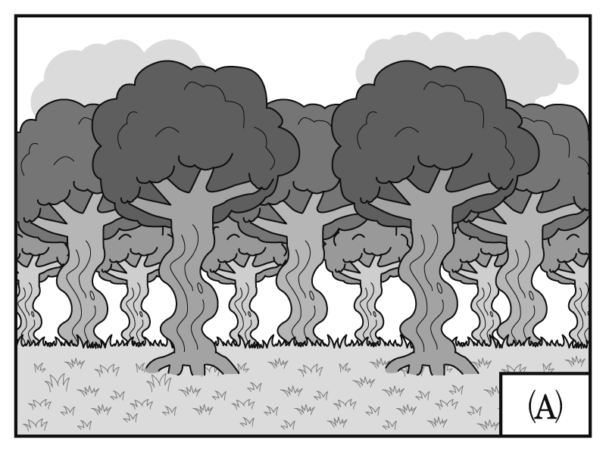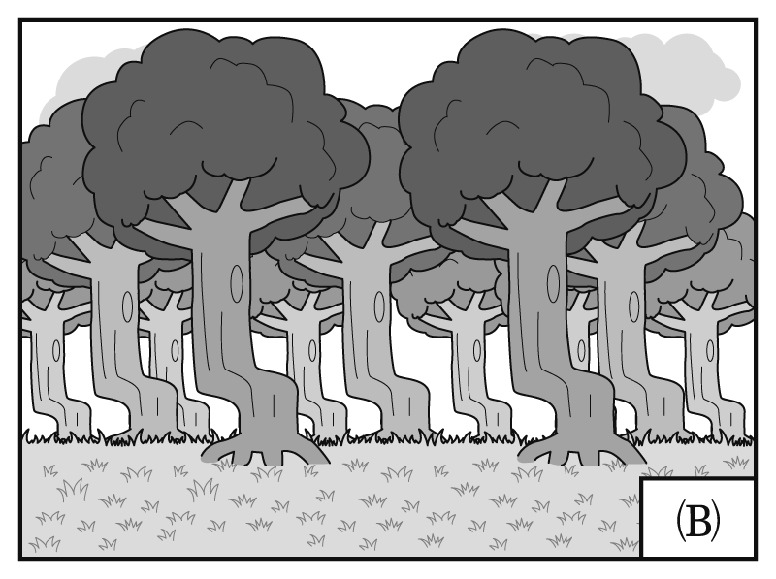
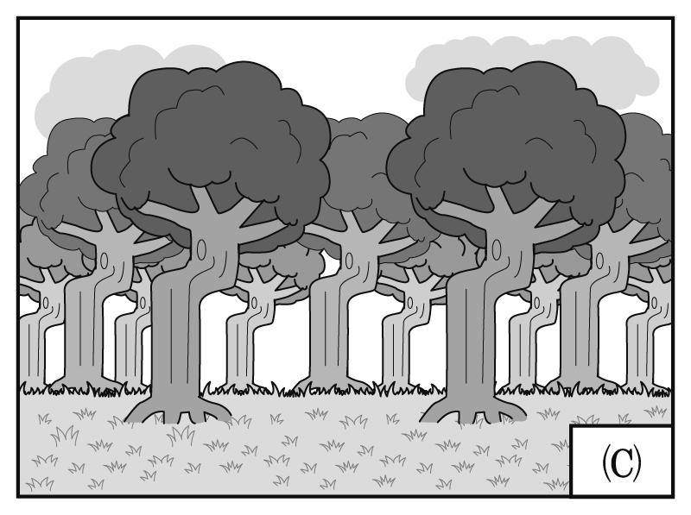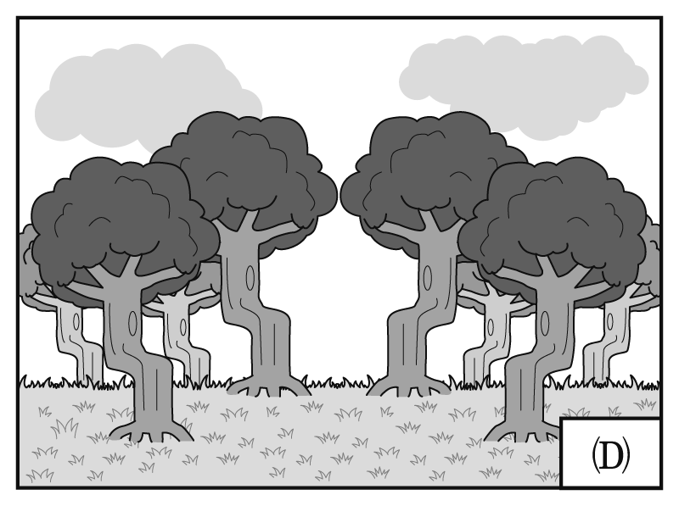
What does the author think is most likely to be responsible for the crooked forest?
Gravity. Wars. Humans. Heavy snow.
According to the passage, which of the following is true?
The wildlife in Krzywy Las attracts numbers of tourists every year.
The naturally grown trees in Krzywy Las were perfect for building ships.
Soldiers were ordered to destroy all the woodlands in Fryfino except for Krzywy Las.
There is no solid scientific evidence to prove how the crooked forest was formed.
答案： ； ； ；
解析：
在波蘭西部的小鎮 Gryfino 附近，有一座怪異的森林，這座森林叫做 Krzywy Las 或被稱之為彎曲森林。它是一塊有四百棵樹的林地，和其他森林不同的地方是這些樹的樹幹在底部彎曲了九十度，接著轉而筆直向上，形成「J」字樣。這些彎曲的樹全都很古怪地指向北方，許多觀光客到此夢境般的林地一訪，就是為了看這些奇形怪狀的樹。
彎曲森林異常如畫般的美景背後，其怪異樹木造型一直有一抹神祕感。人們相信這些樹是約在 1930 年代種植的，並且遭受某種力量的襲擊或損害而導致樹幹彎曲。其解釋有幾個版本，有一個說法是地心引力改變了，因此有某一股力量拉著樹幹。然而，這個說法很快就被摒棄了，因為重力是將物品往下拉，而不是往旁邊。另一個理論是說大雪可能將小樹覆蓋了一陣子，這個說法聽起來比較可信，但仍舊是不可能的，因為這些彎曲的樹是被正常筆直的樹所圍繞。一場大風雪竟然只影響某一塊林地，卻未碰觸其他鄰近地區，這是很難解釋的。

有些人相信彎曲森林的成因是人為的，而不是自然力量。有一個普及的理論是說在 1930 年代的農民為了造船刻意將樹幹折彎，一件有關造船的文件支持這個假設—「……自然彎曲的木材最適合從內部強化結構。」因此，這些刻意安排呈彎曲、指向同一方向的樹可能是要用來造船的，因著第二次世界大戰而中斷，這些樹被遺留在那邊，而成為我們今日看到不可思議的森林景色。然而，這些解釋沒有一個有科學證實過，但是對那些走入這謎樣森林並沉浸在其中的人，這一點都不令人困擾。
本文的主旨為何？
造船的理論。
Krzywy Las 森林的貢獻。
彎曲森林的價值。
一座特殊林地的起源。
下列哪一張圖片最能說明彎曲森林？
文中提及所有樹木在底部皆彎曲，然後接著筆直往上長，且其彎曲的方向都相同，故選 。
作者認為什麼最可能是彎曲森林的成因？
重力。
戰爭。
人類。
大雪。
根據本文，下列何者正確？
Krzywy Las 森林的野生動物每年吸引許多觀光客。
Krzywy Las 森林自然生長的樹最適合造船。
有人下令士兵摧毀在 Fryfino 除了 Krzywy Las 以外的所有林地。
沒有具體科學證據可以證明彎曲森林是如何形成的。
重要字、詞與片語
bizarre adj. 古怪的 crooked adj. 彎曲的 patch n. 小塊 picturesque adj. 美麗如畫的
queer adj. 異常的 curvature n. 彎曲 gravitational adj. 重力的 plausible adj. 可行的
prevailing adj. 盛行的 deliberately adv. 刻意地 hypothesis n. 假設 timber n. 木材
interruption n. 中斷 enchanting adj. 迷人的 immerse v. 沉浸

In Twende, Tanzania, a group of young builders are discussing how they can fix a problem while making their own products. It’s a school as well as a workshop. These young people believe they have the ability to create something.
Twende was founded and is now directed by Bernard Kiwia, who is hailed as “the father of rural invention in Tanzania.” Innovation has been in Bernard’s DNA since his parents, a mechanic and a tailor, had been building and making new things out of old and unwanted stuff in his childhood.
He became a bicycle repairman and electrician when he grew up. He was known for inventing a bicycle-powered phone charger. Then one trip to the U.S. for an innovation conference motivated him to start an innovation center in Tanzania.

Bernard and his team in the school believe Tanzanians, if given opportunities, can be bright
and daring and become innovators. They don’t have any restrictions for people to join the school. They welcome innovators of all ages and genders as long as they are open-minded and passionate.
A lot of successful innovations have been devised. Most of them made use of old parts from daily commodities. One is the Fert-Cart, which is a wheelbarrow that helps reduce the time farmers spend in spreading fertilizers and animal waste by hand. The inventor can rent the Fert-Cart to other farmers and make money from it. The avocado oil press is another example of invention. Some farmers cannot get a nice price for avocados at the market and just let them rot after they fall from trees.
The oil press can help the farmers process avocados and extract oil for sale.
The Twende school changes Tanzanians’ life. Quirky and simple as they seem, inventions like the Fert-Cart and the avocado oil press not only fix inventors’ problems but also bring them profits so that they can pay children’s tuition fees. The Twende school has been striving to offer resources to innovators and will continue to do so in the future.
Which of the following titles best describes the main idea of this passage?
Africans Rising Above Poverty
Africa’s School for Inventors
Best Inventions in Africa Throughout History
Life-changing Experiences in Tanzania
What is the basic requirement for people who go to the Twende school?
They must be young and bright.
They must come from an agricultural background.
They must be enthusiastic about creating things.
They must have an experience of inventing something from bicycle parts.
Which of the following is NOT one of the advantages of attending the Twende school?
Helping rescue unwanted fruits.
Making farmers work more efficiently.
Making more money to support the family.
Helping farmers selling produce at a higher price.
Which of the following can be inferred from the passage?
The Twende school is a success with positive impacts.
Most Tanzanians cannot accept the strange-looking inventions.
All Twende members used to be bicycle repairmen or electricians.
Bernard Kiwia has won an award in the U.S. with his bicycle-powered phone charger.
答案： ； ； ；
解析：
在坦尚尼亞的 Twende 學校，一群年輕的工人正在一邊製作他們的產品，一邊討論他們如何解決一個問題。這是一所學校，也是一個工作坊。這些年輕人相信他們有能力可以創造東西。
Twende 是由 Bernard Kiwia 所創立並主持的，他在坦尚尼亞被譽為「鄉村發明之父」。Bernard 的血液裡流著發明的基因，因為他的父母親分別是技術士以及裁縫師，他們在他兒童時期一直將舊的、不要的東西改造並製作新的物品。他長大之後變成腳踏車修理工以及電器工。他發明了由腳踏車供電的手機充電器，並因而成名。然後他去了一趟美國參加發明研討會，這趟旅程激勵他在坦尚尼亞建立一個發明中心。
Bernard 和他在學校裡的團隊相信如果給坦尚尼亞人機會的話，他們可以是聰穎又有膽量的，並且能夠成為發明者。他們對於參加這所學校的人並無限制，歡迎各個年齡層、性別的發明者，只要能放開心胸並且有熱誠。許多成功的發明被設計出來，大部分都是利用日常生活用品的老舊零件所製造的。其中一個是肥料推車，那是一個可以幫助農夫節省用手施肥時間的手推車，發明者可以將手推車租給其他農民，並且從中獲利。酪梨油壓器是另一個發明的例子，有些農民的酪梨無法在市場賣到好價錢，而讓酪梨從掉下來後，就在農田裡腐爛。這個油壓器可以幫助這些農民處理酪梨，並且從中萃取油來販賣。
Twende 學校改變了坦尚尼亞人的生活，雖然這些發明似乎是奇怪又太簡單，但像肥料手推車以及酪梨油壓器等這樣的發明不但解決了發明者的問題，也為他們帶來利潤，他們因此可以負擔孩子的學費。Twende 學校一直努力提供發明者資源，並會持續到未來。
下列何標題最能描述本文的主旨？
脫離貧窮的非洲人
非洲發明家的學校
歷史上非洲最佳發明
發生在坦尚尼亞改變生命的經驗
參加 Twende 學校的學員基本要求是什麼？
他們必須年輕又聰明。
他們必須有農業背景。
他們必須對創造東西很有熱誠。
他們必須有從腳踏車零件發明東西的經驗。
下列何者不是參加 Twende 學校的優點之一？
幫助拯救沒人要的水果。
讓農夫更有效率的工作。
賺更多錢來養家。
幫助農民以更高價錢賣出農產品。
根據本文可推斷出什麼？
Twende 學校是一大成功，有著正面的影響。
大部分的坦尚尼亞人無法接受長相怪異的發明。
所有的 Twende 學校學員都曾經是腳踏車修理工或電器工。
Bernard Kiwia 以其腳踏車供電手機充電器贏得了美國的發明獎。
重要字、詞與片語
be hailed as ... v. 被譽為 tailor n. 裁縫師 innovation n. 發明 conference n. 研討會 motivate v. 激勵
opportunity n. 機會 bright adj. 聰穎的 daring adj. 大膽的 restriction n. 限制 gender n. 性別
devise v. 設計發明 commodity n. 商品；貨物 wheelbarrow n. 手推車 fertilizer n. 肥料
avocado n. 酪梨 extract v. 萃取 quirky adj. 古怪的 tuition fee n. 學費

During the late 1930s and early 1940s, a fashion trend in the United States caused such controversy that it led to violence and rioting. The zoot suit, an oversized and colorful suit
initially worn by young African-Americans, was subsequently adopted by second-generation Mexican-Americans known as “pachucos.” The pachucos wore the zoot suit out of a desire to distance themselves from mainstream America, which they felt had rejected them. Instead of trying
to fit in as their parents had, the pachucos sought to stand out, both in their choice of clothing and the way they behaved. As the pachucos’ opposition to authority sometimes crossed the line into minor crimes and drug use, the zoot suit began to be associated with criminal behavior.
During World War II, the US experienced a fabric shortage. The government thus introduced tailoring restrictions, which outlawed the manufacture of zoot suits. Demand remained strong, however, and underground tailors continued production. In the eyes of the public, zoot suit wearers were deemed unpatriotic, as wearing them represented a dismissive attitude toward the warfare.
In 1943, tensions between uniformed military servicemen and gangs of zoot-suit-wearing pachucos exploded into violence in Los Angeles. During weeks of rioting, zoot suit wearers were routinely hunted down, attacked and stripped off their offending suits by servicemen. The pachucos, unsurprisingly, fought back. However, the press only emphasized the pachucos’ part of violence
and embellished the soldiers’ acts as “fair punishment.” Reporters also largely ignored the number
of women and white men among those wearing zoot suits, implying zoot suits wearers were either Mexican-American or African-American males trying to avoid military service.
Though little attempt was made to look into the circumstances behind the riots then, people nowadays can fully understand the social, economic, and racial factors contributing to the riots.
There is no denying that the zoot suit riots had strong influence on the entire generation of socially disadvantaged youths. The political awareness and discontent caused by the conflict helped make possible the activism of minorities in the civic rights movement of the 1960s, which eventually led to greater equality and opportunity for all.
What is the passage mainly about?
Zoot suit and its manufacturing purpose.
Zoot suit and the political instability it caused.
Zoot suit and its social and cultural significance.
Zoot suit and its historical relation with Mexican-Americans.
Why did the pachucos adopt the zoot suit?
It showed that they were unwilling to comply with conventional standards of American culture.
It proved that pachucos were able to create outstanding fashion trends within American society.
It allowed pachucos to declare independence from their parents and reject their original culture.
It helped the general public to accept pachucos despite their reputation for committing illegal acts.
What might “unpatriotic” people most likely do?
They would pursue their own benefits at the cost of other people’s welfare.
They might turn a blind eye toward their country’s domestic and international affairs.
They might be violent enough to cause riots and turbulences among their community.
They would deliberately violate laws that are supposed to help maintain social orders.
According to the passage, which one of the following statements is NOT true?
The zoot suit riots open up a gate for future equality movements in America.
When the riots exploded, the press sided with and spoke in favor of the military servicemen.
Zoot suits are a widely embraced fashion statement among different ethnic groups in America.
At times of riots, most people failed to link the riots to the minority youths’ unequaled social status.
答案： ； ； ；
解析：
在 1930 年代晚期以及 1940 年代初期，有一種時尚潮流在美國造成了極大的爭議，以至於最後引發了暴力事件及動亂。祖特裝（zoot suit）是一種寬鬆、色彩鮮豔，且起初由年輕非裔美籍人士們所穿著的服裝，後來一群被稱為「花衣墨西哥人」（pachucos，帶有貶抑、社會地位低下意味）的第二代的墨西哥裔美籍人士也開始穿起這種服裝。花衣墨西哥人穿著這種服飾的原因是出自於一種想要遠離美國主流文化的渴望，因為他們覺得自己被主流文化排拒在外。不像他們的父母那樣試著融入美國社會，花衣墨西哥人在服裝選擇以及行為舉止方面都尋求標新立異。由於花衣墨西哥人反抗權威的行為有時候會越界，而演變成輕微的罪刑或吸毒，祖特裝因此被和犯罪行為畫上了等號。
二戰期間，美國面臨布料短缺的景況。政府因此頒布裁縫禁令，將製作祖特裝列為違法。但是對祖特裝的需求仍然很高，而且有些裁縫師依舊持續私下製作。在大眾眼中，穿著祖特裝的人們被視為沒有愛國心，因為穿著祖特裝代表著對戰事一點都不在乎的態度。在 1943 年，軍警人員和穿著祖特裝的花衣墨西哥人之間的緊張對立終於在洛杉磯演變成了暴動事件。在為期數週的暴動期間，穿著祖特裝的人們常被追捕、攻擊，並且被軍警人員強制脫下他們身上具冒犯性的服飾。不意外地，花衣墨西哥人們也進行反擊。然而媒體報導卻只強調花衣墨西哥人們如何施暴，並且將士兵們的舉動美化為「合理的懲戒」。記者們也大大地忽略了穿著祖特裝的女性以及白人男性的數量，暗示著穿祖特裝的人只有墨西哥裔美籍人士或非裔美籍人士，而且他們都逃避服兵役。
雖然當時暴動背後的情況沒有被深入探究，但是人們現已能理解造成當時暴動時的社會、經濟以及種族因素。無可否認的是，祖特裝暴動事件對於社會上弱勢的年輕人們整個世代都有著強大的影響力。政治意識的覺醒以及對衝突所造成的不滿都有助於 1960 年代少數群體在爭取公民權的運動時更加積極，而這最終更為所有人帶來了更多的平等權以及機會。
這篇文章主要是關於什麼？
祖特裝以及其生產目的。
祖特裝以及其造成的政治不穩定性。
祖特裝以及其社會及文化的重要性。
祖特裝以及其與墨西哥美籍人士們的歷史淵源。
為什麼花衣墨西哥人們會開始穿著祖特裝？
祖特裝表現了他們不願意追隨傳統標準的美國文化。
祖特裝使花衣墨西哥人們能夠從父母身邊獨立並且拒絕他們原本的文化。
祖特裝證明了花衣墨西哥人們能夠在美國社會中創造出自己的時尚潮流。
祖特裝能幫助儘管因常犯罪而聲名狼藉的花衣墨西哥人們被大眾接納。
「沒有愛國心」的人們最可能做出怎樣的事情？
他們可能在追求自己利益的同時犧牲他人的福祉。
他們可能對自己國家內外的事物置若罔聞。
他們可能暴力到造成社區內產生暴動或動盪。
他們會故意違反本來應該用以協助維持社會秩序的法律。
根據本文內容，下列敘述何者錯誤？
祖特裝暴動事件為日後美國平權運動開啟了一扇大門。
當暴動爆發時，媒體偏袒軍警人員並且為他們美言。
祖特裝是一種在美國不同族群間被廣為接受的時尚潮流。
在暴動期間，大部分的人們都無法將暴動事件與少數青年群體不平等的社為地位連結。
重要字、詞與片語
controversy n. 爭議 initially adv. 起初地 subsequently adv. 接下來地
pachucos n. 花衣墨西哥人（具貶意） mainstream n. 主流 fabric n. 布料 tailor v. / n. 裁縫
dismissive adj. 不在意的 embellish v. 美化；潤飾 awareness n. 意識；知覺 minority n. 少數群體

第貳部分：非選擇題（占 28 分）
說明：本部分共有二題，請依各題指示作答，答案必須寫在「答案卷」上，並標明大題號（一、二）。作答務必使用筆尖較粗之黑色墨水的筆書寫，且不得使用鉛筆。
一、中譯英（占 8 分）
說明：請將以下中文句子譯成正確、通順、達意的英文，並將答案寫在「答案卷」上。
請依序作答，並標明子題號。每題 4 分，共 8 分。
智慧型手機已成為生活中不可或缺的一部分，協助我們解決問題並使生活更便利。
答案：Smartphones have now become / an indispensable part of our life (＝lives), / helping us solve problems (＝assisting us in solving problems) and / making our life (＝lives) more convenient.
現在我們能透過智慧型手機支付費用、管理個人財務，更可以和人工智慧互動。
答案： Now we can pay our expenses, / manage our personal finance(s) / through smartphones, and we can even / interact with AI (Artificial Intelligence).

二、英文作文（占 20 分）
說明：依提示在「答案卷」上寫一篇英文作文。
文長至少 120 個單詞（words）。
提示︰隨著網路的盛行與發達，有愈來愈多人在網路上發表個人意見、分享心得、針砭時事，因此逐漸開始出現所謂的「youtuber」或「網紅」（Internet Celebrity）現象。許多年輕人更利用這樣的網路平臺模式進行商業化的經營或與其他網友互動及交流。請以此種「網紅現象」為題，寫一篇英文作文。第一段，以個人經驗或報導所聞為例，試描述這種情形，並分析網紅之所以會盛行的原因。第二段，說明自己對此現象的心得、看法或感想。
答案：
With the advance of Internet and smartphones, more and more people are using social networking media and constantly checking their friends’ updates. Apart from that, there has been a trend of making film clips and posting them on Youtube or other media. There, youtubers or Internet celebrities share their life experiences, teach what they know, comment on politics or social phenomena or simply do something crazy. They become popular when the audience find them attractive, humorous or simply entertaining. In this fast-paced Internet world, youtubers or Internet celebrities can grab people’s attention and interact with them well within a minute. In this way, viewers will subscribe to their channels and continue to follow them.
As far as I’m concerned, the impact of youtubers and Internet celebrities is worrying. Some of the Internet celebrities do not have a sense of morality. They might do something obscene or against the law just to make their films sensational. Other youtubers may show no respect to people from other countries and deliberately discriminate them. What’s depressing is that such films should have been “shared” a million times. Take a recent youtube clip for example. In the film, the youtuber visited Hong Kong. After he arrived at the airport, he kept criticizing Chinese people, including their English language ability, and their behavior. He even stopped a passerby and asked where he could find a prostitute. When this youtuber was condemned in the TV media, not only did he feel no regret, but he also refused to take down the film. It seems that youtubers tend to feel conceited when they have too many followers. Therefore, there should be more regulations or restrictions to make sure youtubers and Internet celebrities behave properly.

