Unit 4 Everyone Is Practicing Hard
Pre-Listening Questions（以既有經驗，為學習對話做準備）

 | 參考問題 | 參考答案
1 | Look at the picture on page 46.What happened to John's knees?
2 | Look at the picture on page 47.What's wrong with Ethan?
3 | Look at the picture on page 47.What are Amy, John, and Patty doing?

課文解析
1 center (_______)
名詞，school ______ _______表「學校保健室」；相關常見詞有_______center（遊客中心）、_______ center（托兒所）。本字亦可表「中央」，例He stood _____________________（他站在圓圈的中央。）
ps. center 和middle, 哪一個範圍大?
2 What's the matter?
若要加對象，以介系詞with＋人表示。相似用法有What's wrong（____＋人）?、What happened（____＋人）?、What's going on（______＋人）?
3 careful
形容詞。相關字整理如下：
英文 | 詞性 | 字義 | 常見片語或例句
care | 名詞 | 照顧 | _____________________________________.（我的爸媽給妹妹和我很好的照顧。）
care | 動詞 | 關心；在意 | _____________________________________.（這個老師非常關心她的學生們。）
careful | 形容詞 | 小心的 | ______________________________________  (小心點! 你會跌倒。)
carefully |  |  | It is wet on the floor, ____________________.  （地上是濕的，所以請小心地走。）
careless | 形容詞 | 粗心的 | Next time, don't be so careless!  （下次別這樣不小心！）
carelessly |  |  | He always does the homework carelessly.  （他寫功課總是________。）

4 knee
名詞，常見片語有on one's knees（下跪）He got down on his knees and proposed to her. 故proposed to her: _____________
5 relay race
relay為可數名詞，常見片語____ / ____ relays 表「以輪班方式；輪流地」，例They _______________________________.（他們輪流玩電玩遊戲。）
6 slowly
英文 | 詞性 | 字義 | 常見片語或例句
slow | 形容詞 |  | ______________________________________
slow/slowly |  |  | ______________________________________.  (她跑得比她姊 / 妹慢。)
相反詞為______，例I walked _______, so I tripped and fell down.（我走得太快，所以我絆倒了。）
7 far
在此當形容詞，比較級______ / further、最高級_______ / furthest，亦可當副詞，本字常見用語整理如下：
常見用語 | 語義 | 例句
far away | 遠離 | Amelia __________________ her family because she's eighteen.（愛蜜莉雅搬離她家人因為她已經十八歲了。）
far beyond | 遠遠超過 | My grandfather's watch was _____________________.  （我祖父的手錶已遠超過它本身的價值。）
8 Good job, Ethan!
Good job表「做得好」，其他稱讚用語整理如下：
英文 | 中文 | 英文 | 中文
You're super! | 你很厲害！ | To the top! | 超越顛峰！
Bravo! | 好極了！ | You're brilliant! | 你真了不起！
9 already
_____，強調「已經做過…事」，例You already told me that.（你已經告訴我那件事了。）It’s already noon. （已經中午了。）We finished already. （我們已經完成了。）
10 cheer ... up
cheer動詞，表「歡呼、喝采」，例Max ___________________ when they got to __________.（當馬克斯的學生們到了終點線，他為他的學生歡呼。）

After Listening Questions（檢視理解程度，練習表達意見與想法）
 | 參考問題 | 參考答案
1 | Who took John's place?
2 | Why did John's class lose the race?
3 | Did Ethan do his best to run the race?

p.52
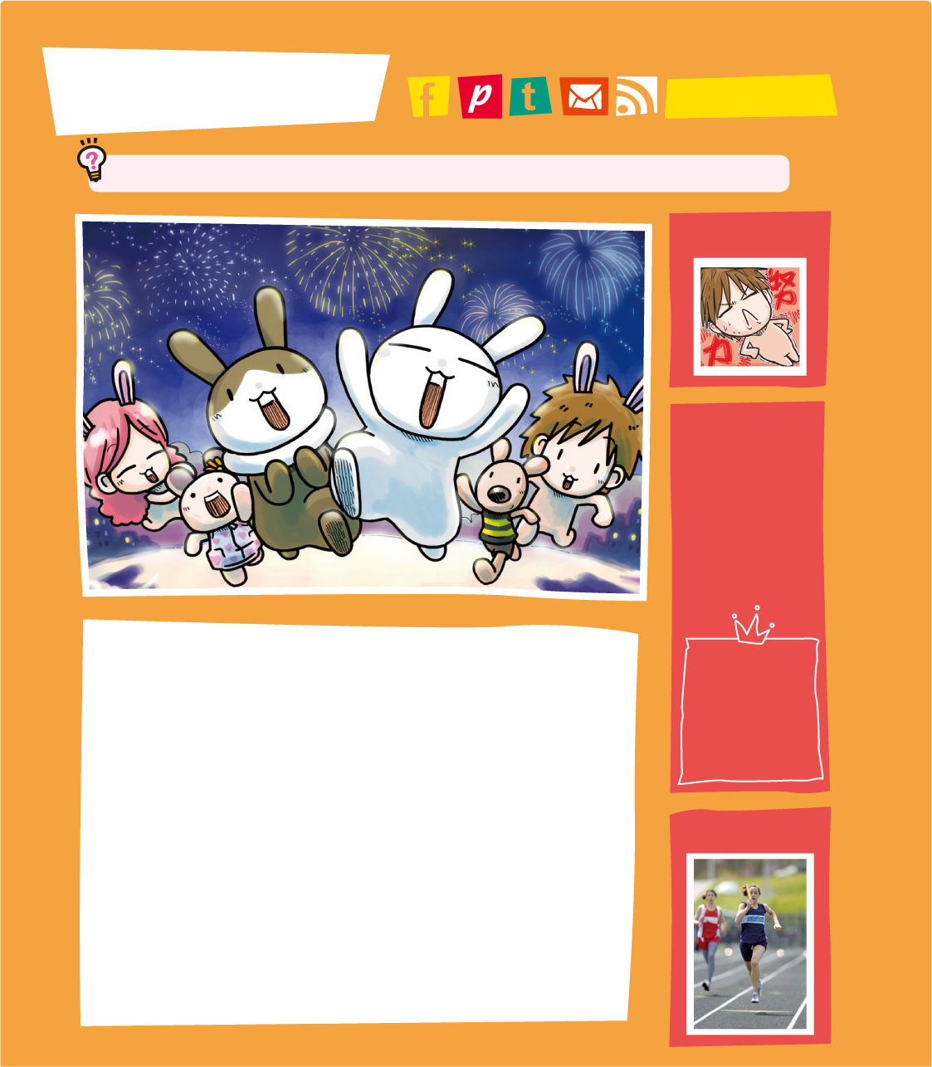

Reading 2-10-11
Do you like to run relay races? Why or why not? Talk about it.
WINNING IS NOT EVERYTHING
Today was sports day. We were all excited about it because we really wanted to win the relay race. I didn't run in the race because I hurt my knee. Ethan took my place. He and all the other runners ran very fast. "Go! Go! Go!" we cheered and shouted loudly.

一字多義
About 802
Our Photos
Ms. Chen
This Month’s
Birthday Boys
& Girls
Jessica Lin
Meg Chou
Ethan Liang
John's Home
2015 Sports Day
約翰的家

關於802班
我們的相簿
陳老師

本月壽星

林潔西卡

邱梅格

梁伊森

2015運動會
search
Vocabulary 2-12
loudly大聲地 | sports day運動會 | cheer歡呼
原文中譯：
勝利不代表一切
今天是運動會。我們都感到很興奮，因為我們很期待贏得接力賽。我因為傷了膝蓋，所以沒有參加比賽。伊森必須代替我比賽。他和其他所有跑者都跑得很快。「加油！加油！加油！」我們歡呼並且大聲地叫喊。！
重點提示
1. 先詢問學生「當比賽輸了時，有什麼想法」，讓其分享。
2. 瞭解運動家「勝不驕、敗不餒」的精神，並利用學過的單字，對個人生活經驗提出反思。
文章大意
John and his class were excited about sports day because they wanted to win the relay. However, they lost and some classmates cried. Their teacher thought they were already number one.
搭配電子書
有關「 Reading 」之課文動畫、單字例句、學習共同體、閱讀策略、閱讀網絡圖、閱讀停看聽及智慧克漏字，請參閱電子書 U4 pp. 52–53。
本篇章可搭配習作聽力p. 55

參考資料
閱讀前參考問題與解答（以既有先備知識，為閱讀新文章做準備）
 | 參考問題 | 參考答案（學生可自行回答）
1 | Do you like sports day? | Yes, I do. / No, I don't.
2 | Do you feel sad when you lose the game? | Yes, I do. / No, I don't.
3 | What can you do to win a game? | We can practice hard.
本文組織架構分析（視覺組織圖graphic organizer ）

課文解析
1 excited
本字的其他詞性法如下：
字形 | 詞性 | 字義 | 例句
excite | 動詞 | 使興奮；激起 | The main goal of this meeting is to excite people.（這場會議的主要目的就是要激勵人們。）
excited | 形容詞 | 感到興奮的 | (1) She was so excited about meeting her new teacher.  （她對於見她的新老師感到很興奮。）  (2) The dog is excited to see her owner.  （那隻狗看見她的主人很興奮。）
exciting | 形容詞 | 刺激的；令人興奮的 | Going to the beach with my friends was an exciting trip.  （和我朋友去海邊是一場令人興奮的旅行。）
2 win
本字的其他詞性法如下：
字形 | 詞性 | 字義 | 相反詞 | 例句
win | 動詞三態為  win-won-won | 贏 | lose（[luz]）  三態為  lose-lost-lost | Did they win the game last night?（他們昨晚贏得比賽了嗎？）
winning | 不可數名詞；動名詞 | 勝利 | losing | I always dream of winning.  （我總是夢想著勝利。）
winner | 可數名詞 | 贏家 | loser（[5luzL]） | Jay was the winner of the speech contest.（傑是這場演講比賽的優勝者。）
3 runner
可數名詞，由動詞run重複字尾再加-er形成。動詞為「子音＋短母音＋子音」時，若表該行為者的名詞時，其變化須重複字尾，再行變化，例winner、shopper（購物者）、beginner（初學者）。
4 loudly
(1) 副詞，比較級與最高級為more loudly-most loudly。其形容詞為loud，例The speaker has a loud and clear voice.（那位演講者有著大又清楚的聲音。）
(2) loud亦可作副詞，較為口語，例Speak louder, please. I can't hear you.（請講大聲一點。我聽不到。）
5 however
副詞，語意上表語氣的轉折，代表與前文相反或不相稱，語氣較弱於but。可放在句首、句中及句末，常與逗號並用，如However, he changed his mind later. = Later, however, he changed his mind. = Later, he changed his mind, however.（可是他後來改變了主意。）
6 guys
複數，指一群人，不分男女，如Are you guys coming to lunch?（你們要一起吃午餐嗎？）；單數指男人或男孩，如He's a nice guy.（他是個好傢伙。）
7 team
名詞，常與球類名稱連用，例basketball team（籃球隊）、soccer team（足球隊）。學校中的校隊則為school team。
8 I couldn't agree with her more!
慣用語，相似用法You can say that again.（我同意你的看法。）

一字多義
take 相關用法整理如下：
出處 | 英文 | 字義 | 課本例句
iEnglish 2 Unit 7 | take a bath | 洗澡 | How often do you take a bath?（你多久洗一次澡？）
iEnglish 3 Unit 4 | take it easy | 放輕鬆；  別擔心 | Honey, take it easy.  （親愛的，別擔心。）
iEnglish 3 Unit 4 | take off | 取下；脫下 | Did you take off the ring and put it somewhere?（妳會不會脫下了戒指並把它在某個地方呢？）
iEnglish 3 Unit 6 | take the medicine | 吃藥 | Ken, did you take the medicine?  （凱文，你吃藥了嗎？）
iEnglish 3 Unit 7 | take a photo/picture | 拍照 | I'm going to take photos of the pretty birds in the mountains.（我要替山裡美麗的鳥兒拍照。）
iEnglish 3 Unit 8 | take＋交通工具 | 搭乘 | We're going to take the Bong Bong Train.（我們要搭蹦蹦車。）
iEnglish 3 Unit 9 | take | 花費  （時間） | How long will it take to get to the night market?（到夜市要多久呢？）
本課 | take one's place | 代替… | Ethan took my place.  （伊森代替我比賽。）

閱讀後參考問題與解答（以既有先備知識，為閱讀新文章做準備）
 | 參考問題 | 參考答案
1 | How did John feel about the sports day? | He felt excited.
2 | Did John run in the race? hWhy or Why not?y or Why not? | He didn't run in the race because he hurt his knee.
3 | Did their class win? | No, their class didn't win.

p.53
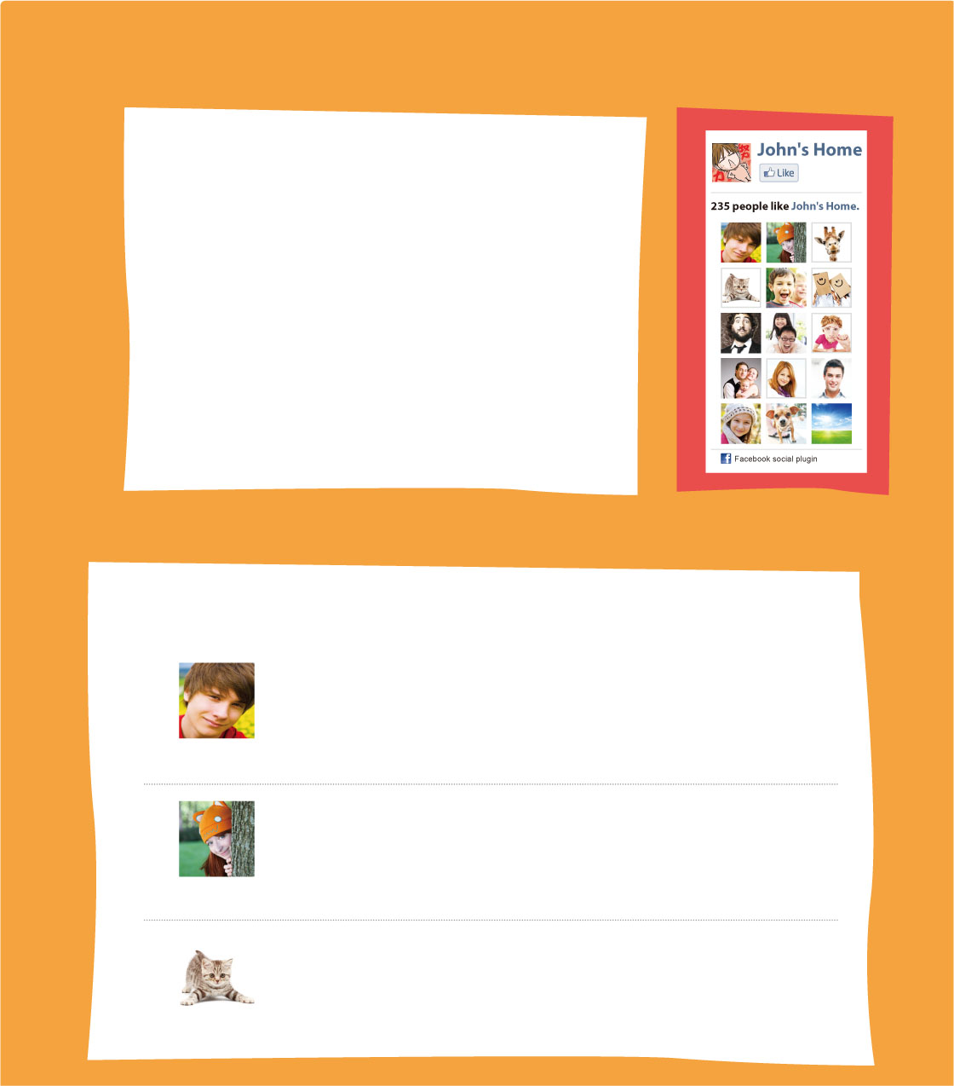
In the end, however, our class lost. Some classmates cried. Ms. Chen said, "Winning is not everything. You guys tried your best. You're already the number one team to me!" I couldn't agree with her more!

#1
#2
#3
Ethan
Amy
Emilia
Ms. Chen is so right. We didn't he race, but we tried our best!
4/2 09:31
How's your now? Does it still hurt? Take care!
4/2 10:12
Hey, John. You guys shouted really .
Everyone was looking at you!
4/2 10:46
原文中譯
然而最後，我們班輸了比賽。有些同學哭了。陳老師說：「勝利並不代表一切。你們大家都盡力而為了。你們已經是我心目中的第一名！」我非常同意陳老師的看法！
Vocabulary 2-12
in the end最後 | however然而 | guy人；傢伙
couldn't agree with... more非常同意…
解答
#1 win
#2 knee
#3 loudly
p.54
Exercise Writing
Look and answer.根據下列圖示作答。
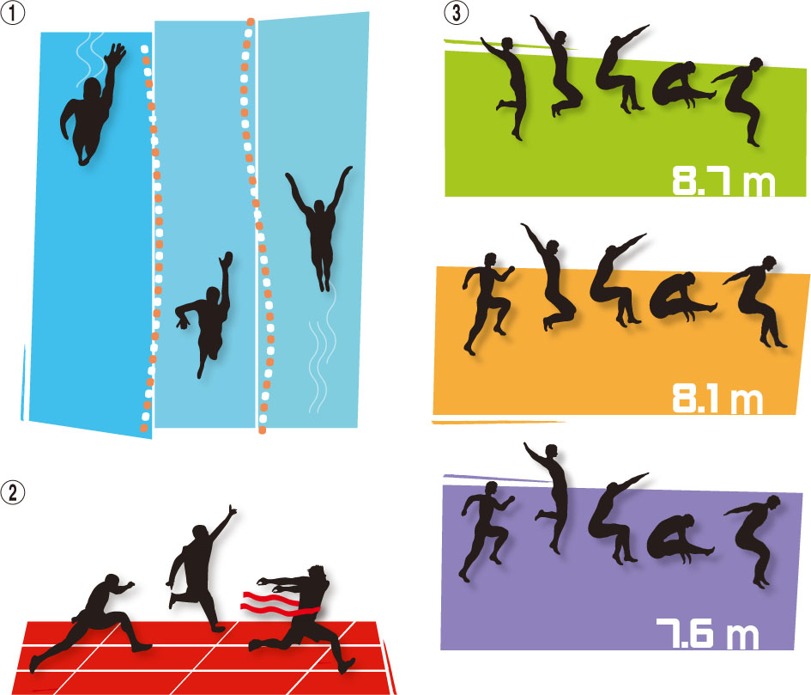
Clint
Mike
Jeff
Clint
Mike
Jeff
Jeff
Clint
Mike
Jeff swam than Mike, but more than Clint.
Did Clint get to the finish line the most quickly?

Who jumped the farthest, Jeff, Clint, or Mike?

解答:
faster slowly
Yes, he got to the finish line the most quickly.
Mike jumped the farthest.

p.55
Exercise Listening
A. Listen and choose. 根據聽到的對話和問題，選出正確的答案。2-13
（ ） (A) The red one. (B) The yellow one. (C) The blue one.
（ ） (A) Jack. (B) Victor. (C) Max.
B. Listen and check.根據聽到的對話，將相符的圖片打勾。2-14
 | □ |  | □ | 
 | □ | 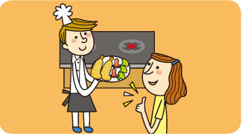 | □ | 
 | □ |  | □ | 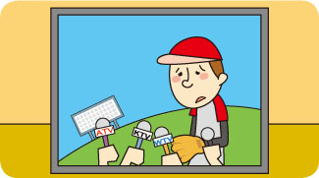
 | □ | 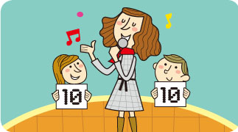 | □ | 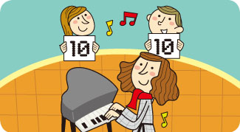
解答
A. Listen and choose.
（A） （B）
B. Listen and check.
 | □P |  |  | □P
 | □P |  |  | □P

A.
1. B: Look! The red helicopter is flying the highest!
G: Nope. The yellow one and the blue one are flying higher than the red one.
B: You're right.
Q: Which helicopter is flying the lowest?
2. M1: Did Jack come in the latest for the soccer practice this morning?
W: No! Max was the latest one.
M2: I don't think so! Victor came in at 8:45, five minutes later than Max.
Q: Who came in the latest this morning?
B.
1. M: Why do you look so tired? W: I studied late last night.
2. M: Oliver is good at cooking. W: Yes. He cooks very well.
3. M: The player is talking sadly on TV. W: Yeah. His team lost the game today.
4. M: Miranda plays the piano terribly. W: But she sings beautifully.
搭配電子書
有關U4之聽力測驗等，請參閱電子書U4 p. 55。
本篇章可搭配習作聽力p. 55
p.56

Challenge
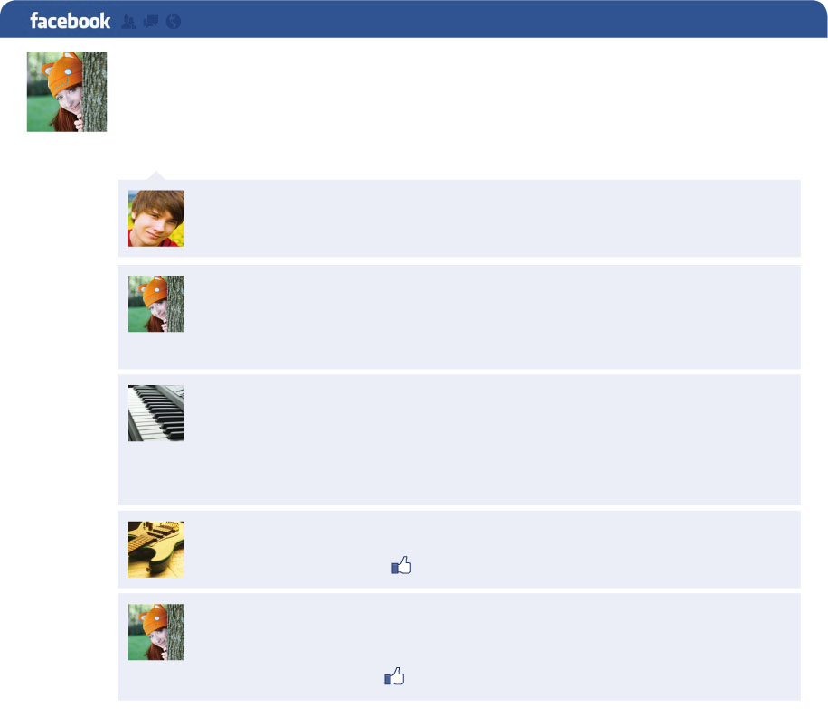
Amy Brown
Oh, no! I can't go camping this weekend! Why does the test have to
be next Monday?
an hour ago. Like. Comment
Ethan Hong What test?
an hour ago. Like
Amy Brown It's my piano test. I have to practice for it this
weekend. :(
fifty minutes ago. Like
Patty Lin Don't be sad, Amy. How about coming to my place
this Saturday? We can practice together, and I can make you
some cookies!
thirty minutes ago. Like
Kevin Hu Patty is so sweet! :)
five minutes ago. Like. 5 people
Amy Brown Thanks, Patty! You play the piano beautifully.
I really want to practice with you! =)
one minute ago. Like. 2 people

comment [`kBmZnt] 評論
Choose. 選出正確的答案。
（ ）What does Amy have to do this weekend?
(A) Go camping. (B) Make cookies.
(C) Practice the piano. (D) Study for a school test.
（ ）Which is NOT true?
(A) Patty is good at playing the piano.
(B) Five people like Kevin's comment.
(C) Amy and Patty will spend their Saturday together.
(D) Ethan will make Amy some cookies this Saturday.
解析
（D）→Patty will make Amy some cookies this Saturday.
解答
（C） （D）
搭配電子書
有關「 Challenge 」之綜合演練單及益智王，請參閱電子書 U4 p. 56。
p.57
Fun with Sounds
A. Listen and say. 聽聽看，唸唸看。2-15
He likes to help people.  [`hZl `pip~] | We had a great trip.  [9gre `trIp]
Was it a hard day?  [9hBr `de] | Let's play with the girl.  [9wITE]
B. Read and draw. 讀讀看，將會連音的部分用"∪"連起來。
She's a big girl. We don't have enough food.
He needs some more coffee. They kept talking to me.
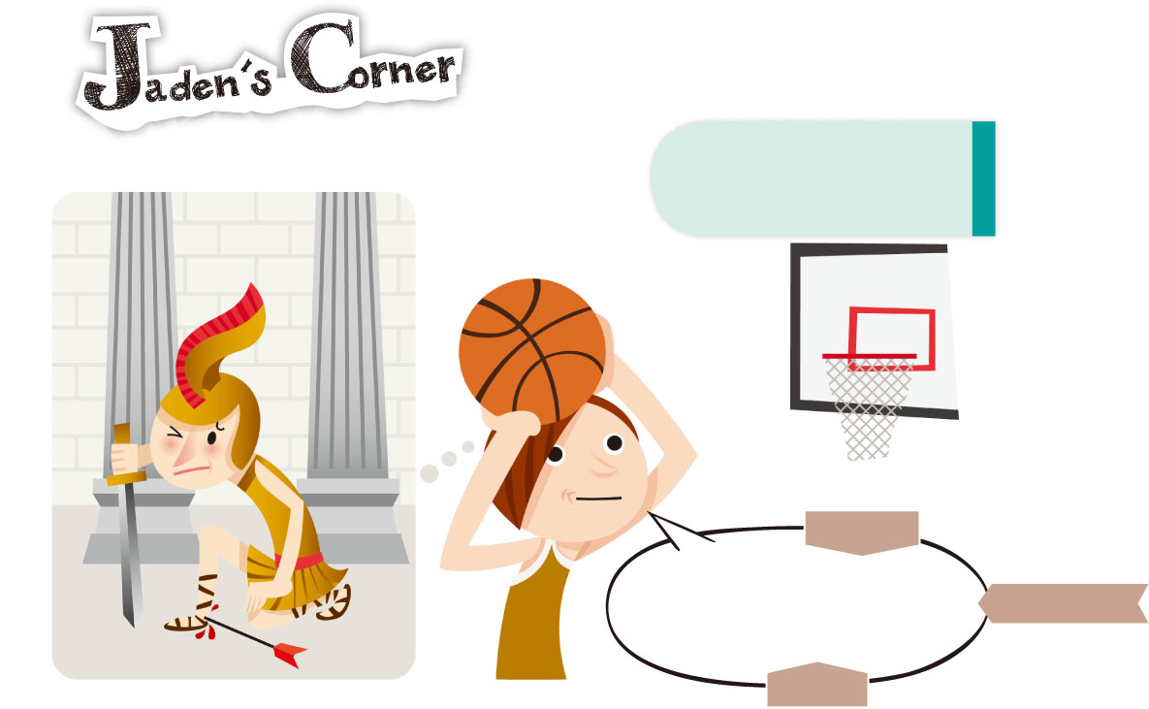
I'm strong on rebounds, but not on three-point shots. That's my Achilles' heel.
Achilles' heel
弱點；要害
[E5kIliz]
[Wri pCInt 5FBt]
[rI5baUnd]
解答
B. Read and draw.
1. She's a big girl. 2. We don't have enough food.
3. He needs some more coffee. 4. They kept talking to me.
重點提示
英文母語人士說英語時，句中常將相臨兩字的前字的「尾音」和後字的「起音」連起來唸成一個音，構成「連音」。前字結尾的音跟後字開頭的音相同時，只唸一個音，例bus stop。
教學步驟
1. 老師可先分享一件自己很在行的事，例I am good at cooking / swimming.，再問全班What about you?，讓學生發表自己的想法。
2. 再分享自己不在行的事，例I am not good at singing / dancing. 並表演出來，將全班分組，令各組討論自己不在行的事。
3. 抽點各組的 1 至 2 個學生，讓其說出自己不在行的事，再引導全班對其說 Playing baseball is your Achilles' heel.
4. 打開課本帶唸本片語數次。
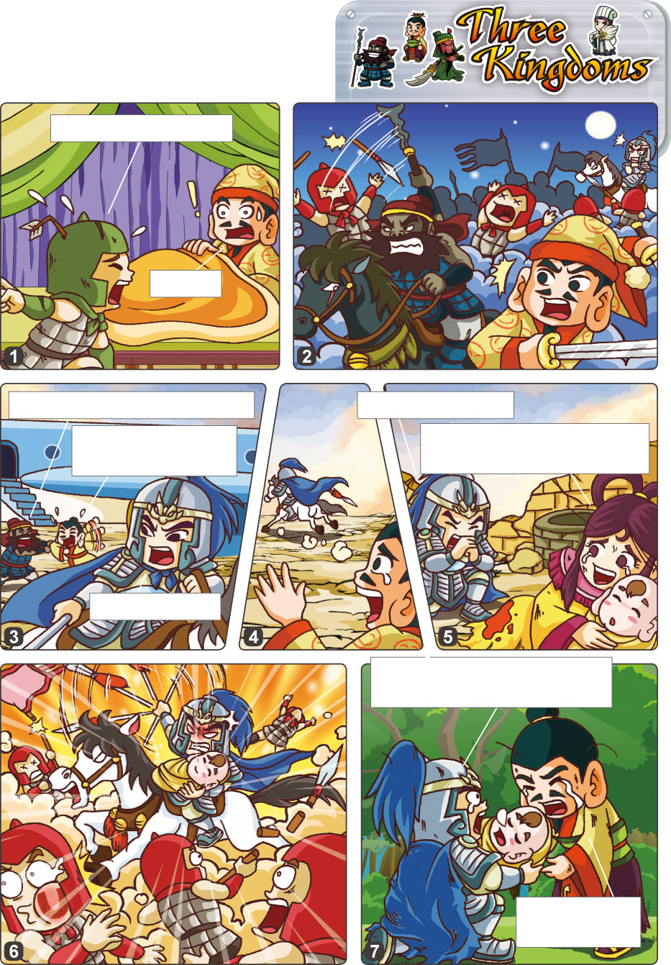
本篇章可搭配習作聽力p. 54
Cao's army is here!
What?
You really have to go now.

Let's go, ma'am.

p.58

Comics
※本篇可彈性使用

What about my
wife and my son?

My legs hurt badly. Just
take the baby and go!

I'll find them.

Sir, I have your son.
Look! He's sleeping well.

Thanks a lot,
Zhao Yun.

army [`BrmI] 軍隊 Zhao Yun趙雲
課文解析
1 What about＋名詞∕動名詞? 表「那…呢？」，相似用法How about ＋名詞∕動名詞?，例How about taking a walk in the park?（去公園散步如何呢？）
2 have在此表「趙雲手中抱著劉備的兒子」，亦可說hold或carry。
（資料來源：http://www.ldoceonline.com/dictionary/have_2）
資源指示器
關於「趙雲」的人物簡介，請參閱本單元備課用書 p. 50 右方插頁。
搭配電子書
有關「Comics」之動畫，請參閱電子書U4 p. 58。

