第一部分、聽力測驗
- 根據聽到的內容，選出相對應的圖片 (每題2分)
- (A) (B) (C)
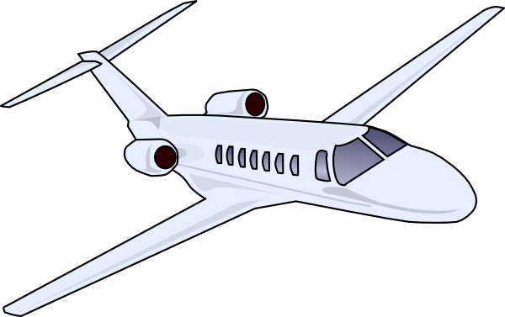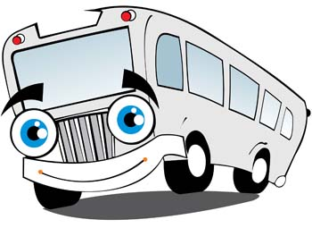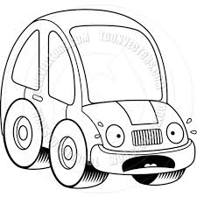
- (A) (B) (C)
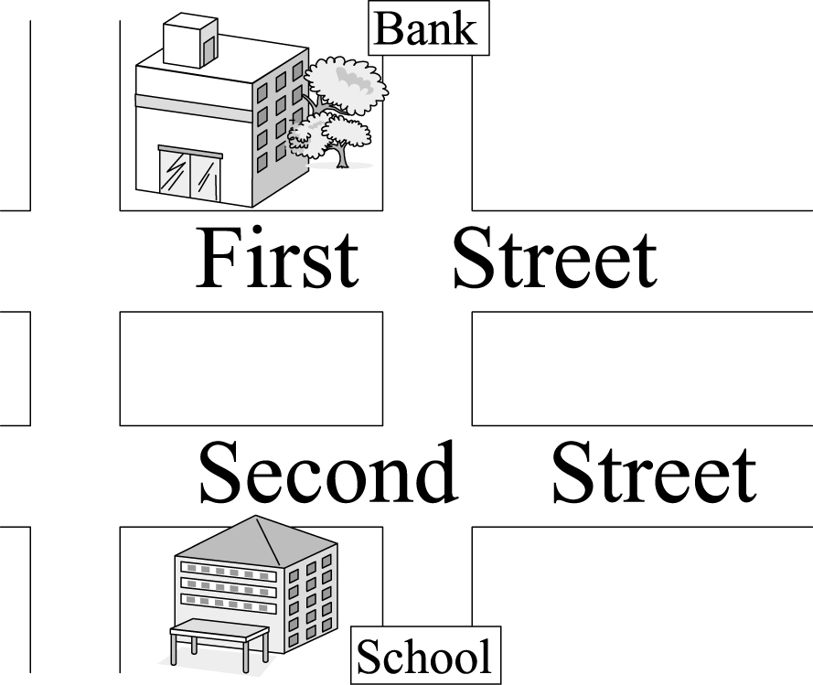 | 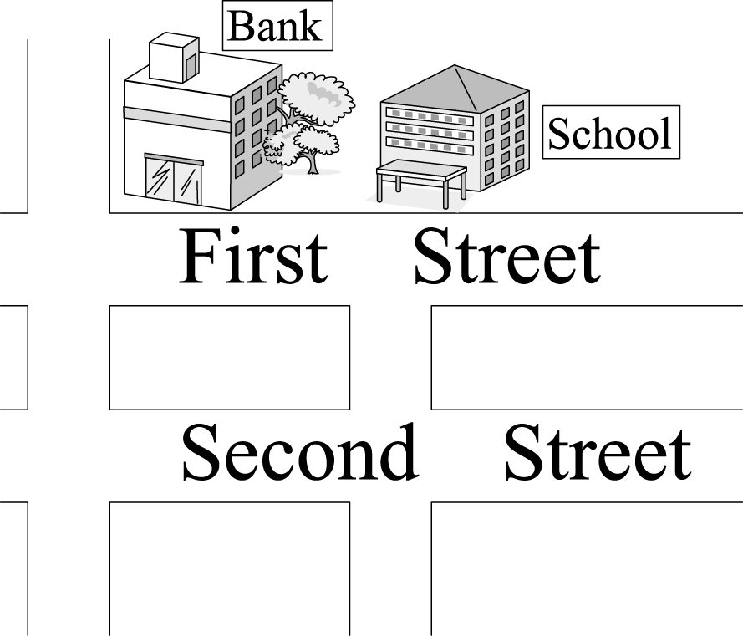 | 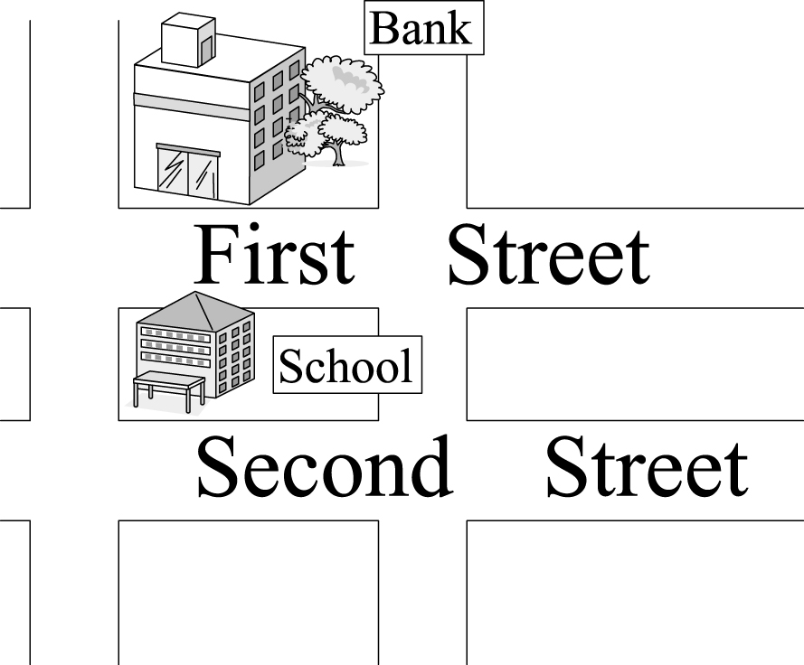

- 依據聽到的內容，選出正確的回應句
- (A) I’m going to buy some clothes with my mom.
(B) How exciting! I can’t wait.
(C) Yes, we had a good time, too.
4. (A) They will go there tomorrow night.
(B) They will drive there.
(C) Thet took a taxi there.
5. (A) Oh,no! You can’t stop here.
(B) Yes,go there by taking a bus.
(C) Yes, go down and turn right at the end.
- 依據聽到的對話及問題，選出正確的答案
- (A) One thousand (B) One (C) Two
- (A) Take the MRT (B) Ride a bike (C) Walk
- (A) At the post office (B) At the parking lot (C) At the department store
- (A) Twenty minutes (B) over forty minutes (C) One hour
- (A) His job is to paint (B) He enjoys his life on the farm
(C) He likes to ride a bike in his free time
四、綜合選擇題 (每題2分)
11. Diana is a pretty model.She can _____ different kinds of special and beautiful clothes when she’s at work.
(A) wear up (B) get on (C) dress (D) try on
12. _____ the country road are many tall trees and new modern buildings.
(A) In (B) Next (C) Along (D) Look at
13. The newly wedding couples are going to _____ their honeymoon in Hawaii.
(A) take (B) spend (C) pay (D) cost
14. Mr.Brown will _____ in the USA on time tonight.Don’t forget to pick him up at the airport.
(A) arrive (B) get (C) fly (D) take
15. My art teacher has a green thumb, so she grows lots of flowers and _____ in her garden.
(A) pants (B) planes (C) paints (D) plants
16. A:_______did you go to the breakfast shop? B:______________
(A) How; by a scooter (B) What; by my bicycle
(C) How; by foot (D) How; by bike
17. Studying in a foreign country _____ me a lot of money, that’s why
I had to sell my car.
(A) cost (B) took (C) lost (D) spent
18. Audery: Do you know the girl _____ a white dress in this photo?
Eric: I know her.She’s my new classmates.
(A) on (B) in (C) at (D) with
19. There _______ heavy rain in Taipei this Saturday night.Are you going to cancel your camping activity?
(A) is going to have (B) will going to have (C) is having (D) will be
20. I spent the whole week _____ for the trip _____ Tokoyo because we know knowing about Japan.
(A) prepre; for (B) preparing; to (C) prepared;for (D) on preparing; to
21. It usually _____ me more than one hour to get to the library. I never thought of that reading books could be such a hard job.
(A) spends (B) costs (C) pays (D) takes
22. How long will it _____ to go home by taxi?
(A) need (B) take (C) cost (D) spend
23. _____ right, and the police station is just _____ the corner.
(A) Turn; on (B) Turning; in (C) To turn; at (D) To turn; around
24. If you want to lose weight, you shouldn't eat _____ meals.
(A) beside (B) before (C) between (D) by
25. See! We get the answer from the map.The science museum is on the right of Museum Road.
(A) The science museum is on the right of the map.
(B) You’ll see the museum after you turn right on Museum Road.
(C) When you walk on Museum Road, you’ll see the science museum.
(D) You can find the map of Museum Road in the science museum.
26. 釋義go V-ing
五、題組 (每題2分)
(一)
The National Science and Technology Museum in Kaohsiung recently unveiled the tallest spiral slide in Asia. Imported from Germany, the slide stands 18 meters in height with a trip down to the base of the slide taking just 12 seconds. The museum hopes the slide will teach visitors about basic science concepts such as centrifugal force.

