Book Two L1 Class_________ Name___________________ No._____
2. fair (adj): +weather/ lady←→dark, unjust (N) 展覽、市集Students e______ teachers to be fair when their teachers grade their papers and their p_______ in school.
Holding the (book/world/agricultural) fair will attract a great n________ of t________(v______) and l_______ alike.
3. praise(V/N)=compliment←→blame Jane won (e_______)贏得 the praise of her teachers ______ helping the poor in the c__________. In the school assembly, the principal spoke in praise of表揚her good b_________.
4. numerous (adj) The times that naughty boy has gotten into trouble are too numerous to mention. 多到數不盡
some, somewhat, a few, a little, a bit, a couple （通常指約兩個，有時指數個。） | many, numerous, lots of, plenty of, a great (deal/ s____/ a__________) of,  a large n___________ of | infinite, countless, numberless, innumerable, a sea of, a mountain of
5. compare (v) comparison (n) In comparison with his earlier works, he does like to make a comparison between life and a stage play.
In Jane’s opinion, nobody’s singing can compare with hers.(match up to)
Its s______ doesn’t compare with _____ of fancy French restaurants.
6. speech(n) The scientist was asked to deliver (m______/ g______) a speech on the latest development of e__________ r_________.
8. concrete (adj)水泥的The city full of (f______ _____) ugly concrete buildings is often c_______ ____ Concrete jungles.
(N) Some scientists are trying to i________ new materials to replace concrete in order to build houses that are more e_________________-_________.
9.water-saving/ alarm警報裝置/ cutout安全開關/ makeshift權宜之計+device (n) The n________ uses v________ literary devices to create an a_________ of m_______ in her latest novel.
The s______ b______ _______the house to plant a監聽裝置covert listening device.
10. ocean (n) C______ _____ Ms. Chen’s donation, mine is a drop in the ocean滄海一粟
The three major oceans in the world are the Atlantic, Pacific, and Indian Oceans.
14. prisoner (s.b) prison(n) imprison(V)=sent to prison imprisonment (n)監禁；關押
He was currently in prison(=imprisoned/ sent to prison)（在監服刑）/ He went to prison坐牢for online fraud（詐欺）. Actually, he could face a ten-year prison (term/ sentence). 徒刑
Life imprisonment is a severe punishment for those who c______ serious c_______.
15. surrender (v)(N) The e_____ took the s______ prisoner俘虜after they surrendered.
The brave soldier f______ back a______ the enemy and showed no sign of surrender.
17. scoop (n)杓子,獨家新聞(v)
Cut the pumpkin in half and scoop out the seeds with a spoon.
P_______ of/ N________ reporters gathered at the police station hoping for a scoop.
18. cone (n)圓錐狀之物 traffic cone錐形交通路障
They are trying to design a building in the shape of a cone/cone-shaped building.
20. tickle (N)(V) His compliment tickled me pink令某人愉悅.
ticklish (adj) 怕癢的Are you ticklish?
21. tease (v) When Louis was imitating my way of speaking English, he was teasing me about (______ a j_______ _____/ ______ fun of) my accent. 嘲笑某人某事
(n) 逗弄人之事物Henry always says silly things! He’s just a tease. Ignore him.
Introduction:
Poets often use figures of speech to make their love poems more vivid and concrete.
What is a simile?
(definition and examples of similes)
What is a metaphor?
(definition and examples of metaphors)
The first poem:
My Love Is like an Ocean
The second poem:
If You Were a Shining Star

How do I love thee… Let me count the ways!
I love you more than a ________________________________. If I had ___________
dollars then I would buy you a _____________________________________. I wish I
could take you to __________________________________________ where we could
__________________________________. You are as sweet as ___________________. If I could bring you flowers I would bring you ________________________ because
they smell _______________________________________. Valentine’s Day is special because we get to say ____________________________________________________. My favorite part of the day is __________________________________________ and _______________________________________________. But most of all, it is special because I get to tell you __________________________________________________!

第一次段考預定的命題教材:
1.Live:2/1~~3/20 2. 教科書(龍騰版): B2 L1~4 (第4 課自修) 3.Grammar: CHPATER 2 4. Vocabulary 2000~4500: Unit 13~~ 20
102學年度第2學期高一英文小考預定進度表
週 | 日期 | Monday/ Tuesday | Wednesday | Friday
1 | 2/13-17 |  | Live:2/1~3 | Live:2/6~10
2 | 2/20-24 | 2/13-17 | Unit 13~~14 | Unit 15~~16
3 | 2/27-3/3 | Happy Holiday | 2/20-28 | Unit 17~~18
4 | 3/6-10 |  | Unit 19~~20 | 龍騰L1
5 | 3/13-17 | 3/1~10 | Grammar CHPATER 2 | 龍騰L2
6 | 3/20-24 | 3/13~20 | 龍騰L4 | 龍騰L3
7 | 3/27-31 | Review | 3/28 & 3/29 Midterm

Book Two L1

Class_____ Name___________ No.___
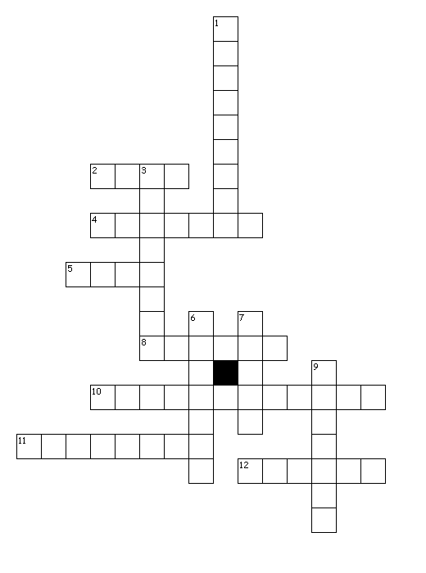
Across
2. His compliment tickled me p______.
4. Its service doesn’t c______ with that of fancy French restaurants.
5. Students expect teachers to be f_____ when grading their papers and their performance in school.
8. The scientist was asked to deliver a s_______ on the latest development of environmental protection.
10. Life i________ is a severe punishment for those who commit serious crimes.
11. The city full of ugly concrete buildings is like c______ jungles.
12. Jane earned the p_____ of her teachers for helping the poor in the community.
Down
1. The brave soldier fought back against the enemy and showed no sign of s________.
3. The times that naughty boy has gotten into trouble are too n______ to mention.
6. The novelist uses various literary _______ in her latest novel.
7. Plenty of reporters gathered at the police station hoping for a s______.
9. When Louis was imitating my way of speaking English, he was t______ me about my accent.

