Film Appreciation 50 First Dates (2004 Romantic Comedy)
Class___________ Name:___________________________________ No._____
1. In the film “50 First Dates”, which part is the most impressive plot? Please give a brief description and share your reasons.

2. How does Henry win Lucy’s heart? If you were Henry, how would you try to overcome your lover’s short-term memory loss?

3. If your beloved family or friends suffer from memory loss, what would you do?

4. If you break up with your lover, how will you make it up?

5. If your dream and relationship conflict, which one will you choose and how will you overcome the problem?

6. Which part of this film is less convincing or interesting, how would you improve it?

7. Which role of this film is played in the most convincing way? Tell us your reasons.

50 first dates
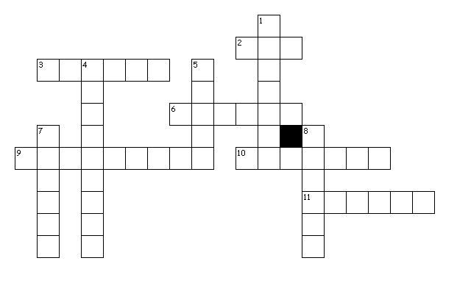
Across2. animal doctor
3. grid-patterned pancake-like food that's tasty with syrup
6. a large marine mammal, related to the seals, and having flippers, a pair of large tusks
9. a large fruit that grows on a tropical tree and that has thick skin and very sweet, juicy, yellow flesh
invalid 10. no longer be legal after a period of time
11. A state of the United States in extreme northwest North America
Down
1. a black-and-white bird that cannot fly, uses its wings for swimming, and lives in or near the Antarctica
4. adjective to describe someone who cannot remember things
5. car number
7. a small piece of official paper to give punishment like speeding
8. A state of the United States in the central Pacific Ocean comprising a group of over twenty islands

