7/9 Kansai Airport Exit-turn right & walk to the deadend to buy ferry tickets(＄1000*2) -- shuttle bus to the pier --附件1 High speed ferry(at 18:00 Bay Shuttle 30 minutes)--shuttle bus to Kobe Domestic Airline stop-- Portliner at 19:00 (enter Kobe Domestic Airport to Floor 2 for electronic train＄330*2) 附件2 The high-speed ferry Bay Shuttle is having a campaign until Dec. 31, 2016, offering visitors to Japan a one-way trip on the boat with 45% off upon presenting our passport. We did enjoy pleasurable atmosphere of a boat trip while appreciating the beauty of the sunset.
Kobe (Domestic) Airport (7/9): An airport connecting Kobe to other areas in Japan including Tokyo, Kyushu & Okinawa. If coming from Kansai International Airport, take the ferry for a more convenient route.
We took a comfortable portliner ride, watching clean high rises of Kobe. After Kobe earthquake in 1995, the locals rebuilt their city collaboratively, passionately, and ambitiously to recreate their amazing living environment. As we approached downtown with more and more local passengers getting on, the awe-inspiring view of Kobe Port was getting more and more remarkable.
After reaching Portliner sannomiya (Floor 2), we took the elevator downstairs to take a shuttle bus at 19:30 departing from bus stop No.8 at sannomiya Mint Kobe building (the green building just opposite Portliner Sannomiya station) to our Oriental Hotel (Orientaru Hoteru), which is built in the form of a big ship. After checking in, a helpful lady porter pushed our luggage and led us to our room. Also, it was kind of her to answer our question about transportation. Luckily, I prepared extra 2 eggs for I could imagine we would be too late, hungry and exhausted to search our dinner. The simple food did revive us to go on an adventure. Around our hotel are many tourist attractions including Meriken Pier, Harborland area, etc.

Kobe Meriken Park Oriental Hotel: We did spend a great amount of $ staying in one of the more iconic buildings in the Kobe waterfront area for 2 nights. There is an international passenger ship terminal on the 2nd floor so it’s a great opportunity to see incoming passenger ships like CONCERTO, LUMINOUS, etc.up close and really feel the port town atmosphere of Kobe. Additionally, this hotel offers a romantic wedding venues including fabulous a church, banquet restaurants, etc. We didn’t eat buffet breakfast here as we ate too expensive dinner here since JP’s top priority is to feast his stomach on Kobe beef. Ironically, the first night we enjoyed beef meal (限定的極牛舌大份量2180/676, raw beer 560/174, 牛たんｼﾁｺｰｾｰﾄ1200/372, tax315/98=4255 in仙台牛たん福助Fukusuke仙台牛たん福助 神戸ハーバーランドumie店. After the late dinner, we moved forward to the famous statue of American Rock & Roll Superstar ~~ Elvis Presley Statue: Originally, it was located in a shop “Love Me Tender,”(featuring Elvis’ goods 原宿竹下通in Tokyo). After the shop was closed, Elvis’s fans decided to relocate it in Kobe, the origin of Jazz in Japan. We did find it in front of Culmeni behind Mosaic.
Kobe Port Tower (7/9-7/11): A red & white tower at the waterfront of Harborland area is the landmark of Kobe built in 1963, with a unique shape & the first in the world made of pipes. Together with other architectural wonders nearby, it forms a picturesque view after the sunset. Some said it resembles beauty’s thin waist (108m). We didn’t look out over the entire city of Kobe from the observation deck. But we did take a great number of pictures of its surrounding’s day and night. Interestingly, we shot several photos of ourselves behind a cute cupboard cut-out next to Kobe Port Tower. To our delight, there are many banners revealing Kobe Port is commemorating the 150th Anniversary of its opening in 2017. The 2 –day trip in Kobe is really memorable and enjoyable.
Kobe Harborland and Umie Mosaic: Harborland is very delightful area with various facilities featuring shopping, gourmet, and restaurant. The two largest shopping complexes in the area are Mosaic and Canal Garden. Mosaic is a pleasant shopping complex along the waterfront with a variety of small fashion boutiques and a wide selection of restaurants, many of which overlook the harbor. We appreciate the amazing view for 2 days & nights. A shopping facility is located right along the sea with about 90 different shops and restaurants as well as an amusement park. Mosaic used to be the area of warehouses. Now it was transformed into a western-style paradise. Besides, 50-meter Wonder Ferris wheel, open in 1995, provides visitors with fantastic light show including a variety of lovely colors, romantic pictures, & surprising words. Lover’s Sanctuary Project Post is an interesting small mail box which was set up by a civil organization promoting true love and marriage to address the issues of low birth rate and remaining single. The travel guide indicates there is another one in Osaka (Umeda Sky Building空中庭園展望台), but I did not notice it there.

Sannomiya Station: As the main terminal for Kobe, Sannomiya is the biggest downtown area in the city of Kobe with major railway terminal (1F), department store, shopping street and restaurant around the station. Opposite it is the Sannomiya center street, a mega scale arcade which is packed by many people at all times. We strongly advise buying drug items here (OS drugｵｰｪｽ ﾄﾗｯｸ), which doesn’t offer free-duty service but its price is economical if you can’t buy more than 5000.) On July 10, we bought Vitamins B for Mom (ｱﾘﾅﾐﾝEXﾌﾟﾗｽ Large: 4550+ Small: 3885 +tax: 675=9111)
Meriken Pier/ Park & Naka Pier: Naka Pier Central Terminal is cruise & ship terminal, providing facilities for arrivals and departures of cruises around Kobe port and toward the Akashi Kaikyo Bridge. Except for the area for Karaoke & Kushikatsu (炸串deep-fried skewer g) in the evening, we certainly enjoyed feeling of the fresh sea breeze while walking here with many ships coming and going around every day. Various statues and decoration art in the park offer informative messages and a peaceful atmosphere even in the center of the sophisticated cityscape. Undoubtedly, it’s a perfect location for strolling and jogging in the morning and evening. On the morning of July 11, I strolled alone, closely watching and photographing the Bell of Hortensia(奥滕西娅;紫阳花/ Hydrangea(繡球花) ,which was built in 1989 for Kobe Fashion Festival but got twisted after 1995 Earthquake. Also, I spotted Meriken Theater Monument (42 well-known movie stars’ names carved on rocks) and Monument of Boarding on the Emigration Ship (a couple with their child), which was designed in 2001 based on the fact that the government used to encourage emigrants to go abroad from this port since 1908, especially to Brazil. Actually, Kobe Maritime Museum (it was built in memory of Kobe Port’s 120th anniversary and its structure resembles sailboat) had 2 exhibits displayed outside such as Techno Super liner “Hayate”(1994~) and Superconducting Electromagnetic Propulsion Ship “Yamato-1”, which was successfully operated in 1992 with fancy and modern looking. It’s a little far to reach “Fish Dance” on foot, which was erected in 1987 to celebrate Kobe Port’s 120th anniversary. Still, taking the shuttle bus to Sannomiya Station on 7/11, I was as excited to spot it again after I caught first sight of it on CITY LOOP BUS on 7/10.
7/10 City Loop (＄660*2—one day pass) could be bought on the bus and passengers will get a ticket card and a leaflet. The lady announcers all have soft and tender voice. Still, with poor command of Japanese, we could just catch key words. Anyway, we could check the TV screen to confirm whether we reach our stop.
Kitano Ijinkangai (北野異人館街): Kitano is an elevated area at the foot of mountain and located on a hill overlooking the port and Kobe city. An area preserves many different Western-style residences where foreigners had lived from the 1890s to the 1930 and visitors can experience a sense of foreign land. Thanks to its exotic international atmosphere, it’s one of Kobe’s foremost sightseeing spot. We just chose two houses (Weathercock House+ Moegi House:＄650*2 (special price). Beside the information center is a small stage with some interesting artist-like bronze statues, playing different musical instruments. On the weekend, many artists will perform their best show here. We did watch a brilliant monkey’s numerous jaw-dropping stunts. Actually, the hostess noticed I was not a Japanese so she showed her piles of paper written both in Chinese and Korean to briefly introduce her program to foreigners like me. JP filmed a series of stunts a brilliant monkey did, including jumping, walking on stilts, etc. Seeing the two shops introduced by the program “Super Taste”, JP bought ice cream from＄400 (Rokko Ranch)六甲牧場(over 100 years old) and I bought a frozen cheese cake＄1400, which could be eaten after one hour. After visiting Weathercock House, we finally spotted a restaurant since most of shops just sold sweets. This western-style house caught our eye and we ate lunch on the second floor. I was amazed at its classy furniture and elegant restroom. (Anne’sﾋﾞｻﾞ ｾ-pizza set:1200 & JP’sｽテ-ｷ ｼﾁﾕ-ｾ-steak~~set 2500+tax296=3996)in ﾌﾚﾝﾁ(French) ラ・テラス(北野) 地址：神戶市中央區北野町3丁目ﾝ
Weathercock House is built by G Thomas in 1909. It is a two-story wooden house, outer wall paved with brick, half-basement & spired roof, gathered ridge structure and slate roof. G. Thomas was a trader living in Kobe when arranging construction of the Weathercock House, which is unique among Ijinkan (foreign houses) in the Kitano Yamamoto region for its brick outer wall. It differs from the others in its grand appearance with its bright colored brick walls, heaped stone porch, and the half timber (wood frame) on the 2nd floor. The weathercock on the spire is renowned throughout the Kitano region. The metal rooster not merely indicates the wind direction but wards off evil spirits, and promotes Christian doctrine with its advocation of caution and respect of nature. The former Thomas’ House has an entrance hall, parlor, living room, dining room and study on the 1st floor, and a bedroom for the couple, nursery, guest room and a breakfast room on the 2nd floor. Despite its unique design in each room, the house as a whole is influenced by German traditionalism, while reflecting the Art Nouveau movement of the late 19th and early 20th century. On the first floor visitors will see the Art Nouveau metallic knobs on each entrance door, as well as the ornamentation at the top of the pillars on the porch, the chandelier-adorned living room and a caricature of the baseboard in the study reflect the period as well. Evoking a medieval castle theme are the wood beams on the ceiling and the ornate sideboard and fireplace ornamentation that are themselves worth the visit. Prominent early 20th century German architect G. de Lalande designed the Thomas House along with other famous works in Japan. Form Dec. 1983 to March 1985, an extensive restoration returned the house to near its original condition.
Moegi House: Surrounded by delightful camphor trees, it was originally built for Mr. Hunter Sharp (former US General Consul) in 1903. The two-story wooden house with a hipped roof (with sloping ends not gables) and crosspiece橫木tile roofing, it contains various beautiful designs including two unique shaped bay windows, an arabesque patterned staircase and a beautifully decorated mantelpiece壁爐架. Mr. Hideo Kobayashi (former president of Kobe Electric Railway) lived here from 1944 and since then, the house has been designated as a National Importance Cultural Property (1980). It used to be called the “White Mansion” though in 1987, it was painted green and its name changed to the “Moegi House”. The wonderful views of Kobe city and its surrounding area can be appreciated from the balcony.
Flower Clock: In 1957, a flower clock, (powered by solar energy) has been created in Kobe, which is the first flower clock in Japan. The model is taken from Geneva flower clock of Switzerland. The length of second hand minute hand is 3.1 m. Compared with Flower Clock in Busan, Korea, it is not so big but my travel guide emphasizes it is arranged by 3000 flowers. Behind it is a Totem Pole Base and Commemorative Memorial, presented in friendship to the people between Kobe and Seattle. We did spend some time to look for Kobe City Hall No. 1 (132 m), built in 1989 & higher than Kobe Port Tower, on the 24 floor of which we had an amazing bird’s eye view around Kobe without charge (open to 10p.m). Most of city halls in Japan are free for locals and tourists to Japanese government did offer rich information about the wide landscape through vivid pictures and informative introduction. More interestingly, they had an excessively clean and peaceful election because the 24th regular election of members of the House of Councillors held on July 10 was not noticed until we walked around the Vicinity of Kobe City Hall. Kobe City Hall No. 2 was arranged to be voting place from 8a.m to 8 p.m.
Higashi Yuenchi Park (冬遊園地): It was built in 1868 for residents in the former foreign settlement to play western sports. Brought by foreigners to play in the park, modern sports like soccer, baseball and tennis were introduced and spread in Japan. I really admired this multi-functional park as I was impressed with flower carvings (representing different cities), some western statues like Marina, Mozart, etc, Light of Hope, Memorial and Restoration Monument and so on. Most of them remind both locals and tourists of the significant moment of 1995 Earthquake.
Marathon Monument (The Birthplace of Marathon in Japan): On our way to Sannomiya Center Gai Shoppoing Street, we encountered this special monument in celebration of the first marathon race conducted in Japan in 1909. The course stretched out from Kobe to Osaka. This monument was built to commemorate it.

7/11 I wander around Merikenpark & took photos 10:00~11:30 went shopping in Kohnan 2 noodles: 158/49*2+25/8(tax)=341 & the others(tax-free) ＄17382/5389 with credit card
Sannomiya JR station (Floor 1) –Kyoto (56 minutes) ＄1080 (13:37~附件3
Kyoto—saga-Arashiyama ＄240*2(round trip)*2 (15 minutes~~15:37-15:52) local Train of Sagano Line for sonobe附件4
Arashiyama is popular as a place of scenic beauty from the Heian period to the present and renowned for the Togetsu-kyo Bridge spanning a river. Kyoto is as hot and humid as Taipei. Actually, getting off JR train, I felt somewhat irritated by the heat which seemed to bite my skin brutally. Still, little by little, I was healed by soothing Bamboo Path(Chikurin no Michi). Though the lush green bamboo forest continues for approximately 400m, it performed wonder when I was immersed in the shade of the bamboo, with cool breezes blowing in scorching hot summer, and the sound of the rustling leaves comforting my fatigued body. Later, I deeply felt impressed by numerous Japanese antique buildings. On the road to Togetsu-kyo Bridge, Rickshaw EBISUYA (人力車),caught my eye. A rickshaw, a dark-skinned and powerfully-built man wearing shorts and traditional black shoes, skillfully and effortlessly pulled his cart on which two Westerners sat. With a rich knowledge of Arashiyama, he will help make a special memory for tourists. Actually, prices depend on the time, distance, and the age of the passenger.
Tenryu-ji Temple: This head temple of the Rinzei Zen (臨繼宗) Buddhism is one of Kyoto’s important cultural properties, registered as a UNESCO World Heritage Site 1994. It was built in the 2nd year of the Ryakuo Era (1339) by Ashikaga Takauji to mourn Emperor Go-Daigo.
Arashiyama Station Hannari Hokkori Square: The building complex at Randen Arashiyama Station (all-day ticket: $500special fare/ flat fare for entire line: $210) holds many souvenir shops and restaurants, which are still open after 8 p.m. The daytime and nighttime views are both captivating. More interestingly, after sunset, poles decorated with Kyoto yuzen dyeing patterns are lit up, creating a brilliant and magical atmosphere. In Hannri Hokkori Square, this so called “Kimono Forest”, composed of 600 textiles rolled up and displayed in tall clear cylindrical poles is particularly gripping.
Footbath at Randen Station: In-station footbath drawn from the Arashiyama hot spring. It is reopened on March 2014. (With towel: $200)
Arashiyama Park: Bounded by the Kameyama District to the southeast of Mt. Ogura and the sandbank of Nakanoshima(中之島)in the Oigawa River(保津川), among other natural feature, tourists can see cherry blossoms, autumn colors, and other beautiful scenery. Next time, I will choose spring to appreciate the blooming cherry blossoms. Besides, Arashiyama Boat Rental is another choice to enjoy the nature here($400). The use of these houseboat for sightseeing originated with the nobles in the Heian Period. Form these sightseeing boats, tourists can experience the natural beauty of the Oigawa River from close at hand.
Togetsu-kyo Bridge: It was built for Emperor Saga’s visits to Horingji Temple(法輪寺) and the total length is 155m. Emperor Kameyama said this well-known scenic place looked as if the clear moon was walking over the bridge so it was named “moon crossing bridge”. After eating dinner on the 2nd floor of a noodle restaurant opposite the entrance of the bridge, it occurred to me that I left my umbrella on a bench in Arashiyama Park (Nakanoshima中之島 Area). Thanks to my forgetfulness, we walked across the bridge again in a different mood from daytime due to the decoration of small blue light. Luckily, my broken but light purple umbrella waited at the same spot for my retrieval. It would have been better if there had been the bright moon hanging in the sky.
Shopping Mall Kyoto Porta AQUA Fantasy: It is a shopping complex connected directly to City Bus, JR & Subway Kyoto Stations. There are various stores, like duty-free cosmetics shops and drugstores & Kyoto-based café shop. Plenty of customer services, including free Wi-Fi, are available. There are ATMs open from 5:00 to 23:00 accepting international debit cards. In the evening, the 15-minute fountain dancing in tune with the music in combination with the colorful lightning is a work of art merging music and light (twice per hour).
Kyoto Tower Hotel: (TWD)9480.71 (2 nights including breakfast & Kyoto Tower special price) (TWD)4741/ 1 night

7/12 Kyoto city Bus One-day Pass ＄500/155 Kyoto Tourist information Center (located on 2F of Kyoto Station Building) can give out sightseeing pamphlets. Also, it sells travel passes, event tickets, etc. Most importantly, we got well-informed bus map & precious advice from a lady there, who advised us to take Bus No. 59 to (立命館大學) and walk uphill for 10 minutes to Lung-an temple. Later we took No 59 to The Golden Pavilion. To our confusion, after asking a lady for direction at the entrance of Kinkaku-ji Temple /Rokuon –ji temple, we failed to find (千本北大路) to take Bus No. 206 for Kyoto University. To our relief, after we walked over 20 minutes, a gentleman kindly told us to move forward to the intersection and then we will spot the bus stop. After wandering around the campus, we took Bus No. 206 again to Gion (衹園). Once again, Bus No. 206 took us to Gion (八坂神社) and Kiyomizu-dera (清水舞台)
Lung-an temple: It is renowned to Westerners as in 1975, British Queen, Elizabeth II valued it highly after her visit. (＄500/155) Originally a country house of the Tokukdji Clan, it was acquired in 1450 by Hosokawa Katsumoto for use as a Zen training temple. It was destroyed by fire during the Onin War and was rebuilt in 1499. It was registered as a World Heritage Site in 1994. The Rock Garden: This simple and remarkable garden measures only 25 meters from east to west and 10 meters from south to north. The rectangular Zen garden is completely different from the gorgeous garden of court nobles constructed in the Middle Ages. No trees are to be seen; only 15 rocks and white gravel are used in the garden. The walls are made of clay boiled in oil. As time went by, the peculiar design was made of itself by the oil that seeped out. This internationally famous rock garden was said to be created at the end of Muromachi(室町) Period (around 1500), by a highly respected Zen monk, Tokuho Zenketsu. Kyoyochi Pond(鏡容池): The pond was made in the late 12th century. Until recent years many mandarin ducks were to be seen on the pond. Hence the Ryoanji was generally known as Oshidoridera, the temple of mandarin ducks. The water wells out from around the two rocks in the south. On the islet named Bentenjima is a hall, where an image of Sarasvati has been housed.

The Golden Pavilion (Kinkaku-ji Temple /Rokuon –ji temple) $400/124 is a must-see sightseeing spot. In 1994, Rokuon-ji Temple was registered as a World Cutural Heritage Site. The dazzling beauty of pure gold is completely overpowering so swarms of visitors from Mainland China flocked into the spots where they could take photos of this golden architecture. This Buddhist hall contains relics of Buddha. The pavilion is part of a temple that is formally named Rokuon-ji Temple, but commonly called Kinkaku-ji Temple or Temple of the Golden Pavilion. It is a Zen Buddhist temple, in the Shokokuji School of the Rinzai Sect (臨繼宗相國寺派). This area was originally the site of a villa called Kitayama-dai & owned by a statesman, Saionji Kintsune. Ashikaga Yoshimitsu, the 3rd shogun of the Muromachi period, took a liking to the area and acquired it from the Saionji family in 1397. He then built his own villa, which he named Kitayama-den. The garden and buildings, centered on the Golden Pavilion were said to represent the Pure Land of Buddha in this world. The villa also functioned as an official guesthouse, welcoming Emperor Gokomatsu (Father of Zen teacher, Ikkuy) and other members of the nobility. Trade with China prospered during the Muromachi period, and the villa reached its height of glory as the heart of what became known as Kitahuma Culture. After Yoshimitsu died, in keeping with his will, the villa was converted into a temple by the priest Muso-kokushi, who became the first abbot. The temple’s name, Rokuon-ji was derived from the name Yoshimitsu was given for the next world, Rokuon-in-den. The Golden Pavilion (Shariden) ~Gold foil on lacquer covers the upper two levels of Kinkaku, and a shining phoenix stands on top of the shingled roof. The 1st level is built in the shinden style of the 11th-century imperial aristocracy; the 2nd level is in buke style of the warrior aristocracy, and the top level is in the Chinese zenshu-butsuden style. Overall, Kinkaku is representative of Muromachi(室町)-period architecture. The Sekka-tei (Tea House)夕佳亭(Place of Evening Beauty): the detached teahouse was built during the Edo Period, Kinkaku is especially beautiful when seen from here in the late afternoon sun. This view is reflected in the teahouse name. The famous alcove pillar is of nandina wood (heavenly bamboo). Garden: the pond with the Golden Pavilion, and islets large and small, is the center of the garden. Rocks donated by various provincial lords of the period are placed throughout the garden. As a pond garden designed for strolling, it is typical of the Muromachi period. The garden is listed as a National Special Historic Site and Special Place of Scenic Beauty.
Kyoto University: (Bus no. 206百方遍站進後/門) or (出町柳駅位於日本京都府京都市左京區叡山電鐵、京阪電氣鐵道的車站)走到東大路通公車站牌就要轉進去, 吉田神社參道旁) Unexpectedly small as its gate is, we were excited to see its Clock Tower. Ever since its birth in 1925, Kyoto University's Clock Tower had been loved as the university's symbol for almost 80 years until its renovation in December 2003. The renovation with sophisticated seismic base isolation, realized as part of the university's centenary celebration, renewed it into a new arena of academic exchange equipped with facilities including the Centennial Hall and the International Conference Halls as well as a platform of communication from the university to the public, while preserving its classic exterior appearance and interior impression.
Kyoto University Clock Tower Centennial Hall is available for events with such intentions as to promote academic exchange at Kyoto University and the university's linkage with the society, and to contribute to the university's research and education endeavors and the development of science and culture.

Gion: An entertainment district lined with buildings exhibiting a more traditional, Kyoto-esque style of architecture. We did catch a glimpse of pale-faced geisha walking by in 花見小路, which faces Yasaka Shrine(八坂神社), a Shinto shrine serving as a landmark of Kyoto. It is also famous for the Gion Matsuri (衹園祭), one of Japan’s 3 largest festivals.
Kiyomizu-dera (清水舞台): One of the top sightseeing places in Kyoto famous for its Kiyomizu Stage. A temple that gets a lot of overseas visitors. It is a pity that we arrived there about 18:00, when it is about to close. Still, we were lucky to meet my colleague, who enjoyed her trip alone.

KyotoTower ＄300/93 (special price) It is a pity that we didn’t come earlier as we failed to identify many architectures without sufficient light. Still, the atmosphere of the illuminated city of Kyoto at night is appealing. Also, Plenty of free telescopes on the 5F of the Observation Deck, is available for tourist to appreciate the amazing night view.
It was established in December, 1964 (opening year episode). A torch runner for the Tokyo Olympics passed right in front of the tower. Before the tower’s construction, the Kyoto Central Post Office stood here. However, in 1953, a decision was made to relocate the post office. Kyoto Tower was established at the site to serve as a highly visible public center of industry, culture, and tourism, thereby leading to the prosperity of Kyoto City. It’s a world-leading construction due to its innovative structure. It’s the 1st tower in the world to adopt a monocoque structure, where steel plates are joined into a cylinder without using iron frames. The tower was designed with safety in mind to withstand typhoons and earthquake. The graceful figure of the white and slender tower was designed in the motif of a “lighthouse” illuminating Kyoto. Over the “waves” of tiled roofs of old buildings, the tower gently illuminates the landlocked city of Kyoto. Kyoto Tower is the highest construction in the city, rising 131 meters (430feet) above the ground. The tower stands on top of a building with 9 stories above ground and 3 stories underground. Although the tower adds roughly 800 tons of weight to the building that serve as the foundation, the building’s function is not damaged due to the tower’s ingenious structure.
7/13 Kyoto Station Building is a commercial building with a department store, hotel, eating and drinking establishment, and other shops conveniently connected directly to JR Kyoto Station. Kyoto Tourist information Center (F2) can give out sightseeing pamphlets. Also, it sells travel passes, event tickets, etc. Nearby there is one stand introducing Gion Festival, one of Japan’s three greatest festivals. Various rites are held over July.
JR Kyoto station –Osaka(梅田) ＄560/174*2=1120 (28minutes: special rapid for Himeji) 13:45-14:13附件5
Osaka(JR梅田)—walk downstairs B1(subway東梅田purple line谷町線) subway (東梅田)—谷町四丁目toyoko inn四谷交叉點＄240/75*2
Osaka Castle (7/13): After checking in, JP took a long rest so we failed to visit free NHK~~~broadcast nearby. Around 5pm??, to save money, we just walked to beautiful Osaka Castle park for a long time. There are over 1000 trees here including cherry trees (about 600), plum trees, etc. Situated on the raised position, Osaka Castle Tower rises 55 meter into the air, so it is visible faraway but we reached it after the sunset. Still, we took many amazing photos of it because yellow & white spotlights created fabulous effects on its well-decorated exterior, especially golden tigers & dragons. Besides, we could use our triangle stand to take numerous pictures without too many visitors blocking our focus.
toyoko inn7/14 &15: 2 nights~~ 16848/5223+1500 (membership fee)=18348 8424/2611(one night including breakfast)
7/14 We took the subway (line green 中央線 & line red御堂筋線—transfer at 本町) 附件6 to 東梅田and bought Osaka Amazing Pass 2-day pass＄3000 can only be used on two consecutive days. Attached coupon booklet gives free admission to about 30 facilities along the railway lines. (Subway, New Tram, & Bus including many free admission tickets around the whole area of Osaka City) one-day$2300
Umeda Sky Building(173 meter梅田藍天大廈Kuchu Teien Observatory $700) with 140meter escalator is composed of two 44-story towers connected at the top by glass-enclosed escalators. The view from its rooftop 360∘-view observatory (the observation deck on the 40th floor of the building) is remarkable since 2013. Undoubtedly, I took a good rest, appreciating an impressive bird’s eye view while sitting on the love/courting seat. Around the wall of its core is a collection of photos introducing magnificent historical architectures worldwide. There is also an outdoor cloister/ walkway located even further up. On this open air rooftop observatory, we were somehow lucky to feel the fresh air and take a stroll to appreciate 360 degree panaromatic views at noon with the temperature of just 31∘But it was still windy so I held my hat tight. It is said that people can enjoy the breath-taking sunset and starry night Thanks to a senior guard, we could reach here without wasting too much time. Walking outside of the station, Google map failed to find out this amazing building. Fortunately, when I asked a gentleman for direction by showing the book photo, he generously left his construction site temporarily and led us to walk through the station. He spared his limited time and walked very fast with his shoelace loose. His kindness really touched our heart. Actually, too many high buildings surround the station but our destination is situated at the other side of the place where we felt confused. To our relief, we met this warm-hearted senior angel. Actually, we met many senior guards (more than 60-year-old) still working very hard under the hot sun. Japanese are really a hard-working people, aren’t they?
HEP FIVE: This landmark in Umeda is noted for its eye-catching bright red Ferris wheel ($500), 75 meters in diameter. All 52 cars are fully air-conditioned; I had to wear my light jacket. On a sunny day, from its highest point 106 meters above the ground, it can command sweeping views of prominent spots in the Kansai area like Osaka Castle and Akashi Kaikyo Bridge (明石海峽大橋). It’s a pity that instead of offering a spectacular scenic view from the sky, 2 minutes after we got into the car, the Ferris wheel failed to let us enjoy a leisurely trip in the air because the drizzle blurred our vision and kept us from taking clear shots. Still, overwhelmingly supported by Japanese youngsters, this building full of fashion retailers is always on the leading edge of style. We encountered gutetama caféぐでたまカフェ on the 7th floor蛋黃哥咖啡廳. Also its 170 fashion shops, restaurants, cafes, confectionery shops, and amusement centers make for a good time for foreigners who can get the Foreign Visitors Guide Book, containing a list of duty-free stores. Next time, if I visit here again, I hope I will have more pleasurable time by appreciating more spectacular views and catching a glimpse of the decoration art “giant red whale” hung in Floor One.

Dotonbori (道頓堀) is a busy area offering a wide range of stores including many restaurants. It’s one of the most celebrated tourist spots in Osaka full of huge crowds even on a rainy day. We took a covered boat, which took us through 9 bridges. Actually, the guide with mustache looked funny but he just briefly introduced the shop/ bridge names without detailed information. Still, he asked us to yell at one store with a big octopus hung outside. Interestingly, there was response from certain sound effect.
golica固力果燈箱
Minami(南區): Shisaibashi (心齋橋)shopping arcade, 600-meter-long covered street, is lined with stores. The largest shopping zone in the Minami area of Osaka is composed of shops & eating drinking establishment fully lining both sides of the arcades. We finally found out OS drug store but it was about to close around 8:30. Unexpectedly, we walked to Hozenji Yoko cho (法善寺橫丁), a 80-meter-long & 3-meter-wide stone-paved lane. It consists of old restaurants, bars, old-fashioned tea shops, Okonomiyaki restaurants (pancake-like), Kushikatsu (炸串) restaurants, etc. People’s footsteps on the stone pavement create a nostalgic atmosphere. The temple (法善寺) features~~~
7/15: Osaka Castle Museum (7/ 15) $600: The popular castle is well-known as a symbol of Osaka, with the main tower set up as a history museum. The current tower is the third one (rebuilt in 1931) since the Toyotomi(豐臣) and Tokugawa (德川) periods, with its magnificent presence still well representing many historic dramas. The museum displays the history of the castle such as Hideyoshi Toyotomi, the age of civil wars, and many other historical facets are on public display. With plenty of things to see, JP was interested in checking all of the information about intriguing backgrounds of Japanese “heroes”. But I was very tired of seeing many tourists. Only its observation deck (8F)was interesting to me. (10:30-13:30)
The Turbulent History of Osaka Castle:
Isiyuma Honganji (石山本願寺) Era: In 1496 a high-ranking monk of the Joudoshinshu淨土真宗（淨土佛教）sect had a monastic修道院的residence built near the site of present-day Osaka Castle. This eventually grew into a large temple known as Isiyuma (Osaka) Honganji. The temple boasted great power and influence until 1580 when it yielded to Nobunaga Oda織田信長 during his campaign of national unification and was burned to the ground.
Osaka Castle under Toyotomi(豐臣): After the death of Nobunaga Oda 織田信長, Hideyoshi Hashiba (Toyotomi) took control of political affairs and began construction of a castle on the site of Isiyuma Honganji in 1583. He built a castle becoming the permanent residence of the ruler of Japan. However, after his death, political control moved to the Tokugawas (德川) and the castle fell during the Sumer War in Osaka 1615.
Reconstruction by the Tokugawas Shogunate德川幕府: By command of the second Shogun幕府時代的將軍, Hietada秀忠, reconstruction of Osaka Castle began in 1620. It was a large-scale reconstruction that took 10 years to complete. In 1665 the Main Tower was destroyed by a lightning strike. However the castle played a major role as the base for the Shogunate’s control of Western Japan. Many buildings were later destroyed by fires during the turbulent transition to imperial restoration.
Reconstruction of the Main Tower in the (Showa Period昭和時代): After the Meiji period, the site of Osaka Castle was used by the army. During this time, in 1931, public efforts and enthusiasm brought about the reconstruction of the Main Tower, and it was included in the list of Registered Cultural Properties of Japan in 1997. The area around the Castle was damaged during the bombing raids of World War II, but restored and turned into a historic site park after the war.
Floor Guide:
1F: Museum Entrance Hall (1.Movie Theater: a series of 5 programs concerning Hideyoshi Toyotomi & Osaka Castle are shown with subtitles in Japanese, English, Chinese, and Korean. 2. Legends and Mysteries of Osaka Castle 3. Information counter, Audio Guide Rental Counter (Japanese, English, Chinese, and Korean).
2F: Osaka Castle Facts and Figures (1. Display Panels—facts & figures about Osaka Castle 2. Replicas: Full-scale replicas of the SHACHI—legendary dolphin-shaped fish and FUSETORA—crouching tigers, currently in use in the Main Tower are on display 3. Osaka history at a glance: “After the Tokugawa Regime and the Meji Period” 4. Experience wearing a samurai helmet and battle surcoat
3F: 1. Historical artifact selection (Exhibits are changed from time to time) 2. Full-scale Replica: The Golden Tea Room (a portable tea room constructed by Hideyoshi Toyotomi 3. Models of Osaka Castle in the Toyotomi and Tokugawa periods 4. Osaka Castle History at a glance: “Osaka Castle in the Edo Period江戶時代”
4F: Hideyoshi Toyotomi and His Era: Objects associated with Hideyoshi Toyotomi and other artifacts and records of the Sengoku era戰國時代(the age of provincial wars) and Osaka Castle are on display. 1. Historical artifact selection (Exhibits are changed from time to time) 2. Osaka Castle History at a glance “Osaka Castle Reconstruction by the Tokugawa Shogunate”
5F: Scenes from “The Summer War in Osaka” Folding Screen: Wars scenes are visualized with images and miniature figures 1. Miniature: “The Summer War in Osaka” (See a representation of the intense battle between Sanada真田and Matsudaira松平.) 2. Panorama Vision: “The Summer War in Osaka” (watch a movie of the famous scenes of the folding screen of the Summer War in Osaka) 3. Osaka Castle History at a glance “Osaka Castle under Hideyoshi Toyotomi” 4. Information Counter, Audio Guide Rental Counter
7F: The Life of Hideyoshi Toyotomi: Presentation of the life of Hideyoshi, who built Osaka Castle and succeeded in unifying the entire nation 1. Karakuri Taiko-ki (The life of Toyotomi Hideyoshi “Taiko” is introduced in miniature diorama西洋鏡;縮型立體布景) 2. Osaka Castle History at a glance “The period of Ishiyama Honganji石山本愿寺” (The castle’s history is introduced on each floor, with replicas, movies and maps.)
8F: Observation Deck: Enjoy a magnificent panoramic view of Osaka City from 50m above the ground (accessible by wheelchair) 1. Stereoscope: “Famous views of Naniwa” (Three Dimensional Landscapes of “Old Osaka”)
Tennoji Station area: Big scale terminal with 4 stations of 7 different train lines functioning a gateway of south Osaka city with many users. It just take 6 minutes from Namba by 御堂筋線purple subway line.
Shitennoji Temple (over 1400 years old): Founded in 593 by Prince Shotoku, this historic and the most iconic temple in Osaka reared more than 1400 years ago. Fairs are held there on 21st and 22nd of every month. In this precinct, many stalls line up, creating a lively atmosphre. One pond inside were swimming countless turtles. It must be a rich religious organization since there are school campus and a hospitals beside the temple. Pitifully, we didn’t go up to the top of the five-story pagoda erected inside the temple grounds to see the overview of the grounds and look across the sweep of the neighborhood.
Shin-sekai: Old town in south Osaka is known for Tsutenkaku Tower(通天閣). In Jyan-jyanYoko cho (Jyan-jyan橫丁), a huge puffer fish shaped lantern and more restaurants of Kushikatsu (炸串 deep-fried skewer g) often mentioned as originated in Shin-sekai add lively mood to the retro atmosphere of the town. Also, here we got a sense of Osaka’s working-class area. Indeed, its price of takoyaki (octopus-filled balls 250 for 5 pieces) is much lower than that in Dotonbori (350 for 5 pieces). Tsutenkaku Tower, the symbol of Osaka, is also located here. The current tower is the 2nd generation of Tsutenkaku Tower, which was reconstructed in 1956 by the same architect of Tokyo Tower. Actually, its first generation was built in 1912, with the similar “Steel” idea like Paris Eiffel Tower, but destroyed in WWII like Osaka Castle. Anyway it offers the amazing Osaka view form the observatory, located on the top of the tower, where the Billiken (the god of good fortune) shrine is also located. We took some photos with the life-sized “running golica固力果” stand. I appreciate more Kyoto Tower than Tsutenkaku Tower as the latter is more commercialized with the brand “Hitachi” carved outside & many goods were merchandised inside. Actually, the tower let us spot Tennoji zoo, 100-year urban zoo, and SpaWorld, Onsen from around the world. In the former people can feel like being in an African safari at the Savanna zone where different animals like lions and zebras reside together under one environment. The zoo currently houses around 900 animals of 200 species including Asian elephants and polar bears. There is also a giraffe named Harukas, after the tallest building in Japan. In the latter people can enjoy 16 different kinds of hot baths from 11 different countries worldwide as well as an indoor pool and other amusement facilities.
Fraster Residence (sharp washing machine+dryer & kitchen) 7200.68 (TWD)/ 1 night. Nearby is Namba Nankai Electric Railway Station & Namba Parks, a gigantic shopping center popular with young people that has brand boutiques, eating & drinking establishment, and a movie theater as well as a park located on the roof of the building. Out of expectation, our breakfast was rich with plenty of bread, yogurt, and juice. It is French-style breakfast but the Western servers all communicated with each other in fluent Japanese.
天保山Tempozan Ferris Wheel: (大阪港) After JP got the hotel washing machine work, we took the subway at Namba (orange line) to transfer at本町for line green 中央線to (COSMO SQUARE/ｺｽﾓ ｽｸｴｱ駅). Thanks to its 112.5-meter diameter, people see it as a landmark in Osaka. It has 62 cars in total, divided into two lines--one for normal cabins and the other for those with the glass (see-through) bottom. Not wanting to waste half hour waiting, we chose non-transparent gondola. Its vicinity is not so bright but the height is very frightening. Next time, I want to see the sunset view here so its surroundings will be much clearer feast for my eyes. We were excited to see a giant and cute lego giraffe with the colorful Ferris Wheel behind.

Osaka Prefectural Government Sakishima Building Observatory (World Trade Center-WTCﾄﾚ-ﾀｳﾝ駅): (9:30-10:00pm $700) We took a new subway (南港線Nanko Port Town Line/ ﾎ-ﾄ ﾀｳﾝ線). It is an Osaka bay/ area landmark, towering over Sakishima and including post office, bank, clinic, restaurants, wedding venues, etc. We took the upward see-through elevator to the observatory entrance on the 52nd floor and used the escalators from 52F to reach the observatory on the 55th floor. Rising 252 meters above ground, the observatory (F55) provided cozy love seats as Umeda Sky Building for tourists to comfortably appreciate the stunning 360-degree panoramas. It did make us feel as though we were looking down from the clouds, overlooking the splendid night view. Especially to the North is the central part of the Osaka waterfront. The faraway but eye-catching天保山Ferris wheel we just rode one hour ago stands next to the Osaka Aquarium Kaiyukan. Beyond that are Universal Studio Japan, which is JP’s craving and regret, and the Umeda area’s Kuchu Teien Observatory, we visited on July 14. Interestingly, on the far side of the bright red Minato Bridge is central Osaka. Tsutenkaku Tower and Osaka Castle we visited during the daytime are visible alongside the more modern designs in Osaka Amenity Park, offering a look at the past and present of Osaka, a city of commerce. After feasting our eyes on the awesome night view, we failed to find the subway station we got off. Luckily, a Chinese family told us how to reach COSMOSQUARE, where we just took Line Green to transfer at本町for Namba (orange line)

大阪燒okonomiyaki (pancake-like)
7/16 0101(Marui丸井): It supplies the collaboration products of Marui and popular brand, cosmetics. If you buy over $5000, it offers duty-free price (refund) on floor 6. JP’s credit card had 10% discount here so we bought a black luggage (7F) to get our merchandise loaded inside. The clerk is a friendly Taiwanese gentleman & offered us some sincere advice. He said most bags with Japanese brand names were made in China. I also bought HTC sun gel & lipstick. It’s a pity that our time was too limited to be smart shoppers. (luggage ＄8553/2652) (DH C: 4451/1379~~ 2 lip stick & Sunblock)
~~Drug store: Tax Free: 34975/10842
OS Drug facial cleaner:298/92.38*5 + sunblock398/ 124*2+193/60 (tax)=2469/766
15: 35-16:11 Nanba—Kansai Airport ＄1310 Nankai Electric Railway (private) is convenient for travel to and from the southern part of Osaka & Kansai Airport.
7/11 Kobe Sannomiya
附件1 附件2 附件3 附件4 附件5 附件6

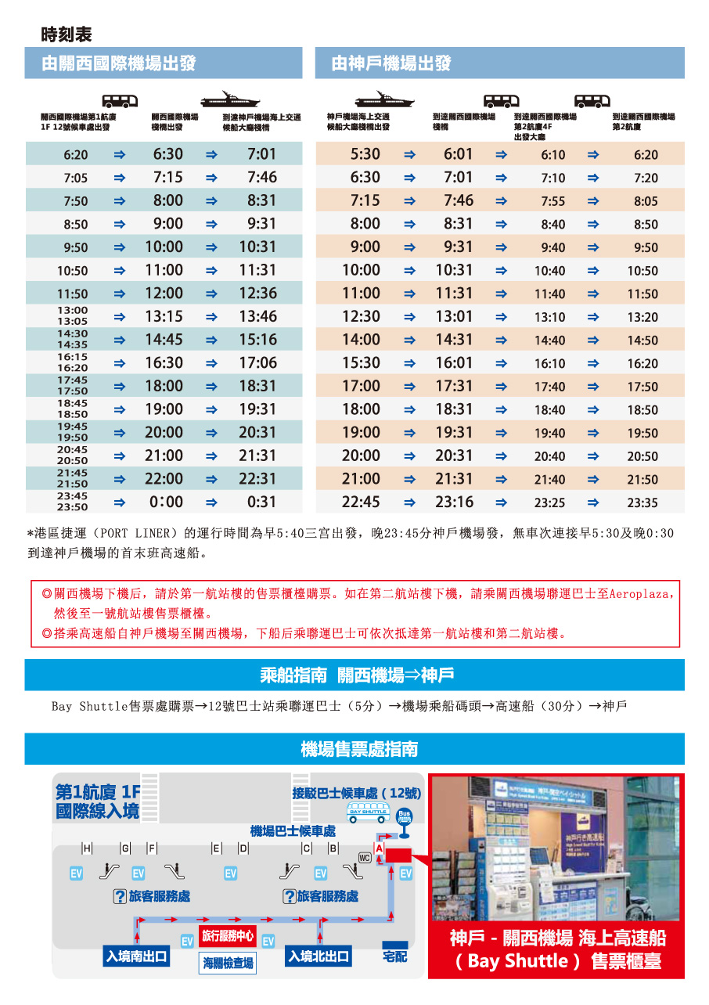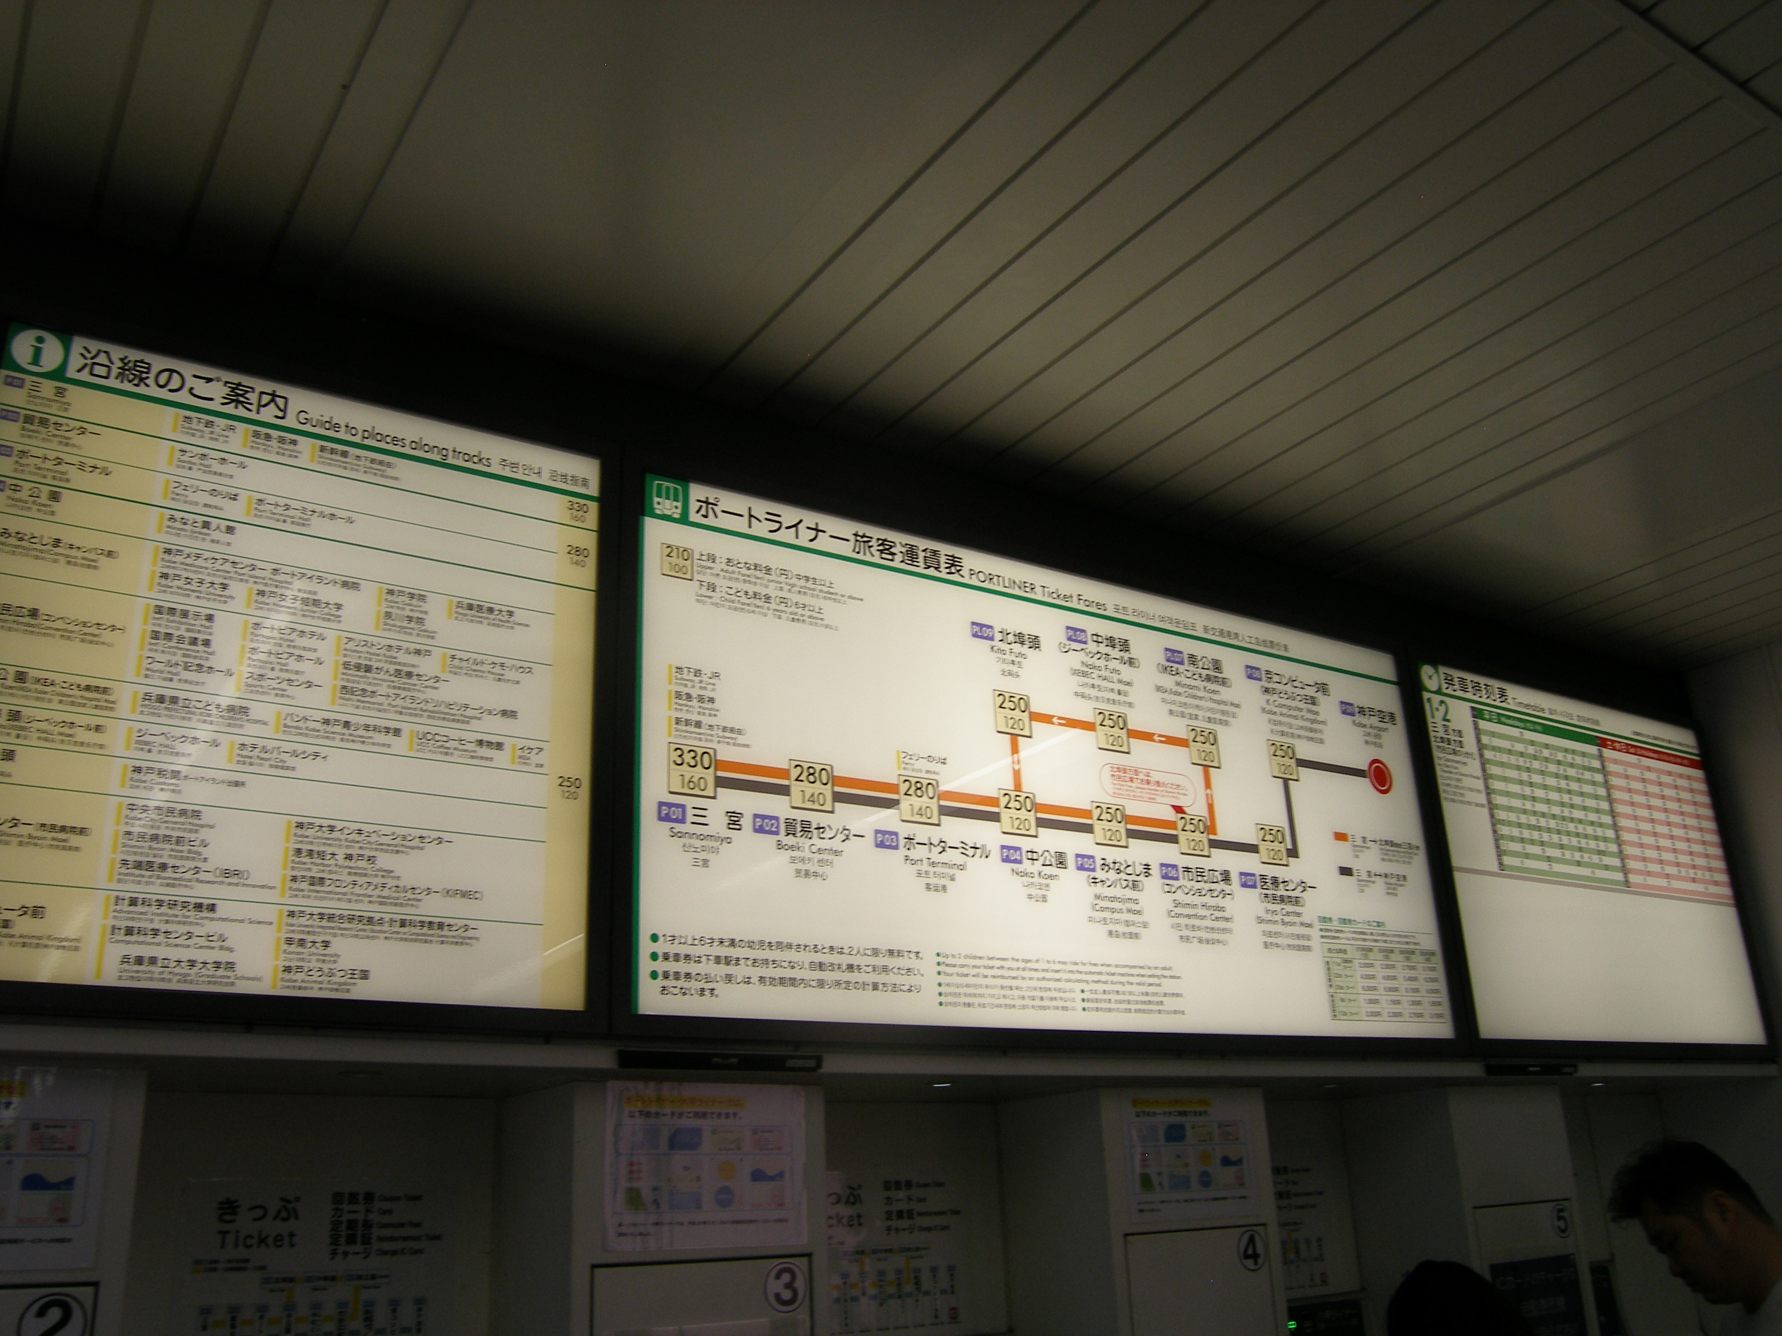
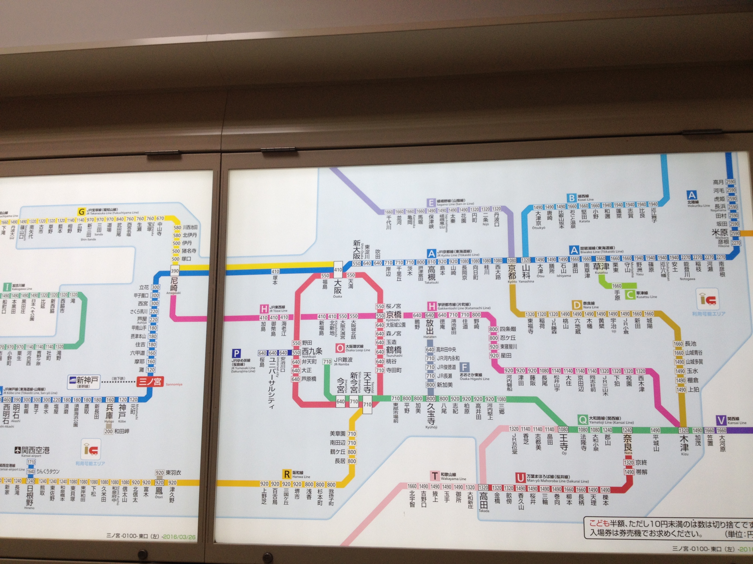
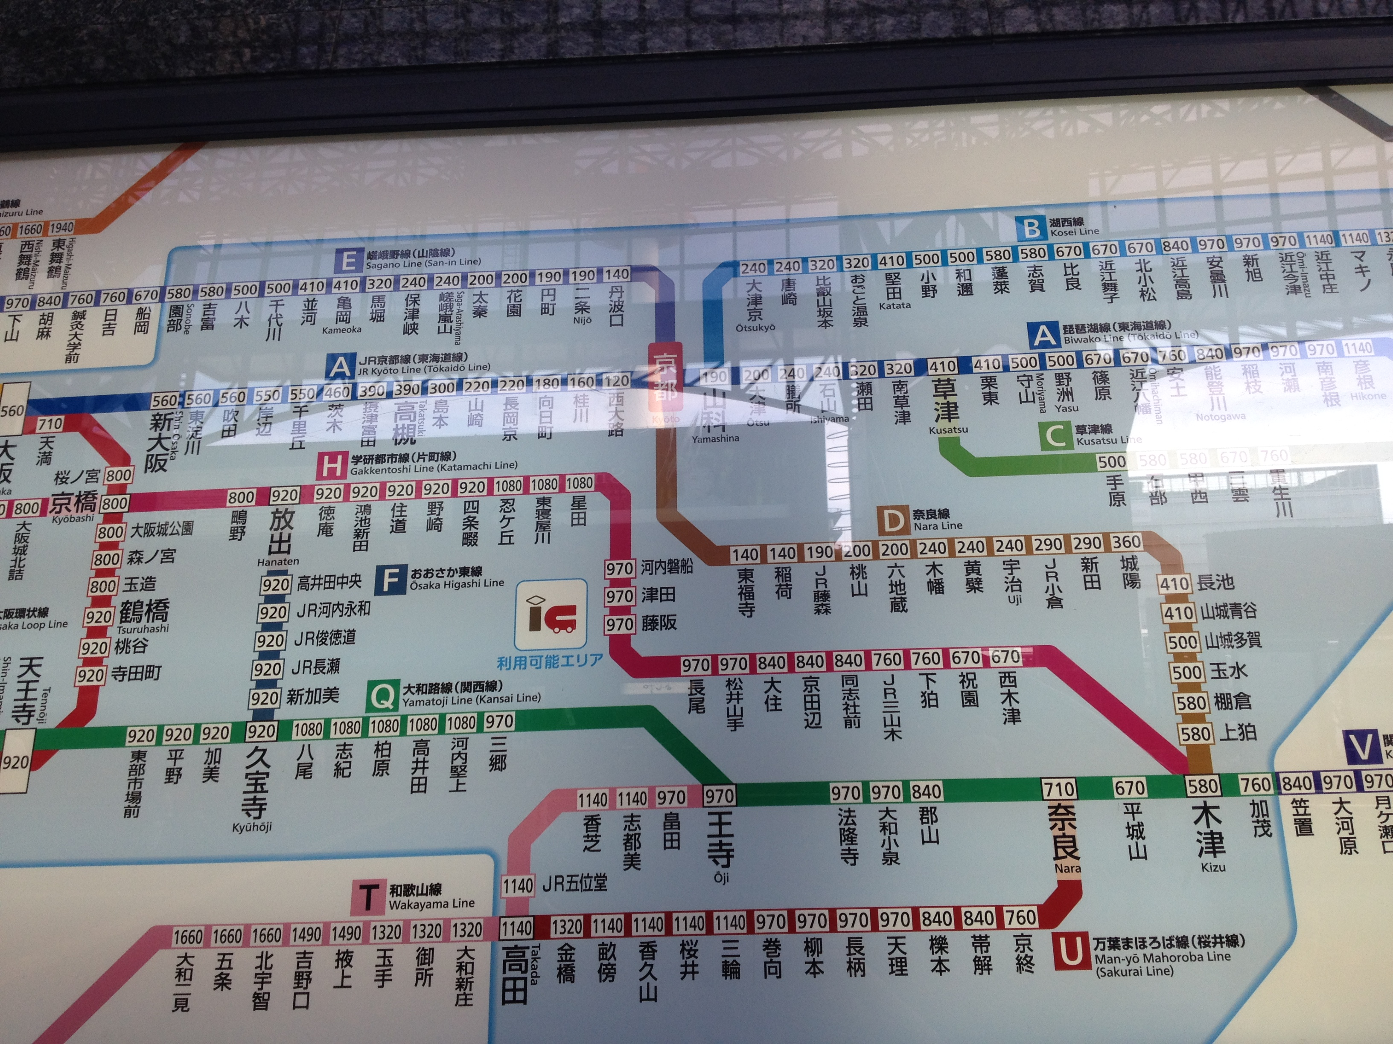
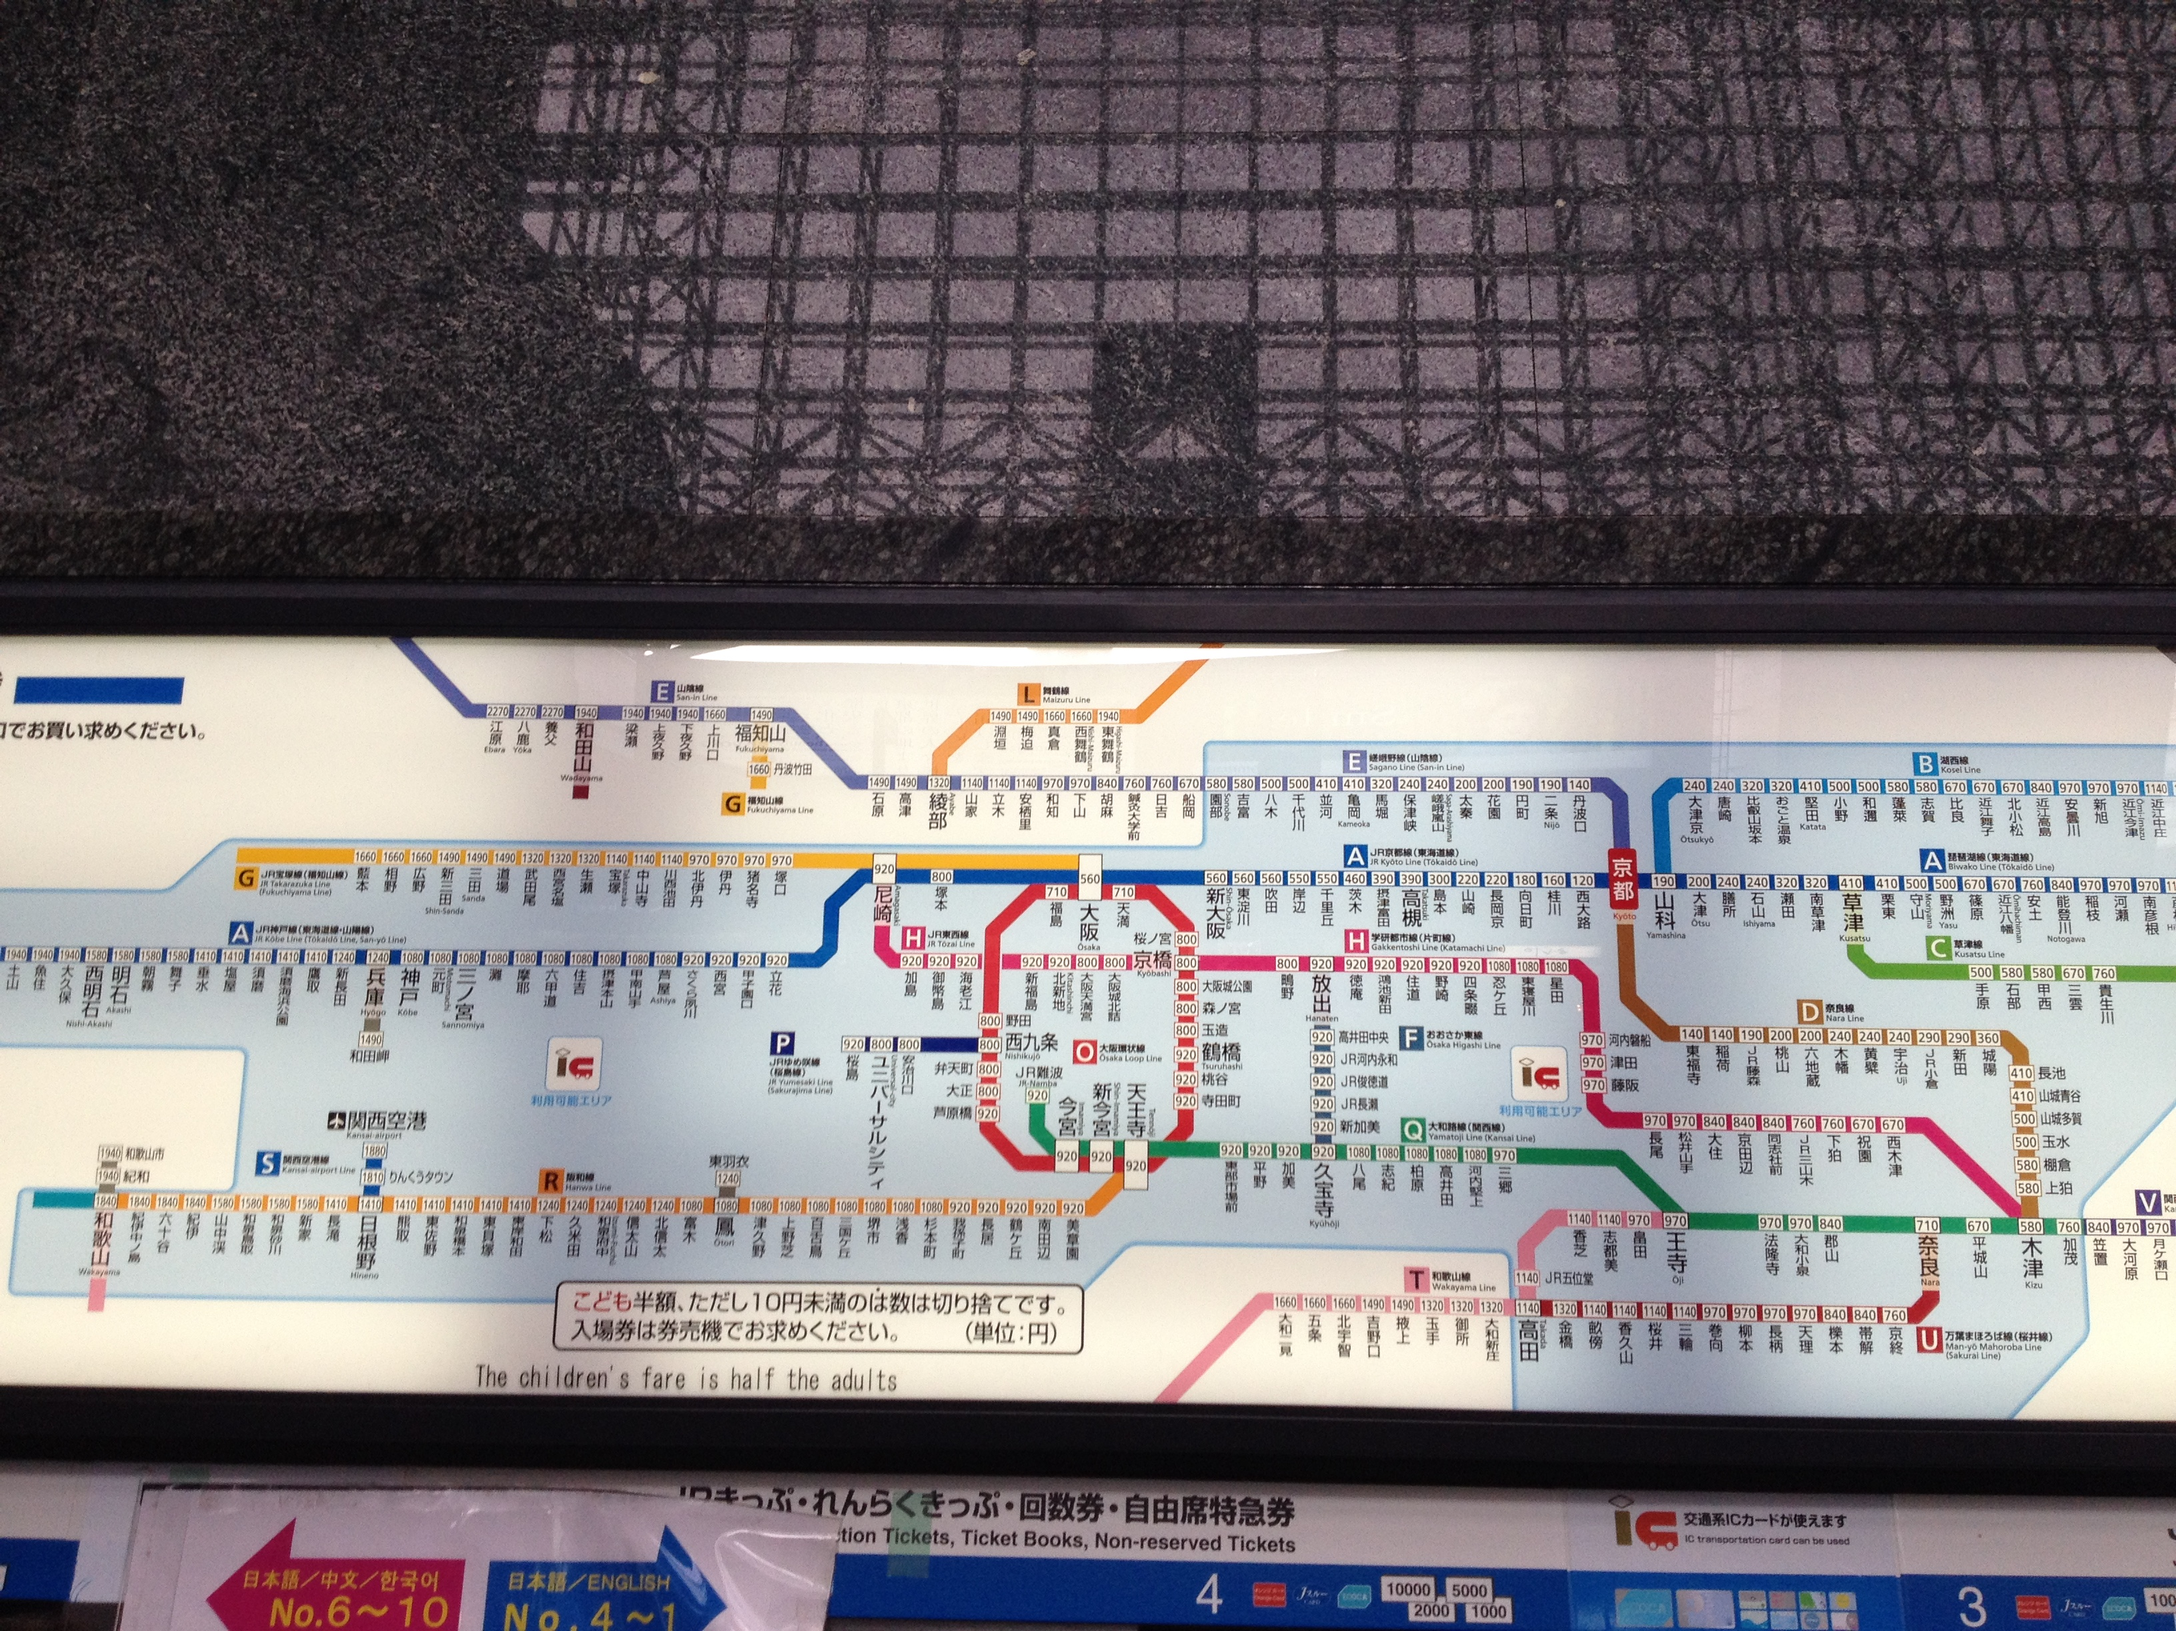
附件5
