海山高中國中 英語科 閱讀測驗複習 考試卷 ___年 ___班 座號：___ 姓名：__________

一、閱讀測驗
- There are 30 girls and 50 boys in Class 301 and Class 302. 50% of the girls and 60% of the boys have smartphones. What do they do with their phones? Read the graphs below：
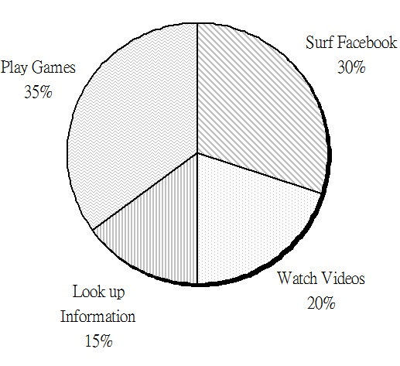
【Graph 1： What do the boys do most with their smartphones?】
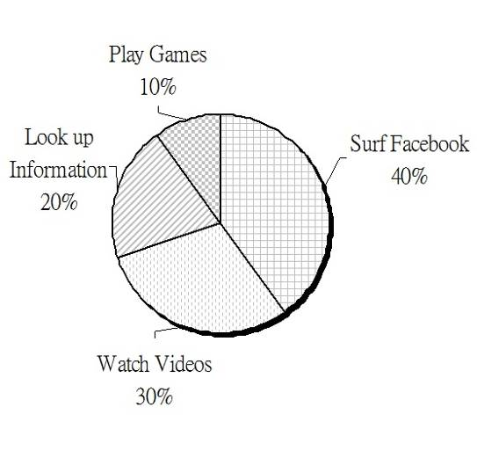
【Graph 2： What do the girls do most with their smartphones?】
graph 圖表
（ ）1. What do the boys do most with their smartphones?
(A) Watch videos.
(B) Surf Facebook.
(C) Play games.
(D) Look up information.
（ ）2. How many girls use their smartphones to surf Facebook most of time?
(A) 3. (B) 4. (C) 5. (D) 6.
（ ）3. Which is true about the reading?
(A) 40% of students in Class 301 and Class 302 have smart phones.
(B) There are 5 girls who use their smartphones to look up information.
(C) There are 8 boys who use their smartphones to watch videos.
(D) More boys like to surf Facebook than girls.
- Dear Sir / Ma’am,
We feel sorry for the wrong price of KT201 cellphone on OMG online shop. The price should be 15,000, but we marked it 1,500 because of our carelessness. We changed the price soon after we found the mistake. We are sure to be responsible for it. People who bought the KT201 cellphone at 1,500 dollars in our online shop can get the special price. If you have any questions about the price you paid, you can check your transaction record. You may also choose to cancel your order in 7 days. OMG was set up in 1995, and we’ve always been honest to everyone who shops in our store. OMG will hold a big sale to thank you next weekend. We truly welcome you.
Mark Lin
OMG online shop
 mark 標示 carelessness 粗心 responsible 負責任的 transaction record 交易紀錄 cancel 取消 truly 真誠地
（ ）1. What does “ it” mean in the letter?
(A) OMG online shop.
(B) The brand of cellphone. brand 品牌
(C) The mistake of the wrong price.
(D) Changing the price.
（ ）2. Why does Mark Lin write this letter?
(A) He’s angry that many people bought cheaper KT201s.
(B) He wants to tell people that OMG is an honest shop.
(C) He tries to change the price of KT201 cellphone.
(D) He doesn’t want to sell KT201 at a special price.
（ ）3. Which is true according to the letter?
(A) OMG will sell only cheaper KT201s next weekend.
(B) You have to show your transaction record if you buy KT201 at 1,500 dollars.
(C) OMG is more than 15 years old.
(D) You can’t regret after you place an order in OMG online shop. regret 後悔
- Modern technology should make our life convenient. However, some inventions are troubling. A verification code is a good example. When you do online shopping or visit some Internet sites, you are asked to type numbers or English letters you see. But sometimes they are not so clear that you can’t easily tell them. Then you have to give up entering the site. Another example is a hand dryer. Hand dryers are seen in some public restrooms. It’s a good design because we can use less restroom paper. It can help to save the Earth. But after you spend a few seconds rubbing your hands, you find you still have to dry them with your clothes. By the way, the sensitive faucet in the restroom is also terrible. You wave and wave your hands in front of it, but it’s not so easy to make water out. Next time when you have an idea of inventing something, you have to think twice.
troubling 令人困擾的 invention 發明 verification code 驗證碼 site 網站 rub 搓揉 sensitive faucet 感應式水龍頭
（ ）1. What is NOT the invention that the writer considers troubling? consider 認為
(A) A verification code.
(B) A hand dryer.
(C) Restroom paper.
(D) A sensitive faucet.
（ ）2. Why does the writer think a hand dryer is a good design?
(A) It doesn’t need a verification code.
(B) Using less paper is good for the Earth.
(C) It doesn’t cost lots of money.
(D) It’s easy to use.
（ ）4. What does the writer want to tell us?
(A) There are many terrible inventions in restrooms.
(B) Saving water and paper is important.
(C) People should get used to all inventions.
(D) Inventions should be convenient for people.
- Betty：Hello, I’m the host, Betty. Let me introduce you the new technology, the amazing housekeeper.
Mr. Lin：Yes, the robot can help you clean the house, wash clothes, and water flowers. You can ask it to do any housework you don’t want to do.
Betty：Sounds cool. How do you make it do housework? Show us, Mr. Lin.
Mr. Lin：Set the time and the housework you want it to do. Do each thing by yourself first, and let it follow you. It can record your moves and every move will be saved in its memory. It’s just like a smart student who can learn things quickly.
Betty：I can’t wait to have one. Isn’t it an expensive product with such great technology?
Mr. Lin：Not at all. Just save 200 dollars a day. And after one month, you can get a useful housekeeper.
Betty：Nice. Now, everyone who is watching the channel can get 30% off discount.
Mr. Lin：Yes. Just call the number on your screen to place an order. The amazing robot will be sent to your house as soon as possible.
 introduce 介紹 housework 家事 record 錄製 move 動作 discount 折扣
（ ）1. Where may the dialogue happen?  dialogue 對話
(A) In Betty’s living room.
(B) In a college.
(C) In a TV program.
(D) In a factory.
（ ）2. What does “one” mean in the dialogue?
(A) A robot. (B) A host.
(C) A student. (D) A study tool.
（ ）3. What CAN’T the robot housekeeper do?
(A) Chat with you when you’re lonely.
(B) Wash clothes of the whole family.
(C) Mop the floor.
(D) Water flowers.
（ ）4. Which is true according to the dialogue?
(A) You can order the robot on the internet.
(B) If you call the number to order the robot, you have to pay about 4,200 dollars.
(C) You have to take the robot home from the factory.
(D) You can just tell the robot the things it has to do, and it can do them well.
- GNB News
Forever Takes a Bow
Actor Nathan Lang, 78 years old, died in his sleep last night in his house. Nathan Lang started his acting life in the 1970s. He was most known for playing Justin Maud in Young Hours. The movie made the world swoon over him. Women wanted a husband like him; men wanted a brother like him. Forever Justin, his fans called him. After Young Hours, Nathan Lang was seen in several big movies： Fallen, After Tonight, and Killing Jules. The last one won him a best actor award. In the 1980s, Nathan Lang lost his shine on the big screen. During this time, his movies never entered the top 20 list. Nathan Lang’s last movie was Dreams. Though the movie won him two best actor awards, it did not bring his fans back to the theater.
This Saturday morning, 10 o’clock at St. Peter’s Church, there will be a “movie party,” as Lang wished. Friends and family will get together and enjoy once again the good times he brought to the world.
 award 獎項
【103教育會考】
（ ）1. What is this reading mostly about?
(A) Nathan Lang’s love and hate for his family.
(B) The good and bad about Nathan Lang’s movies.
(C) The rise and fall of Nathan Lang in show business.
(D) Nathan Lang’s life before and after he became an actor.
（ ）2. What does swoon over mean in the reading?
(A) Close the door on.
(B) Go crazy about.
(C) Share the joy with.
(D) Try hard to deal with.
（ ）3. Here are reviews about Nathan Lang’s movies. From the reading, which is most likely a review for Dreams?  review 評論 likely 可能
(A) …nothing new in the story; Nathan Lang clearly didn’t do enough homework about his part in the movie. It was no surprise that the movie didn’t make it into the top 10 list the first week it was out…
(B) …it became Nathan Lang’s second best-selling movie and also this year’s third best-selling movie in the country and may even get him another best actor award…
(C) …see him not as the actor Nathan Lang anymore but as the poor old man in the movie. However, good acting does not always help with the ticket sales…
(D) …the story is fresh and interesting, but the acting is not. However, it has been the country’s best-selling movie for the past three weeks. Clearly Nathan Lang’s fans cared less about his acting than his handsome face…
- （Here is this year’s report on the Top Ten Cities of Animal Island by Best Living.Com.）
① Goosetown：Climbing up from last year’s second place, Goosetown comes in first for its lovely parks, cultural centers, and comfortable living space.
② Tigerville：Losing its top place to Goosetown, Tigerville is still a beautiful city, and as green as ever.
③ Duckland：The only city staying in our top three for five years, Duckland is now cleaning itself up for next year’s Football World Cup.
④ Oxtown：Not just a famous business city, Oxtown has turned itself into a garden city.
⑤ Lionville：Famous for its culture and beautiful gardens, Lionville is the first city in the north to enter our top five.
⑥ Sharkville：With winter sports as good as Oxtown’s, this exciting city is our second best pick in the east.
⑦ Foxland：This city with white beaches could rise higher in the rankings if there were fewer traffic problems.
⑧ Goatville：Dropping two places, Goatville should now think more about parks than shopping centers.
⑨ Turtleland：New in our top ten, this old fishing town is full of surprises.
⑩ Cowtown：Dropping from number seven, Cowtown must clean up the air.
 culture(-al) 文化（的） ranking 排名
【103教育會考】
（ ）1. Which is NOT true about the report?
(A) It tells us what some cities are known for.
(B) It tells us what some cities need to deal with.
(C) Green space plays an important part in the report.
(D) It is the second year that Best Living.Com did the report.
（ ）2. What can we learn about the cities in the report?
(A) One city in this year’s top five is in the east.
(B) Few people come to Oxtown to do business.
(C) No city in the north entered this year’s top ten.
(D) Goosetown is Animal Island’s second biggest city.
（ ）3. Which is the most likely ranking of LAST year’s top ten cities of Animal Island?  likely 可能
(A) ① Tigerville ② Goosetown ③ Cowtown
④ Oxtown ⑤ Duckland ⑥ Goatville
⑦ Lionville ⑧ Sharkville ⑨ Foxland
⑩ Turtleland
(B) ① Tigerville ② Goosetown ③ Duckland
④ Beartown ⑤ Lionville ⑥ Sharkville
⑦ Goatville ⑧ Cowtown ⑨ Foxland
⑩ Oxtown
(C) ① Goosetown ② Tigerville ③ Duckland
④ Foxland ⑤ Beartown ⑥ Goatville
⑦ Cowtown ⑧ Lionville ⑨ Oxtown
⑩ Sharkville
(D) ① Tigerville ② Goosetown ③ Duckland
④ Oxtown ⑤ Beartown ⑥ Goatville
⑦ Cowtown ⑧ Lionville ⑨ Foxland
⑩ Sharkville
- Here are the rules for a game called “Trip to Dreamland.”
1. Each player begins at START.
2. In each turn, first take one of the four cards  to decide how many spaces to move：  for one space,  for two spaces,  for three spaces, and  for four spaces. Then follow the words next to the , if there is a at the place you arrive at.
3. The first one who gets to Dreamland wins the game.
 turn 回合 space 步、格
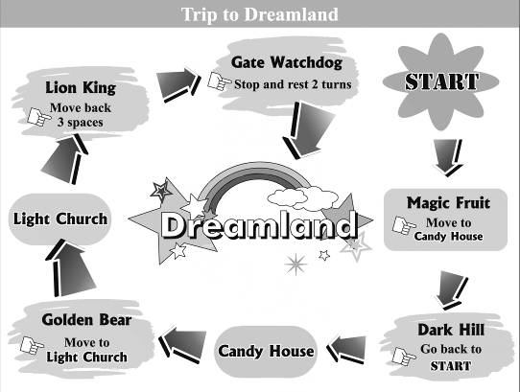【104教育會考】
（ ）1. Below are the cards which four kids have taken since they began the game. Who has won the game?
(A) Anna：→→.
(B) Kate：→→.
(C) Billy：→→.
(D) Ivan：→→.
（ ）2. What can we learn about the game?
(A) One can never begin his turn from Lion King.
(B) The cards can be used to decide who goes first.
(C) One can never get to Light Church at the first turn.
(D) The cards can be used to decide where to start the game.
- The idea may hit you once or twice a year. You come home on a hot summer day, hoping to have a cool bath, and find out there is no water. Then you see how important water is in your everyday life. However, in many parts of the world, water is not just about one’s everyday needs.
In countries like Tanzania, water is hard to get, and the job of collecting water falls on women’s shoulders. Girls are often kept home from school to collect water while their brothers stay at school studying. Studies show Tanzanian girls who live 15 minutes from clean water spend 12% more time at school than those who live an hour away. More time spent collecting water means less time for learning. For these girls, “Knowledge is power” is not just words; it is a sad fact in real life. With less time spent at school, their chances of getting well-paid jobs are small, and they often have no voice in important matters, like who to marry. These girls are often married into poor families. They have little money or knowledge to take care of their children, who often end up dying young. For the baby girls who are lucky enough to live, their life may still center around “water,” just like it did for their mothers.
【104教育會考】
（ ）1. What does The idea mean in the reading?
(A) Water is important in one’s everyday life.
(B) Water is not just about one’s everyday needs.
(C) It is nice to have a cool bath on a hot summer day.
(D) We should not take a bath when there is little water.
（ ）2. What is the reading mostly about?
(A) Why it is important to save water.
(B) How water may give a country power.
(C) How water may play a part in one’s future.
(D) Why it is hard to get water in poor countries.
（ ）3. What do we know from the reading?
(A) Children in poor countries die from drinking dirty water every day.
(B) Girls who spend little time at school have a harder life when they grow up.
(C) Girls in countries like Tanzania are often paid less for the same job than the boys are.
(D) Children from poor families are often kept from school to take care of younger children.
（ ）4. Families in the countries of Benin, Ghana, Guinea and Madagascar deal with the job of water-collecting the same way Tanzanian families do. From the reading, which chart best shows the fact?  chart 圖表
(A) 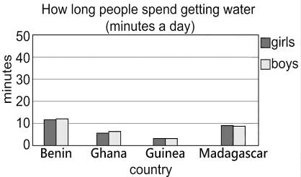
(B) 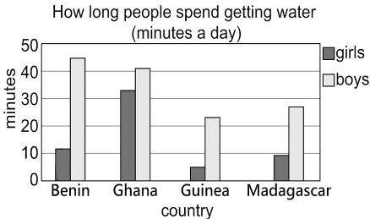
(C) 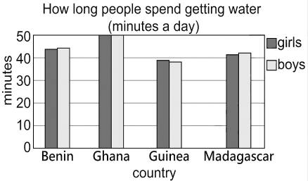
(D) 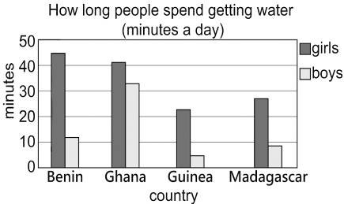
- (At Liz’s birthday party)
Amber：Don’t tell me you didn’t go to Garden House.
Keith：Why would I go there?
Amber：For Liz’s birthday cake! I left you a voice message this morning!
Keith：But you said Matt would go to the bakery! And why did you come here without me? I was waiting outside your apartment for an hour!
Amber：No! I said I’d have lunch with Matt, and we’d come straight here from the restaurant. So I asked you to help get the cake after work.
Keith：No, you did not! And why didn’t you answer my calls?
Amber：My cellphone is dead! I said in the message that you could call Matt’s number if you wanted to find me. Now please tell me you did bring the gift we got for Liz.
Keith：What gift? I’m sure you didn’t say anything about a gift in the message.
Amber：I told you that yesterday!
 message 留言
【104教育會考】
（ ）1. What is Garden House?
(A) A bakery.
(B) A gift shop.
(C) A flower shop.
(D) An apartment.
（ ）2. What can we learn about Keith?
(A) He forgot to meet Amber and Matt for lunch.
(B) He did not know how to get to Amber’s apartment.
(C) He called Amber without knowing her phone was not working.
(D) He did not know Amber left him a voice message this morning.
（ ）3. Which sentence was most likely part of the message that Amber left Keith this morning?  likely 可能
(A) “Matt and I will go to the party after lunch.”
(B) “Don’t forget to buy a birthday gift for Liz.”
(C) “You can go straight to the party from your office.”
(D) “I need to talk to you about the party this weekend.”
- The Metro Times
Oct. 1. 2020
These years churches are in a calamitous state. To start with, the number of church-goers is dropping sharply (see Figure 1). Many say they do not belong to any church, and those who do go less often than they used to. Going to church appears less and less on people’s to-do list. Another worrying fact is that fewer and fewer young people go to church, which leads to an older church (see Figure 2).
And there is also the problem with money. Keeping a church door open is not cheap. Fewer people going to church means little money coming in. This makes it harder to keep a church open.
When the time comes for a church to close, there is little to do but to sell it. Churches that were lucky enough to find a buyer were put to other uses. Some were changed into restaurants or school gyms, and some even became nightclubs, for example. Churches that had little luck were knocked down in the end.
Just like a store that keeps losing business needs to think of ways to save itself, it is perhaps time for the church to try to win people’s hearts back and play an important part in people’s lives again. This is not something that one can simply pray to get an answer to.
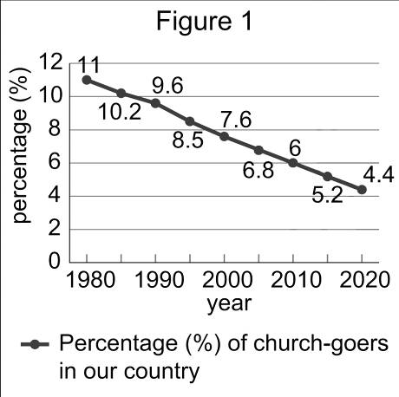 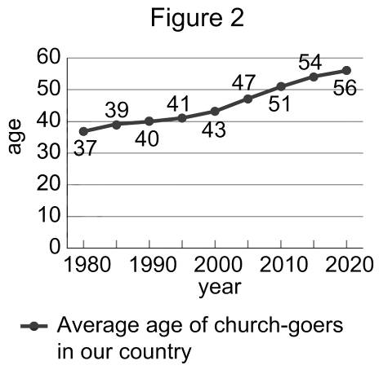
 figure 圖 average 平均
【104教育會考】
（ ）1. What does it mean when someone is in a calamitous state?
(A) They have serious trouble.
(B) They try to change themselves.
(C) They are looking for a second chance.
(D) They lost interest in the outside world.
（ ）2. What can we learn about the church-goers from the report?
(A) Between 1980 and 2005, few church-goers were younger than 50.
(B) In 2010, only 6% of church-goers were younger than 50 years old.
(C) In 2020, the percentage (%) of church-goers drops to lower than half that in 1980.
(D) Between 1980 and 2020, the rising number of old church-goers has led to an old church.
（ ）3. What is talked about in the report?
(A) Where the church’s money goes.
(B) How people decide to join a church.
(C) What happens to churches that are closed.
(D) Why people have stopped going to church.
（ ）4. Below are four findings from other reports. Which does NOT agree with the idea of the report?
(A) “Reports show over 90% of church-goers go to church because their fathers do. In the last 20 years, 49% of men under 30 have left the church. That means there’s a 90% chance that their children won’t go to church. This is hard for the church to take in.”
(B) “Between 2003 and 2010, over 1,000 new churches were built in the country. This may sound like good news. During the same years, however, more than 2,000 were closed.”
(C) “In the report, 33% of the people that were interviewed say they never go to church and another 33% say they used to. Only 15% go to church at least once a month.”
(D) “Of the 15 countries in the report, the percentage (%) of church-goers in some countries, like Denmark, is lower than 10%; in others, like Poland, the percentage is higher than 70%.”
- Enjoy the 4D movie in Hans Theater. Feel the shaking, odor and the wind around you. Totally a new experience of watching movies. Become our member, and you can get one popcorn and cola for free.
digital 數位的 totally 完全地 member 會員 credit card 信用卡 offer 優惠
（ ）1. What is special about a 4D movie?
(A) You can feel the smell or the shock just like you’re in the movie.
(B) You can see actors walk by your side.
(C) You need to stand to watch the movie.
(D) Everyone has to play like the actor or the actress in the movie.
（ ）2. Jane and Tim watched 3D Outer Space last weekend. Jane has a Happy Bank credit card. How much did they pay for the movie?
(A) 480 dollars.
(B) 576 dollars.
(C) 600 dollars.
(D) 640 dollars.
（ ）3. Which is true about Hans Theater?
(A) There are 4 movies shown at Hans Theater.
(B) You can watch 3D digital Let’s Fall in Love at Hans Theater.
(C) There are two banks in cooperation with Hans Theater. in cooperation with 與……合作
(D) You can buy cheaper tickets if you are the member of Hans Theater.
- Dear Natalie,
Last weekend, I went to Taipei to visit Aunt Sally. We haven’t seen each other for eight years. She was very busy these years because she had three part-time jobs at the same time. She told me that she had bought a house before she had Andy, my cousin. Besides, Uncle David died of a car accident ten years ago. She had to pay the loans and raise Andy herself, so she worked much harder than others. Now Andy has grown up, and he can share some work from Aunt Sally. Guess what? The delicious dinner was made by Andy. He’s sweet and humorous. If you don’t mind having a boyfriend younger than you, Andy is the best choice.
Best Wishes.
Olivia
loan 貸款 raise 養育
（ ）1. Why did Aunt Sally work so hard these years?
(A) She moved to Taipei.
(B) She failed in her business.
(C) She had to raise Andy and pay the loan on her own.
(D) She wanted to buy a car.
（ ）2. What happened to Uncle David ten years ago?
(A) He moved to the USA.
(B) He died in a car accident.
(C) He met Olivia.
(D) He married Aunt Sally. marry 嫁娶
（ ）3. Which is NOT true according to the letter?
(A) Andy can cook meals.
(B) Olivia thinks Andy is nice boy.
(C) Aunt Sally rents a house now. rent 租
(D) Andy is younger than Natalie.
- Bangkok is chosen as the best city for traveling in 2013. It defeats London, Paris and many other famous cities to become the first Asian city which gets the prize. Why is Bangkok popular with tourists? First, you can have delicious food in fine restaurants without paying much. Second, choosing a hotel for a stay isn’t difficult at all because there are thousands of hotels in every price range. Families, lovers and backpackers can find their favorite hotel easily. If you like shopping, you can’t miss wide markets in Bangkok. It’s the dream city for shoppers.
Most importantly, people in Bangkok are friendly to tourists. Though they don’t speak English well, they’re glad to help. And they don’t cheat. Some say their religion makes them kind and honest to people. However, most tourists may not put up with traffic jams which can be seen in many parts of this city. They really hope they can spend more time in a night market but not in a taxi.
Asian 亞洲的 tourist 遊客 range 範圍 backpacker 背包客 religion 宗教
（ ）1. What may “defeat” mean?
(A) Connect. (B) Surprise.
(C) Win. (D) Pass.
（ ）2. Which is NOT the reason that makes Bangkok popular? reason 原因
(A) There are many choices of hotels in Bangkok.
(B) Tourists can be closer to nature.
(C) Shopping in Bangkok is convenient.
(D) Tourists can enjoy delicious meals.
（ ）3. Why are Bangkok people friendly to others?
(A) It’s because of their religion.
(B) They have made lots of money from tourists.
(C) The history teaches them not to lie.
(D) They enjoy making friends.
（ ）4. Which is true?
(A) Taipei has won the prize of the best city for travelling in 2013.
(B) The hotels in Bangkok are nice but expensive.
(C) Most Bangkok people can speak good English.
(D) Tourists like Bangkok for many reasons except its traffic jams.
- Lucy：Hey, Mark. It seems that you’re worried about something.
Mark：You really read my mind.
Lucy：Tell me!
Mark：I sent messages to my new classmate, Lisa on LINE. She read them, but she seldom replied, or sometimes only with pictures. I hope she can chat with me.
Lucy：I don’t know what she really thinks, either. Maybe she was busy then. Or maybe she didn’t want to chat with you. Isn’t it better to ask her out and have a talk? You can’t know everything through technology.
Mark：You’re right. And what are you looking for? You look anxious.
Lucy：I’m looking for my mobile battery. My cellphone is running out of power. I need to check my Facebook to know what my friends are doing now. Oh, no! It’s left in my room.
Mark：Technology also makes you blind.
message 訊息 LINE 聊天程式的名稱 reply 回覆 anxious 焦慮的 mobile battery 行動電源
（ ）1. What does “You really read my mind.” mean?
(A) Forget it.
(B) You have to say something.
(C) You’re sick.
(D) You understand me very much.
（ ）2. Why does Lucy feel worried?
(A) Lisa didn’t reply to her on LINE.
(B) She cares about Mark.
(C) She can’t check Facebook.
(D) She can’t understand Lisa.
（ ）3. Which is true?
(A) Mark and Lucy can’t see things clearly.
(B) Mark doesn’t like Lisa.
(C) Lucy usually surfs the net.
(D) Lucy usually loses things.
- Since Michael Jackson died on June 25, 2009, most of his fans have been sad. In fact, Michael Jackson began singing songs at the age of 11. At that time, his first album was popular with people around the world. Three years later, with his successful second album, he was thought to be one of the greatest and richest singers in the world. In 1985, he sang the song We Are the World with many other singers. They made a lot of money and gave most of it to help the children in Africa. However, Michael Jackson got into trouble in 1993. All kinds of problems made him unhappy and tired. He also lost a lot of fans after many lawsuits. When he was 50, his life ended in a surprise. Many people still can’t believe the legendary singer has gone to another world.
 album 專輯 lawsuit 訴訟 legendary 傳奇性的
（ ）1. What does “it” refer to?  refer to 指稱
(A) Africa. (B) Money.
(C) Michael’s song. (D) The world.
（ ）2. When did Michael start to be a singer?
(A) When he was an eleven-year-old boy.
(B) After he sang the song We Are the World.
(C) After his second album became successful.
(D) Just before his life ended.
（ ）3. Which is true about Michael Jackson?
(A) His second album was not successful.
(B) He died when he was fifty.
(C) His first song made him get into big trouble.
(D) He was born in 2009.
- Since Queen Elizabeth was a child, she has been taught to speak six different languages and to know a lot about poems and history. After she became the queen, she put much emphasis on literature. Then, many writers became world-famous with their beautiful poems, such as William Shakespeare, Christopher Marlowe, and Edmund Spenser.
Queen Elizabeth herself also wrote many works in English. The translation of The Art of Poetry is one of her famous works. She changed the language written in the book into another. In the time of Queen Elizabeth, England became the strongest country in the world. She had never been married before she left the world in 1603. Now, she is still prized as one of British people’s favorite leaders.
 emphasis 強調 literature 文學 translation 翻譯 poetry 詩歌
（ ）1. What DIDN’T Queen Elizabeth learn when she was young?
(A) Languages. (B) History.
(C) Railway. (D) Poems.
（ ）2. Which is true about Queen Elizabeth?
(A) Queen Elizabeth was not married.
(B) Her country was weaker than others in her time.
(C) Shakespeare is her husband.
(D) She traveled to England in 1603.
- Scouting Report–Hong-Chi Kuo
His fast ball from the left side makes left-handed batters not do well when he is on. However, his history of getting hurt has always been a big problem. In fact, from July, 2008 to August, 2010, he had been troubled by his hurt left arm. That stops him from being a stronger and more famous baseball star.
 scouting report 球探報告 left-handed batter 左打者
（ ）1. What does “That” mean?
(A) Hong-Chi Kuo’s fast balls.
(B) Left-handed batters.
(C) Famous baseball stars.
(D) Hong-Chi Kuo’s history of getting hurt.
（ ）2. How long had Hong-Chi Kuo felt troubled by his hurt arm?
(A) Almost three years.
(B) Almost two years.
(C) About one year.
(D) Fewer than six months.
（ ）3. Why can’t left-handed batters hit Hong-Chi Kuo’s balls well?
(A) His fast ball comes from the right side.
(B) Those left-handed batters have history of getting hurt.
(C) He throws balls too fast for the batters to hit well.
(D) Most of the left-handed batters aren’t strong.
- Have you ever been abroad? Do you want to create opportunities to practice English? Welcome to join our four-week English camp this summer. At camp, you can practice speaking English every day. Also, you’ll visit several beautiful places in the USA. The following is our schedule and activities：
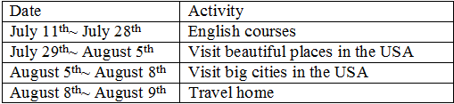
Join us! You’ll have different experiences in learning English. If you apply before April 5th, 2013, you just need to pay NT$150,000. However, if you apply after April 5th, you need to pay NT$160,000.
schedule 時間表 activity 活動 course 課程 apply 申請
（ ）1. Where will the English camp be held?
(A) In Taiwan.
(B) In America.
(C) In Canada.
(D) In Australia.
（ ）2. How long will the English camp last?
(A) Four hours.
(B) Four days.
(C) Four weeks.
(D) Four months.
（ ）3. If you apply before April 5th, how much money can you save?
(A) One hundred.
(B) One thousand.
(C) Five thousand.
(D) Ten thousand.
（ ）4. Which is true?
(A) The English course starts on July 28th and ends on August 5th.
(B) You can visit different places if you join the English camp.
(C) At camp, you can have different experiences in learning Japanese.
(D) If you apply on May 5th, you just need to pay NT$150,000.
- Dear Aunt Erica,
How are you doing? I need your help. I have trouble learning English. I’m doing well with my grammar, reading, and writing. However, I always get bad grades on English listening tests. Do you have any tips on listening to English? Please teach me.
Jane
****************************************
Dear Jane,
To tell you the truth, there’s no shortcut to improve your listening ability. You just need to practice listening every day. You should spend at least 30 minutes listening to an English radio program that is called “Let’s Chat in English”. If you do it every day, I believe your listening ability will become better soon. That’s my learning experience. Please give it a try!
Love,
Erica
shortcut 捷徑 improve 改善 ability 能力
（ ）1. Who is Erica?
(A) She’s Jane’s English teacher.
(B) She’s Jane’s mother.
(C) She’s Jane’s aunt.
(D) She’s Jane’s sister.
（ ）2. What is Jane’s problem?
(A) She wants to improve her English listening ability.
(B) She has problems with English grammar.
(C) She can’t read.
(D) She can’t hear what people say.
（ ）3. Which is true?
(A) Jane needs to practice writing every day.
(B) Jane has to spend thirty minutes listening to English every day.
(C) Jane’s English is almost perfect.
(D) Jane is going to have an English test soon.
- Some of my friends are on a diet. In order to be healthier, they all try to use different methods to lose weight. The following are their tips and experiences on weight loss：
Grace
Grace uses exercises to lose weight. She goes to the gym three times a week. Until now, she has already lost seven kilos.
Anne
In order to lose weight, Anne stops eating snacks after 6 p.m. and only eats vegetables for dinner. She has lost three kilos.
Cherry
As for Cherry, she rides her bike and goes hiking every morning. In the evening, she exercises in the park. That’s why she can keep slim all the time.
Sandy
Sandy is the most successful one. She eats diet food. Until now, she has already lost eighteen kilos. She was even interviewed on TV.
on a diet 節食 method 方法 weight 重量 weight loss 減重 diet food 代餐 interview 訪問
（ ）1. Who uses exercises to lose weight?
(A) Grace and Anne.
(B) Grace and Cherry.
(C) Cherry and Sandy.
(D) Anne and Sandy.
（ ）2. What is Sandy’s tip on weight loss?
(A) She eats less.
(B) She exercises.
(C) She eats diet food.
(D) We don’t know.
（ ）3. Why do these people try to lose weight?
(A) They want to be more beautiful.
(B) They dream to be models.
(C) They want to be healthier.
(D) They want to look slimmer.
- Reporter：Do you like barbecue? If so, you shouldn’t miss this BBQ restaurant. Mr. Lin, what’s so special about your restaurant? Can you tell us why your restaurant is different from other BBQ restaurants?
Mr. Lin：To be honest, people seldom eat in a BBQ restaurant because they’re afraid that they may burn their food. So, in our restaurant, we have professional waiters and waitresses to teach you the tips on barbecuing. They will also help you barbecue seafood, so you will never eat burned food.
Reporter：Wow! That’s cool! Then, how much should we pay for each BBQ meal?
Mr. Lin：It’s all-you-can-eat and NT$399 per person.
Reporter：I see. Thanks for your introduction.
BBQ 烤肉 burn 燒焦 professional 專業的 all-you-can-eat 吃到飽 per 每 introduction 介紹
（ ）1. What kind of food can people eat in this restaurant?
(A) Chinese food.
(B) Japanese food.
(C) Barbecue.
(D) Fast food.
（ ）2. Who will help the customers in this restaurant?
(A) Cooks.
(B) Waiters and waitresses.
(C) The reporter.
(D) We don’t know.
（ ）3. If Jane and her parents are going to eat in this restaurant, how much should they pay?
(A) NT$399.
(B) NT$798.
(C) NT$1,197.
(D) NT$1,596.
- Rick：Hey, Betty! Did you know Annie just bought her own apartment?
Betty：I didn’t know that. Wow! How could she make it?
Rick：She has a lot of tip on saving money. Look! She’s coming. Let’s go ask her.
Betty：Hey, Annie! We heard you just bought an apartment on your own. Can you share with us your tips on saving money? Annie：Of course. Every month, I save at least half of my salary in the bank. I only spend NT$1,000 on food. I usually cook myself and seldom eat out. When I go out, I never take a taxi. I usually take a bus or the MRT. I only buy clothes at a night market. I never buy anything in a department store.
Betty：I see. Thank you for sharing your tips with us. We should all learn from you.
salary 薪水
（ ）1. Who bought a new apartment?
(A) Betty.
(B) Rick.
(C) Annie.
(D) We don’t know.
（ ）2. How much does Annie spend on food every month?
(A) One hundred.
(B) One thousand.
(C) Ten thousand.
(D) More than ten thousand.
（ ）3. Where does Annie buy clothes?
(A) In a department store.
(B) In a shopping mall（購物中心）.
(C) At a night market.
(D) She makes her own clothes.
（ ）4. If Annie makes NT$40,000 every month, how much money will she save?
(A) NT$40,000.
(B) NT$30,000.
(C) NT$25,000.
(D) NT$20,000.
- Dear Rick,
Good morning. I have a meeting this morning, so I need to go to work early. Your breakfast is on the table. Don’t forget to eat it before you go to school. Also, I have to work late today. I won’t get home until 10 p.m. Don’t worry. Dad will bring dinner home. I want to make a deal with you. You have to finish the following things before I get home：
1. Finish all of your homework.
2. Practice playing the violin at least for 30 minutes.
3. Take a shower.
After you finish the above things, you can do whatever you like.
Love, Mom
（ ）1. Who has a meeting today?
(A) Rick.
(B) Rick’s father.
(C) Rick’s mother.
(D) Nobody.
（ ）2. What does Rick need to do before he goes to school?
(A) Take a shower.
(B) Eat breakfast.
(C) Finish his homework.
(D) Practice playing the violin.
（ ）3. How long does Rick’s mom want him to play the violin?
(A) At least three minutes.
(B) At least thirteen minutes.
(C) Less than thirty minutes.
(D) More than thirty minutes.
（ ）4. Which is NOT true?
(A) Rick has to take a shower before his mom goes home.
(B) Rick’s mom will take dinner home.
(C) Rick’s mom has to work late today.
(D) Rick is a student.
- Erica：Hello, Kate. This is Erica. Long time no see. How have you been? I just want to ask when you guys will come back to Taipei.
Kate：We’ll go back to Taipei this Friday night.
Erica：Really! Then, will you be in Taichung next weekend? Mike and I plan to take kids to Taichung next weekend. Can we get together next Saturday?
Kate：No problem. We’ll be in Taichung next weekend. You’re welcome to visit us.
Erica：That’s great! The kids will be excited. By the way, will you come to church this Sunday?
Kate：Perhaps. My big girl wants to go to Sunday school. Can my little one also stay in QQ Land?
Erica：Of course. Kids who are more than three years old can also stay in QQ Land.
Kate：Cool! I’ll tell them the good news.
Erica：Let’s keep in touch with each other.
Kate：OK.
 Long time no see. 好久不見。 Sunday school 主日學校
（ ）1. When will Kate and her family go back to Taipei?
(A) Tomorrow.
(B) This Friday.
(C) Next weekend.
(D) Next month.
（ ）2. What’s the relationship between Micah and Erica? relationship 關係
(A) Father and daughter.
(B) Teacher and student.
(C) Brother and sister.
(D) Husband and wife.
（ ）3. How old may Kate’s daughters be?
(A) Less than three years old.
(B) More than three years old.
(C) More than thirteen years old.
(D) We don’t know.
（ ）4. What may QQ Land be?
(A) An elementary school.
(B) A junior high school.
(C) A senior high school.
(D) A Sunday school.
- Aunt Anna：Congratulations, Bob! You’re going to graduate from junior high school. How do you feel about it?
Bob：I can’t wait to say “Hello” to senior high school.
Aunt Anna：Really! You’re looking forward to the new chapter of your life. That’s great!
Bob：When I go to senior high school, I can make more new friends and do more things on my own.
Aunt Anna：Wow! You’re really a people person. I believe you must enjoy your senior high life. Wish you luck, and I’ll pray for you.
Bob：Thanks, Aunt Anna.
 congratulations 恭喜 look forward to 期待 wish 祝 luck 運氣
（ ）1. How old may Bob be?
(A) Five years old.
(B) Fifteen years old.
(C) Fifty years old.
(D) Ten years old.
（ ）2. How does Bob feel about starting a new chapter of his life?
(A) Worried.
(B) Sad.
(C) Excited.
(D) Afraid.
（ ）3. Which is true?
(A) Bob is a people person.
(B) Bob doesn’t like to make friends.
(C) Bob is shy.
(D) Bob needs help all the time.
- Ms. Chen：Hey, Tom! How was your summer camp? Did you enjoy it?
Tom：Yes, it was fun. I have lots of good memories.
Ms. Chen：Can you share with me what you did at the camp?
Tom：Sure. We played many games, sang songs, danced together, and watched a funny play. All the teachers there were nice to us. Our team leader was pretty funny. He usually said something to make us laugh. Most importantly, we learned to work with other teammates and respect each other. Although some boys had a fight, our team leader always brought us together again.
Ms. Chen：Thank you for sharing your summer camp with me. I’m so glad that you like the camp. Now let’s start our English class.
 teammate 隊友
（ ）1. Who is Ms. Chen?
(A) Tom’s mother.
(B) Tom’s team leader.
(C) Tom’s neighbor.
(D) Tom’s English teacher.
（ ）2. What did Tom learn at summer camp?
(A) To cook.
(B) To play basketball.
(C) To work with others and respect each other.
(D) To play computer games.
（ ）3. Which is NOT true?
(A) Tom likes the summer camp.
(B) Tom’s team leader was funny.
(C) Tom’s team leader usually made them cry.
(D) Tom shared his summer camp with Ms. Chen.
- My dear friends,
My family and I moved into our country house one month ago. The kids are planning to give a party at our new house. I hope all of you can come. The party will begin at 11：00 a.m. on Saturday. There will be lots of food and drinks.
Together with this letter is a map to our house. After you get off the train, take the road in front of the station. Follow it and you’ll see a chicken farm. Don’t make any turns. Keep going and you’ll see a bridge. Cross the bridge and there will be a big tree on you left. Walk past the tree, take the first right turn, and then walk for five more minutes. You’ll see several houses. My house is at the end of the road, next to the river.
Angelica
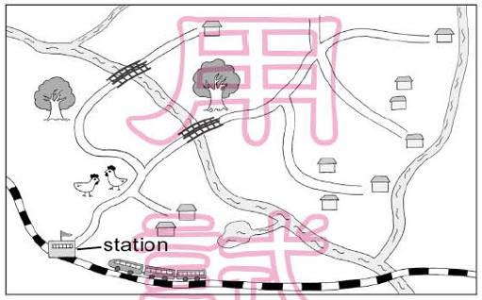
【103教育會考】
（ ）1. Why did Angelica invite her friends?
(A) To see her new home.
(B) To visit the chicken farm.
(C) To take a train trip.
(D) To have a picnic.
（ ）2. Look at the map. Where does Angelica live?
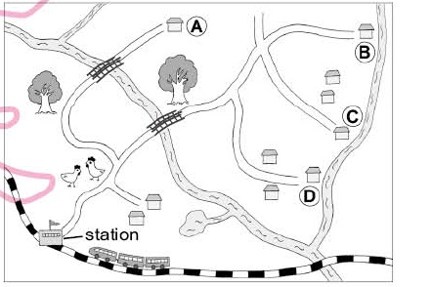
(A) At A. (B) At B. (C) At C. (D) At D.
- 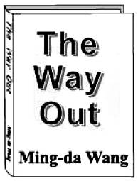
The Way Out
by Ming-da Wang
$450 → $199 Buy it now!
http://www.mingdawangbooks.net/thewayout/
Words from readers
I couldn’t put the book down after I read some pages at my friend’s home. I borrowed it and read it over that night. I think it can help someone who is afraid to face family problems.—Sam Lee
The book saved my life. It opened a door that led me into a world of true love. I was able to look at the world around me with fresh new eyes.—Candy Vigor
The first part of the book really touched my heart and made me want to read on. However, I was getting bored when I came to the second part. In fact, I didn’t finish the book.—Rod Green
The book helped me forget about my worries. I laughed and cried with those people in the book. With its simple and clear language, people of all ages can enjoy it.—Vivian Lu
【103教育會考】
（ ）1. Which is NOT said about the book in the reading?
(A) It tells a true story.
(B) It is cheaper now.
(C) A reader thinks it is easy to understand.
(D) A reader thinks its second part is boring.
（ ）2. What can readers most likely learn from the book?  likely 可能
(A) A new way of seeing the world.
(B) How to be a comic writer.
(C) A smart way to face work problems.
(D) How to buy a book on the Internet.
- Cecilia：Eddie’s having a tasting party this Saturday.
Gloria：No!
Cecilia：And we’re both invited.
Gloria：No! I told you I’d never go to any of his tasting parties again!
Cecilia：He said he wanted to share his newest cakes with his dearest friends.
Gloria：If he sees us as his dearest friends, he should stop having tasting parties!
Cecilia：Well, looks like baking really brings joy to his life.
Gloria：But it takes joy away from mine! Last time I was in bed for three days after his party.
Cecilia：If you hate it so much, you can just tell him.
Gloria：Why do I always have to be the bad person? Remember when I woke him up from his dream of making clothes? There was a lot of crying, and he wouldn’t talk to me for moment. You do it this time.
Cecilia：I can’t. How am I going to face him in our dancing classes if I tell him?
Gloria：So we still have to lie at his party again?
Cecilia：I’m afraid so.
【103教育會考】
（ ）1. What can we learn about Eddie?
(A) His friends think he is a great dancer.
(B) He is taking baking classes with Cecilia.
(C) His friends did not like the clothes he made.
(D) He did not know how to say no to his friends.
（ ）2. Which is true?
(A) Cecilia has not talked to Eddie for a month.
(B) Cecilia had a good time at Eddie’s last party.
(C) Gloria shared Eddie’s cakes with other friends.
(D) Gloria does not want to go to Eddie’s tasting party.
（ ）3. What does it mean?
(A) Tell Eddie about his baking.
(B) Tell Eddie to stop telling lies.
(C) Tell Eddie how to find joy in baking.
(D) Tell Eddie to stop crying over small things.
- （Six people are being interviewed about the garden on the roof of their building.）
Jasmine：I loved the idea when Wilber first told me about it. We had lots of meetings with our neighbors, trying to make them understand why it’s good to build a garden on the roof. Now people love coming here, and it’s helped many of us become friends!
Wilber：The whole thing wasn’t easy at first. But Jasmine helped a lot. And she was really good at making people happy to give money for the roof garden.
David：My kids love going up there. They sit there watching butterflies and birds. The roof garden brings them closer to nature.
Samuel：You want something green? Visit the park! It’s only one block away! After the roof garden was built, bugs started flying into my apartment! And the kids leave mud on the stairs when they come down from the roof!
Rosie：Our building is now cooler in the summer. My baby sleeps well even on hot summer days!
Flora：Guess where these tomatoes are from! Not from the supermarket. They’re from our roof! Isn’t that wonderful?
 roof 屋頂
【103教育會考】
（ ）1. What do we know about the six people in the interview?
(A) They all said good things about the roof garden.
(B) Some of them were paid to help build the roof garden.
(C) They all talked about the roof garden before it was built.
(D) Some of them worked on the plan to build the roof garden.
（ ）2. Which of the good things about the roof garden is NOT talked about in the interview?
(A) It brings people in the building closer together.
(B) It uses the rainwater that falls on the top of the building.
(C) It makes the building a more comfortable place during summer.
(D) It gives people in the building a chance to grow their own food.
（ ）3. What does the whole thing mean in the interview?
(A) Having meetings at the roof garden.
(B) Taking care of the roof garden every day.
(C) Having people agree to the idea of the roof garden.
(D) Inviting people to make more use of the roof garden.
- Last Saturday, Ginny and her friends had lunch at Howell’s Bowl. Here is their order, and the poster of the restaurant.

 poster 海報
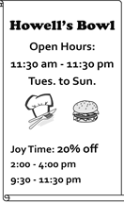
【104教育會考】
（ ）1. On the order list, Ginny ordered a sandwich with cheese, a fruit milk shake, and a fruit drink without ice. How much did she have to pay for her food?
(A) $300.
(B) $320.
(C) $385.
(D) $410.
（ ）2. Ginny wants to go to Howell’s Bowl again during Joy Time. When will she possibly go there?
(A) 11：00 a.m. on Wednesday.
(B) 2：30 p.m. on Monday.
(C) 8：00 p.m. on Friday.
(D) 10：00 p.m. on Thursday.
- Below is how four students answered their teacher’s question in class.
Lily：I like shopping and talking to people. I think I can learn how to do business. Maybe selling clothes is a good business for me.
Ryan：My hobbies are playing computer games and making friends online. We often share our funny stories by e-mail. I guess I will learn more about computers and make super-smart computer programs.
Bill：My parents have kept lots of pets since I was little. We’ve experienced many things together, good and bad, happy and sad. Those stories have always stayed in my mind. One day, I will share them with people by drawing and writing books.
Anna：Though my mom and two sisters are all doctors, I’m sure I will stay as far away from a hospital as I can. I hate being sick, and I’m afraid of seeing sick people looking weak and sad. I’ll keep strong by playing my favorite sport, tennis, every day. One day I’ll join the national team and be another Lu Yen-Hsun.
【104教育會考】
（ ）1. What question did the teacher most likely ask in class?  likely 可能
(A) “What do you want to do in the future?”
(B) “What’s your plan for the coming vacation?”
(C) “What do you like to talk about with your friends?”
(D) “What’s your favorite thing to do with your family?”
（ ）2. What do we know from the reading?
(A) Lily is good at making clothes.
(B) One of Bill’s parents is an animal doctor.
(C) Ryan enjoys meeting people on the Internet.
(D) Anna was once very sick and stayed in the hospital for a long time.
（ ）3. What does them mean?
(A) Pets.
(B) Books.
(C) Stories.
(D) Parents.
- Here is the preface of Nick Foster’s new book Married to Food.
Preface
My mother was lousy at cooking. To her, cooking was more like an exciting experiment. You put some of this and some of that in a pot, and you wait and see what will happen. “No experiments, no experiences.” is what she would say when her experiment did not turn out good, and I heard that a lot.
My father was a good cook, and he loved to cook, too. He often said that he got my mother to marry him with a table of delicious food, not with a beautiful ring. “A family needs only one good cook,” he said.
Now I am a cook myself. And I have my own restaurant. I learned how to cook from my father, of course. From him, I learned the art of cooking. But I did learn one thing from my mother. It’s her famous saying： “No experiments, no experiences.”
 preface 前言 experiment 實驗
【104教育會考】
（ ）1. What does it mean when someone is lousy at something?
(A) They are famous for it.
(B) They cannot do it well.
(C) They think it is important.
(D) They are not interested in it.
（ ）2. What can we learn from the preface?
(A) How Foster started his own restaurant.
(B) When Foster’s father married Foster’s mother.
(C) What Foster’s mother taught him about cooking.
(D) How Foster learned the art of cooking from his father.
- Froggie was a frog who never remembered where he had been. His biggest dream was to find the best pond to swim freely without worrying about water snakes. One day, Froggie hopped to a kitchen and jumped into a pot full of hot water. Froggie felt the burning heat and hurried out of the water as fast as his legs could carry him. “I almost died there!” Froggie thought.
A few days later, Froggie went back to the same kitchen, totally forgetting he had been there. He again hopped into the same pot. This time, the water inside was cool. He looked around and thought, “There’s no water snake trying to eat me and I can have this place all to myself!” At that moment, Froggie knew it was his dream pond. What he didn’t know was that the water was warming up over a low heat.
After thirty minutes of swimming, Froggie felt the water was warmer but he thought of this as a nice surprise. “This sure is the best place for swimming. I get to have a hot bath, too.” During his comfortable bath, the water kept getting warmer and warmer. Froggie was so comfortable that he fell asleep. And he never woke up.
【104教育會考】
（ ）1. What lesson can we learn from Froggie’s story?
(A) Life is too short; one should live it to the fullest.
(B) Those who use their time well will win in the end.
(C) People are blind to problems that slowly get worse over time.
(D) It is difficult to give up old habits, but easy to pick up new ones.
（ ）2. What do we know about Froggie?
(A) He learned to share what he liked with others.
(B) He thought what he had hoped for became real.
(C) He once almost lost a dear friend to a water snake.
(D) He wanted to go back to the same pot for a hot bath.

