B6L2單字
- strip n.[C]+s
Peanuts is my favorite comic .
Please cut the beef in strips.
- jam n. [C]+s 果醬[U]
Jerry was late because of a traffic .
- neither adv. 用於否定附和句，需倒裝
Joy can’t swim, and can I.
當「代N」：Neither of my daughters is married.
當連接詞：Neither you nor your brother
told the truth. (既非A也非B)
- 對等連接詞：either…or…(非A即B)；
not only A but (also) B (不僅A還有B)；
both A and B (A和B都)
-連接主詞時，動詞根據最接近的主詞變化
- explain v.+ed explanation (n.)
Please why you’re so late.
- secret n.[C] +s
Can you keep a (保守秘密)?
- according to片語放句首或句中(前無，) + N
the police, the thief was
caught in the park last night.
- host n.[C] +s host (v.)主持；主辦
Larry is a famous talk show in America.
Oprah is one of the greatest talk show hostesses.
- vase n.[C] +s
There is no water in the .
- on purpose片語←→by accident
Class: No: Name:
purpose (n.)[C]目的
Kevin said that he didn’t do it .
It was an accident.
- react v.+ed
How did your boss to your idea?
- finding n.[C]+s
The of Jane’s study surprised all of us. ★情緒V→were surprising to
- accident n.[C]+s
Peggy’s brother died in a car .
- shock v.+ed shock (n.)
The bad news all of us.
- so adv. 用於肯定附和句，需倒裝
She has been sick for days, and her son.
- in one’s blood 片語
Jack’s parents are both painters, so being an
artist is .
- kid v.+ded kid (n.) [C]小孩
Don’t be so angry. We’re just .
- study n.[C]studies study (v.)學習、研究
Dr. White will present his
on Australian wild birds in tomorrow’s meeting.
- group v.+ed group (n.)團體
These books were by their size.

Unit2 He's Always Late, and So Is Ken's Brother文法講義

- 附和句
  - 肯定的「也...」表示方法有too及so：
肯定句 | too的位置：放在句尾，前面加「，」 | so的位置：以倒裝句呈現放在句尾  so + beV/助V +主詞
肯定句 | He is a student, and I am, too. | He is a student, and so am I.
肯定句 | I like English, and he does, too. | I like English, and so does he.
  - 否定的「也不...」表示方法有not...either及neither：
注意否定字no、nothing、never、seldom、few、little、hardly
否定句 | not..., either的位置：放句尾，either前加「，」 | neither的位置：以倒裝句呈現放在句尾  neither + 肯定beV/助V + 主詞
否定句 | He isn’t a student, and I am not, either. | He isn’t a student, and neither am I.
否定句 | I don’t like cats, and he doesn’t, either. | I don’t like cats, and neither does he.
- Here的倒裝句：此為強調地方的倒裝句，表達某人或某物出現在「這裡」時，將 here 放置在句首，以強調地方 here，中文意思為「這是……；……來了／到了」。
Here + beV/助V + 主詞 ; Here + 代名詞 + beV/助V
例：Here is your money, sir.
Here you are. I’ve been looking for you for an hour.
There sits a woman in a blue jacket.→即A woman in a blue jacket sits there.
- used to (表示過去的習慣)+原V；be used to (表示一直有的習慣)+Ving
例：(1) He used to drink much coffee, but he has quit it. (2) He didn’t use to smoke.
1. A: You are going to school on foot. B: . (A) I am, so. (B) So I do. (C) Me, either. (D) So am I.
2. The club activity plays an important part in my life, and ＿＿＿.
(A) my studies are, too (B) neither do my studies (C) so do my studies (D) my studies don’t, either
3. Betty wasn’t born in Tainan, and Jim.(A) neither was (B) so was (C) neither is (D) so is
4. Henry loves mountain climbing. So his girlfriend. (A) love (B) loves (C) do (D) does
5. I the piano every day, but now I seldom do.
(A) used to playing (B) am used to playing (C) used to play (D) am used to play
6. Phoebe drink three glasses of milk every day. However, she drinks little milk now.
(A) was used to (B) is used to (C) used to (D) didn’t use to
7. Tina wasn’t invited to the party, and Ann. (A)neither wasn’t(B)neither was(C)so was(D)so wasn’t
8. Mr. Wang: Tom didn’t go to the party. Mary: Neither did I.
(A) Mr. Wang didn’t go to the party. (B) Mary didn’t go to the party.
(C) Mr. Wang and Mary didn’t go to the party. (D) Tom went to the party.

9. Mark has never been to America, and .
(A) I have, too (B) I have, either (C) I haven’t, too (D) I haven’t, either
10. Gary and his wife have been to Australia many times, and ＿＿＿ his son.
(A) also has (B) so does (C) so has (D) neither does
11. Joyce seldom makes the same mistake, and his brothers _______.
(A) does, too (B) do, too (C) doesn’t, either (D) don’t, either
12. A：May I take a look at your new cellphone? B：Sure. Here ＿＿＿.
(A) it is (B) is it (C) are you (D) are they
13. A: May I borrow your ruler? B: (選出錯誤的答案)
(A) Here it is. (B) Here you go. (C) Here the ruler is. (D) Here is the ruler.
14. Bob used to wait for his wife, but this time he doesn’t want to.(釋義)
(A) Bob always waited for his wife. (B) Bob doesn’t want his wife to wait.
(C) Bob wanted his wife to use time. (D) Bob still waits for his wife now.
15. Susan doesn’t like to eat meat, and 或 .(用「我」寫出兩附和句)
16. My brother doesn’t like to swim.My sister doesn’t like to swim, either.（用 Neither… nor… 合併句子）

The Datung Park used to 17. a beautiful park. Many wild animals lived there, and the ponds in the park 18. very clean. There was no trash, and it was very quiet. However, things 19. since several factories moved to the area(地區) near the park. The park isn’t as beautiful as it was. Jenny often took a walk there, and 20. did Mark. But now they don’t do it anymore. In fact, she feels sad for the park.
（ ）17. (A) being (B) be (C) was (D) is
（ ）18. (A) is (B) are (C) was (D) were
（ ）19. (A) has changed (B) changed (C) will change (D) are changing
（ ）20. (A) neither (B) either (C) so (D) here
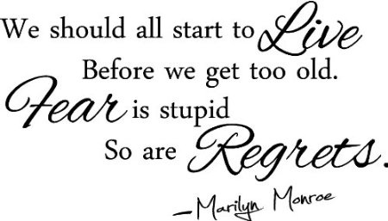
Sally: Hey, Angela. Look. I 21. everything for the party tonight.
Angela：Really? So now you have all the drinks?
Sally: Yeah. 22. The cola and the black tea. I also have the delicious fried chicken.
Angela: Good. Then, where’s the cake for Dad?
Sally: Oh, I’ve put it in the refrigerator.
Angela: What’s its flavor? Chocolate or strawberry?
Sally: 23. I got Dad’s favorite—Blueberry.
Angela: Great. But Sally, do you think Dad will like the party?
Sally: I think so. After all, we hold it for him.
Angela: Do you think we could write down what we want on the card and give it to Dad?
Sally: Of course we could. That 24. what we hold the party for.
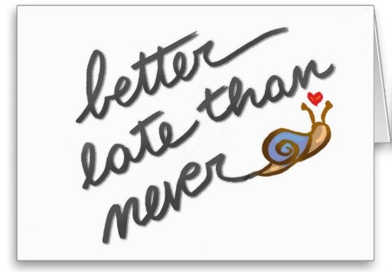
（ ）21. (A) will get (B) am getting (C) was getting (D) have got
（ ）22. (A) Here it is. (B) Here they are. (C) Here they come. (D) Here it comes.
（ ）23. (A) Both. (B) All. (C) Either. (D) Neither.
（ ）24. (A) is (B) was (C) has been (D) had been

